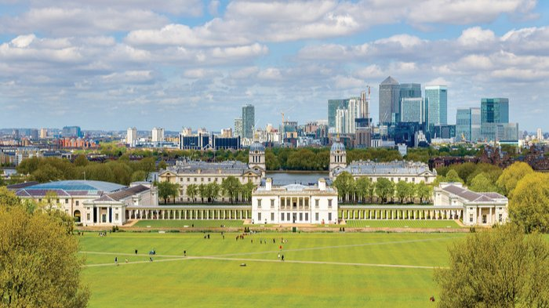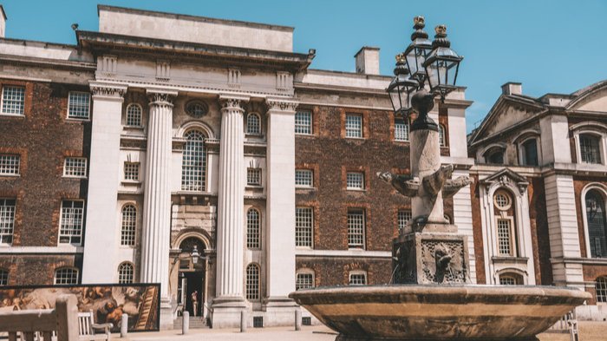

Bayswater London University of Greenwich — summer school in the UK
London SE10 9LS, UK, from 12 to 17 age

Course intensity | 15
Accommodation | Residence
Room type | Single
Bathroom facilities | En-suite
Meals | Breakfast, Lunch and Dinner
Excursions per week | 4
Weekday excursions | 3
Full day excursions | 1

Description

Why choose this program

Infrastructure

Sport infrastructure

Hobbies and clubs

What else included in the program price

Recommended arrival city

Лондон

Sample timetable
 | Morning | Afternoon | Evening
Day 1 | Arrival day | Arrival day | Arrival day
Day 2 | Lessons | Half day excursion to London including Thames Cruise | Disco
Day 3 | Lessons | Art/cultural activities | Karaoke
Day 4 | Lessons | Half day excursion to London with Planetarium + Cutty Sark | Robots War
Day 5 | Brighton inc Royal Pavilion | Brighton inc Royal Pavilion | Brighton inc Royal Pavilion
Day 6 | South Kensington Museums & Hyde Park | South Kensington Museums & Hyde Park | South Kensington Museums & Hyde Park
Day 7 | Lessons | Half day excursion to London including Emirates Cable Car | Lip Synk Battle

Price: €2,133.57

Dates: 2020-07-21 - 2020-08-04

Group leader: Pakuleva Margarita Borisovna, +7 (906) 748 93 52, Pakuleva-m@yandex.ru

