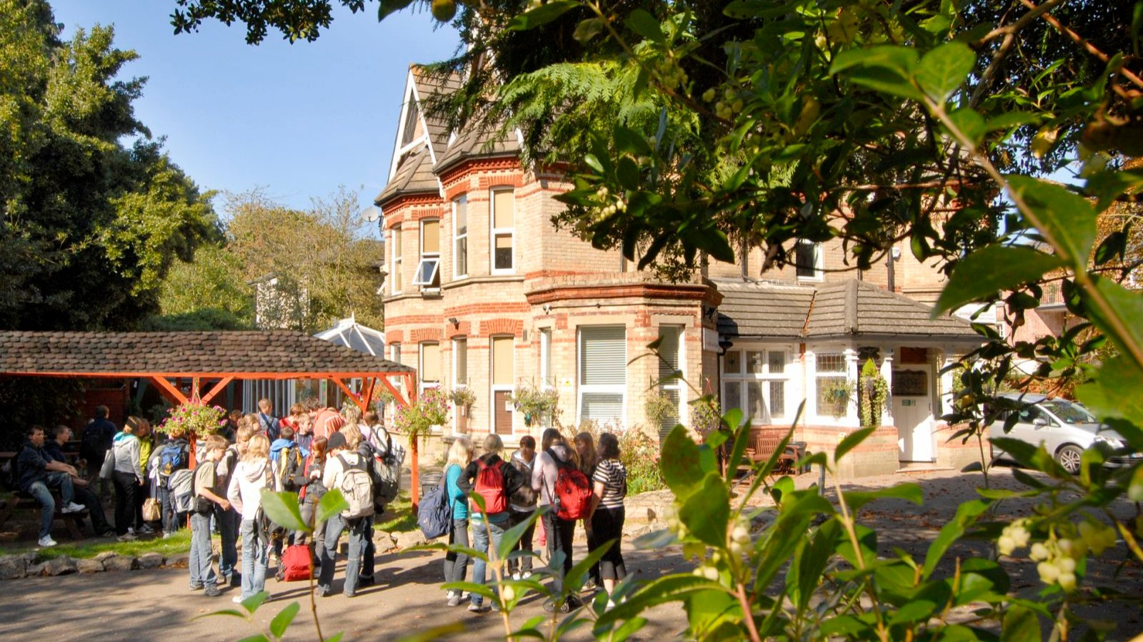

Cavendish School of English Bournemouth — language school in the UK
63 Cavendish Road, Bournemouth, UK, from 9 to 90 age

Course intensity | 37
Accommodation | Host family
Room type | Twin
Bathroom facilities | Shared
Meals | Breakfast, Lunch and Dinner
Excursions per week | 3
Weekday excursions | 2
Full day excursions | 1

Description

Why choose this program

Infrastructure

Sport infrastructure

Hobbies and clubs

What else included in the program price

Recommended arrival city

Лондон

Sample timetable
 | Morning | Afternoon | Evening
Day 1 | Arrival day
Day 2 | Lessons | Free time | Laserquest
Day 3 | Excursion to Winchester | Lessons | Bowling evening
Day 4 | Speedboat ride & free time | Lessons | Party
Day 5 | Full day in London | Full day in London | Full day in London
Day 6 | Activity | Lessons | Cinema
Day 7 | Free day or trip to Themepark | Free day or trip to Themepark | Free day or trip to Themepark

Price: €1,674.90

Dates: 2020-08-09 - 2020-08-22

Group leader: Natalya Kareva, +8 (910) 848 73 27, Kareva-1981@mail.ru

