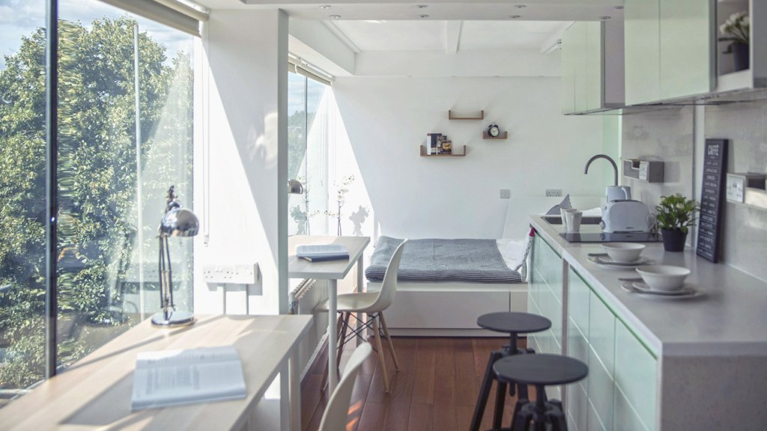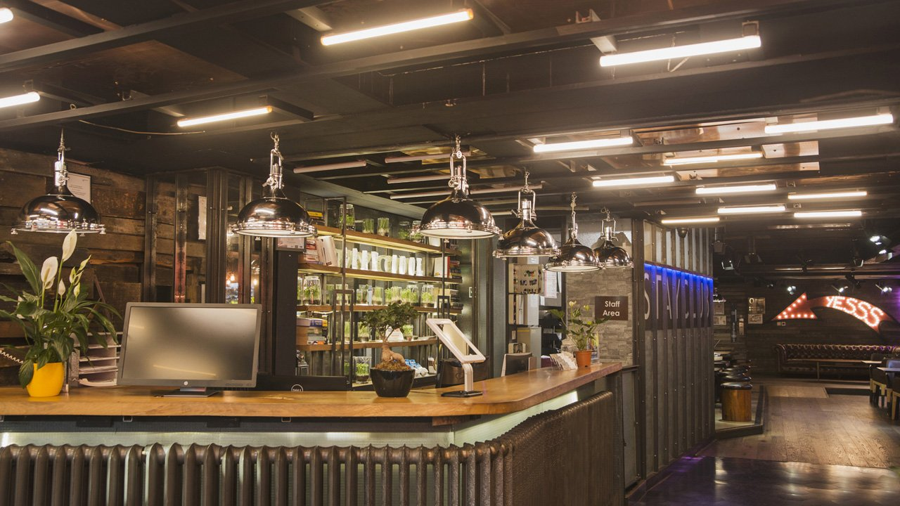

Stay Campus London Camden — language school in the UK
34 Chalk Farm Rd, Лондон NW1 8AJ, Великобритания, from 12 to 100 age

Course intensity | 15
Accommodation | Campus
Room type | Quadraple
Bathroom facilities | En-suite
Meals | Breakfast, Lunch and Dinner
Excursions per week | 6
Weekday excursions | 5
Full day excursions | 1

Description

Why choose this program

Infrastructure

Sport infrastructure

Hobbies and clubs

What else included in the program price

Recommended arrival city

Лондон

Sample timetable
 | Morning | Afternoon | Evening
Day 1 | N/A | ARRIVAL | DINNER
Day 2 | BREAKFAST & LESSONS | National Gallery & Trafalgar Square | DINNER & DISCO
Day 3 | BREAKFAST & LESSONS | Borough Market & Southbank | DINNER & BINGO
Day 4 | BREAKFAST & LESSONS | British Museum | DINNER
Day 5 | BREAKFAST & LESSONS | Covent Garden & Picadilly Circus | DINNER & KARAOKE
Day 6 | BREAKFAST & LESSONS | Camden walk | DINNER & GAMES EVENING
Day 7 | Cambridge & Punting (inc. travel & entrance ticket) | Cambridge & Punting (inc. travel & entrance ticket) | Cambridge & Punting (inc. travel & entrance ticket)

Price: €1,959.99

Dates: 2022-06-12 - 2022-06-25

Group leader: Elena Leonova , +7 (910) 464 48 61, l.leonova83@gmail.com

