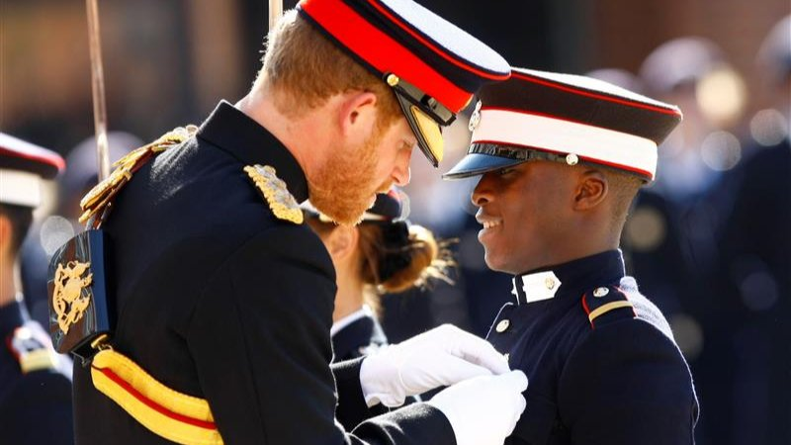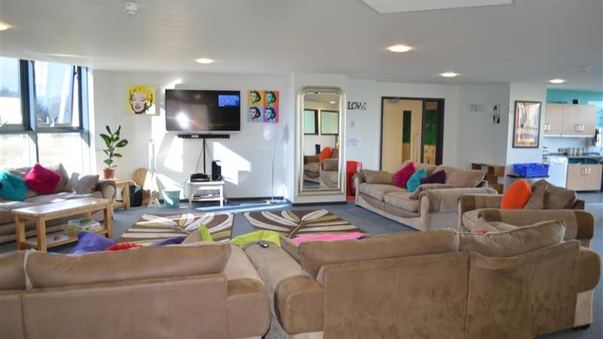

MLA Duke of York&#039;s — language school in the UK
The Duke of York's School, Guston, Dover, UK, from 8 to 16 age

Course intensity | 15
Accommodation | Campus
Room type | Twin
Bathroom facilities | En-suite
Meals | Breakfast, Lunch and Dinner
Excursions per week | 4
Weekday excursions | 3
Full day excursions | 1

Description

Why choose this program

Infrastructure

Sport infrastructure

Hobbies and clubs

What else included in the program price

Recommended arrival city

Лондон

Sample timetable
 | Morning | Afternoon | Evening
Day 1 | Arrival | Orientation Learning MLA Summer Song | Welcome Disco Party
Day 2 | Lessons TASKtime book E-Board | Half Day White Cliffs of Dover | Karaoke
Day 3 | Lessons TASKtime book E-Board | Sport & Leisure | Fashion Night Chit Chat Club
Day 4 | Lessons TASKtime book E-Board | Half Day Leeds Castle and Maze* | Kahoot Night
Day 5 | Lessons TASKtime book E-Board | Sport & Leisure | Hawaiian Disco Party
Day 6 | Lessons TASKtime book E-Board | Half Day Dover Museum Shopping in Dover Centre | Selfie Scavenger Hunt
Day 7 | Full Day London Walking Tour | Cruise on Thames* Houses of Parliament Westminster Abbey Trafalgar Square Piccadilly Circus and Leicester Square | Movie Night
Day 8 | Sport & Leisure | Lessons TASKtime book E-Board | British Disco
Day 9 | Half Day Dover Castle | Lessons TASKtime book E-Board | Kahoot Night Chit Chat Club
Day 10 | Sport & Leisure | Lessons TASKtime book E-Board | Peter Pan Experience
Day 11 | Half Day Canterbury Cathedral* The Old Butter Market The King’s Mile | Lessons TASKtime book E-Board | Karaoke
Day 12 | Sport & Leisure | Lessons TASKtime book E-Board | MLA’s Got Talent
Day 13 | Full Day Brighton Walking Tour The Lanes Churchill Square Shopping Centre Sea Life Centre* Madeira Drive Brighton Palace Pier | Full Day Brighton Walking Tour The Lanes Churchill Square Shopping Centre Sea Life Centre* Madeira Drive Brighton Palace Pier | Farewell Disco Party
Day 14 | Graduation Ceremony & Student Portfolio | Packing & Goodbyes Departure

Price: €2,513.75

Dates: 2020-07-05 - 2020-07-18

Group leader: Kvashnina Liudmila, +7 (915) 066 33 54, ludmila777.64@yandex.ru

