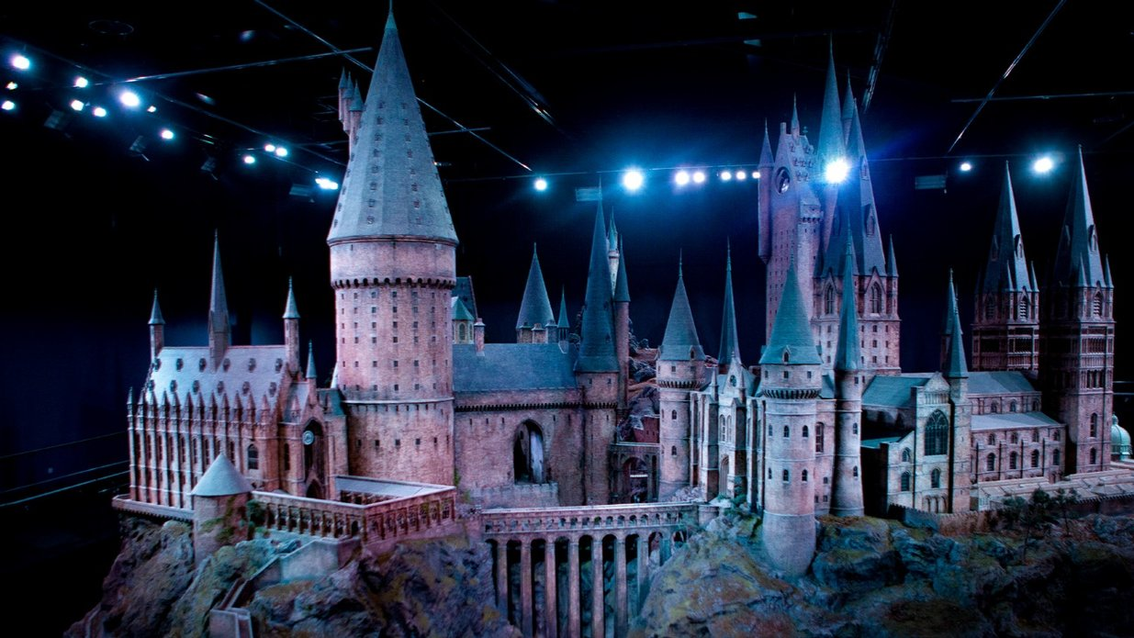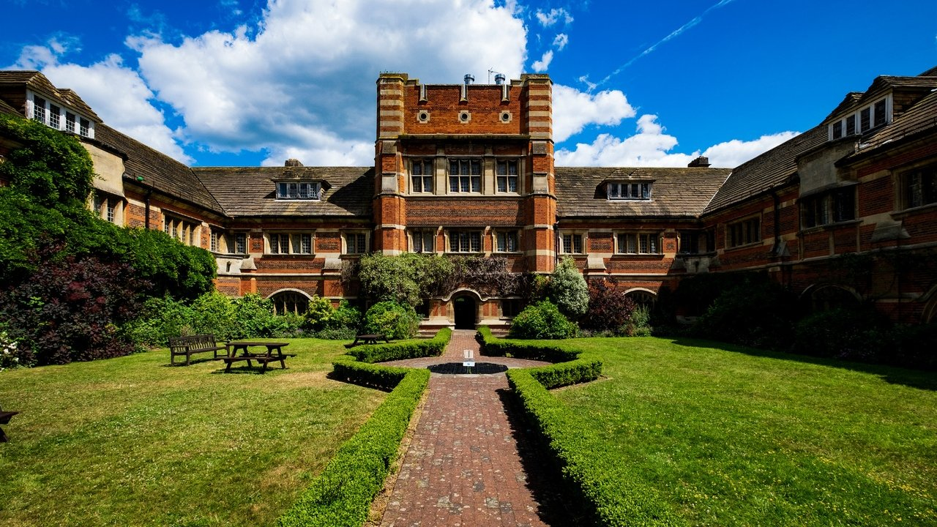

Oxford International Academy St. Albans — language school in the UK
St Albans AL2 1AG, UK, from 8 to 17 age

Course intensity | 15
Accommodation | Campus
Room type | Multi-bedded
Bathroom facilities | Shared
Meals | Breakfast, Lunch and Dinner
Excursions per week | 4
Weekday excursions | 1
Full day excursions | 3

Description

Why choose this program

Infrastructure

Sport infrastructure

Hobbies and clubs

What else included in the program price

Recommended arrival city

Лондон

Sample timetable
 | Morning | Afternoon | Evening
Day 1 | Arrivals | Arrivals | Campus tour and ice-breaker activities
Day 2 | Placement Test and Lessons | Half day to St. Albans by coach | Onsite Activities
Day 3 | Extended full day to London by coach with travelcard | Thames River Cruise and free time to explore Southbank | Late return to campus
Day 4 | Lessons | Lessons | Onsite Activities
Day 5 | Entrance to Warner Bros. Studio Tour | Entrance to Warner Bros. Studio Tour | Onsite Activities
Day 6 | Lessons | Lessons | Onsite Activities
Day 7 | Extended full day to London by coach with travelcard | South Kensington, Natural History Museum and Hyde Park | Late return to campus
Day 8 | Free day - On-site or optional excursions (supplement) 1 week departures | Free day - On-site or optional excursions (supplement) 1 week departures | Free day - On-site or optional excursions (supplement) 1 week departures
Day 9 | Lessons | Half day to St Albans by coach | Onsite Activities
Day 10 | Extended full day to London by coach with travelcard | Entrance to Madame Tussauds with Oxford Street and Piccadily Circus | Late return to campus
Day 11 | Lessons | Lessons | Onsite Activities
Day 12 | Full day to Oxford by coach | Entrance to a University College | Onsite Activities
Day 13 | Lessons | Lessons | Onsite Activities
Day 14 | Extended full day to London by coach with travelcard | Thameside Walking Tour with TATE Modern, St Paul's and the South Bank | Late return to campus

Price: €1,113.96

Dates: 2021-01-03 - 2021-01-10

Group leader: Ivannikova Olesya, +7 (910) 440 58 51, O-olesia@bk.ru

