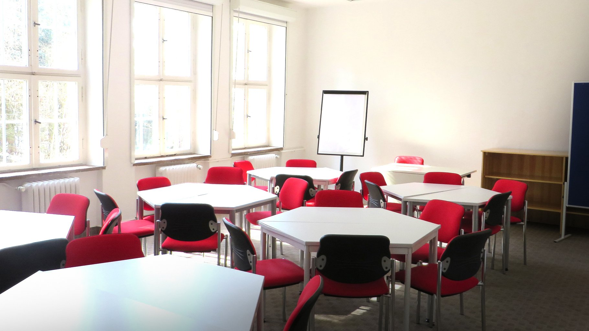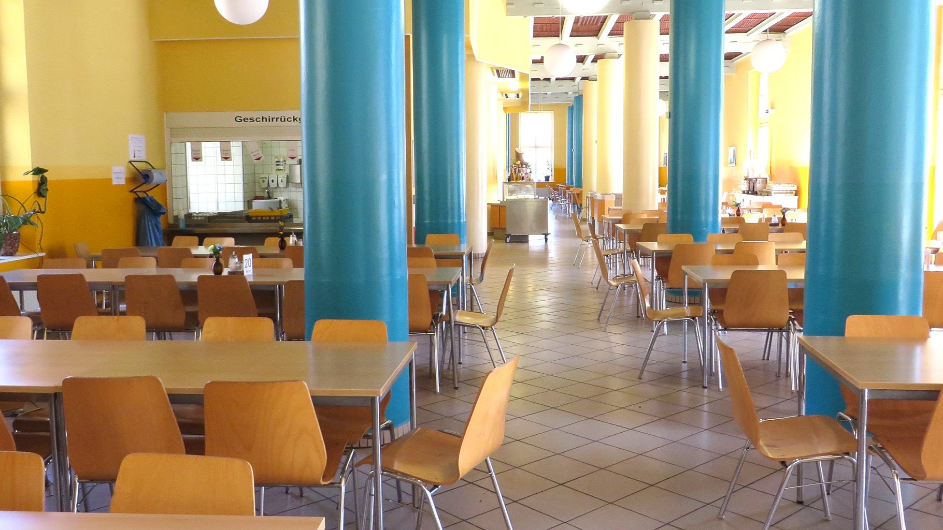

ALPADIA Berlin-Werbellinsee — summer school in Germany
Werbellinsee, Joachimsthal, Germany, from 10 to 17 age

Course intensity | 20
Accommodation | Campus
Room type | Triple
Bathroom facilities | En-suite
Meals | Breakfast, Lunch and Dinner
Excursions per week | 2
Weekday excursions | 1
Full day excursions | 1

Description

Why choose this program

Infrastructure

Sport infrastructure

Hobbies and clubs

What else included in the program price

Recommended arrival city

Берлин

Sample timetable
 | Morning | Afternoon | Evening
Day 1 | Arrival day | Excursion to Checkpoint Charlie or Victory Column | Welcome party
Day 2 | Classes | Package activities | Music blind quiz
Day 3 | Classes | Package activities | Movie night
Day 4 | Classes | Excursion to Adventure Park | BBQ
Day 5 | Classes | Package activities | Challenge night
Day 6 | Classes & weekly test | Package activities | Disco party
Day 7 | Free time | Shopping excursion to Berlin | Free evening or Sports tournament
Day 8 | Free day
Day 9 | Classes | Watersports by the lake | Games
Day 10 | Classes | Package activities | Karaoke
Day 11 | Classes | Package activities | Games
Day 12 | Classes | Excursion to Checkpoint Charlie | Movie night
Day 13 | Classes | Package activities | Disco
Day 14 | Departure

Price: €2,379.72

Dates: 2019-07-07 - 2019-07-20

Group leader: Marina Maksina, +7 (903) 011 96 78, maksina.marina@gmail.com

