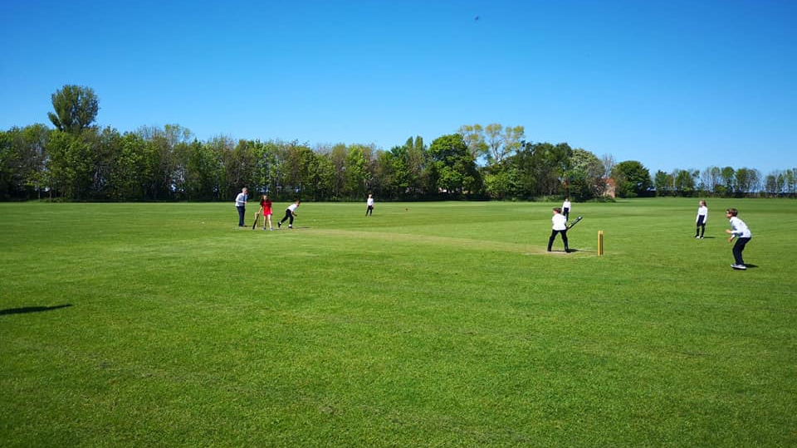

Loretto Edinburgh — summer school in the UK
1-7 Linkfield Rd, Musselburgh, UK, from 10 to 17 age

Course intensity | 15
Accommodation | Campus
Room type | Twin
Bathroom facilities | Shared
Meals | Breakfast, Lunch and Dinner
Excursions per week | 3
Weekday excursions | 2
Full day excursions | 1

Description

Why choose this program

Infrastructure

Sport infrastructure

Hobbies and clubs

What else included in the program price

Recommended arrival city

Эдинбург

Sample timetable
 | Morning | Afternoon | Evening
Day 1 | Arrivals - Check in | Orientation Tour | Welcome Night & Carousel Conversations
Day 2 | Lessons | Half Day Excursion to Edinburgh visiting: MUSEUM OF CHILDHOOD (entrance), JOHN KNOX HOUSE, CANONGATE TOLLBOOTH, CANONGATE KIRK Audio Walking Tour provided By public transport, supervised by staff. Packed dinner and travelcards provided | Summer Disco
Day 3 | Lessons | Half Day Excursion to Edinburgh visiting: MUSEUM OF EDINBURGH (entrance), SCOTTISH PARLIAMENT BUILDING (entrance), PALACE OF HOLYROODHOUSE, CALTON HILL Audio Walking Tour provided By public transport, supervised by staff. Packed dinner and travelcards provided | Knockout
Day 4 | Sports Activities (Tennis, Football, Rugby, Dance, Basketball, Volleyball) | Preparation for the Talent Show | Monopoli
Day 5 | Sports Activities (Tennis, Football, Rugby, Dance, Basketball, Volleyball) | Sports Activities (Tennis, Football, Rugby, Dance, Basketball, Volleyball) | Movie night
Day 6 | Full Day Excursion to St. Andrew and Glamis Castle visiting: WEST SANDS BEACH, ST ANDREWS CASTLE (entrance not included), ST ANDREWS CATHEDRAL, MARKET STREET, ST ANDREWS MUSEUM, GLAMIS CASTLE (entrance included) Audio Walking Tour provided By private coach, supervised by staff. Packed lunch provided. | Full Day Excursion | Karaoke
Day 7 | Lessons | Half Day Excursion to Edinburgh visiting: GRASSMARKET, GEORGE HERIOT’S SCHOOL, EDINBURGH OLD TOWN - SOUVENIR SPREE Audio Walking Tour provided By public transport, supervised by staff. Packed dinner and travelcards provided | Black and White Disco
Day 8 | Lessons | Half Day Excursion to Edinburgh visiting: GREYFRIARS KIRKYARD (entrance), NATIONAL MUSEUM OF SCOTLAND (entrance) | Scavenger Hunt
Day 9 | Lessons | Sports Activities (Tennis, Football, Rugby, Dance, Basketball, Volleyball) | Karaoke
Day 10 | Lessons | Half Day Excursion to Edinburgh visiting: UNIVERSITY OF EDINBURGH, PARLIAMENT SQUARE, ST. GILES CATHEDRAL (entrance), MERCAT CROSS, GLADSTONE’S LAND (entry not included) | Picture Hunt
Day 11 | Lessons | Sports Activities (Tennis, Football, Rugby, Dance, Basketball, Volleyball) | Talent show
Day 12 | Sports Activities (Tennis, Football, Rugby, Dance, Basketball, Volleyball) | Sports Activities (Tennis, Football, Rugby, Dance, Basketball, Volleyball) | Newspaper Fashion Show
Day 13 | Full Day Excursion to Loch Ness Centre v | Full Day Excursion to Loch Ness Centre v | Lights - Camera - Action!
Day 14 | Lessons | Half Day Excursion to Edinburgh visiting: ST ANDREW SQUARE, SCOTT MONUMENT, PRINCES STREET GARDENS (entrance), SCOTTISH NATIONAL GALLERY (entrance) | Graduation & Farewell Disco

Price: €1,955.92

Dates: 2020-07-21 - 2020-08-04

Group leader: AKHMETGALEEVA Olga Vladimirovna , 79778026654, muska28@mail.ru

