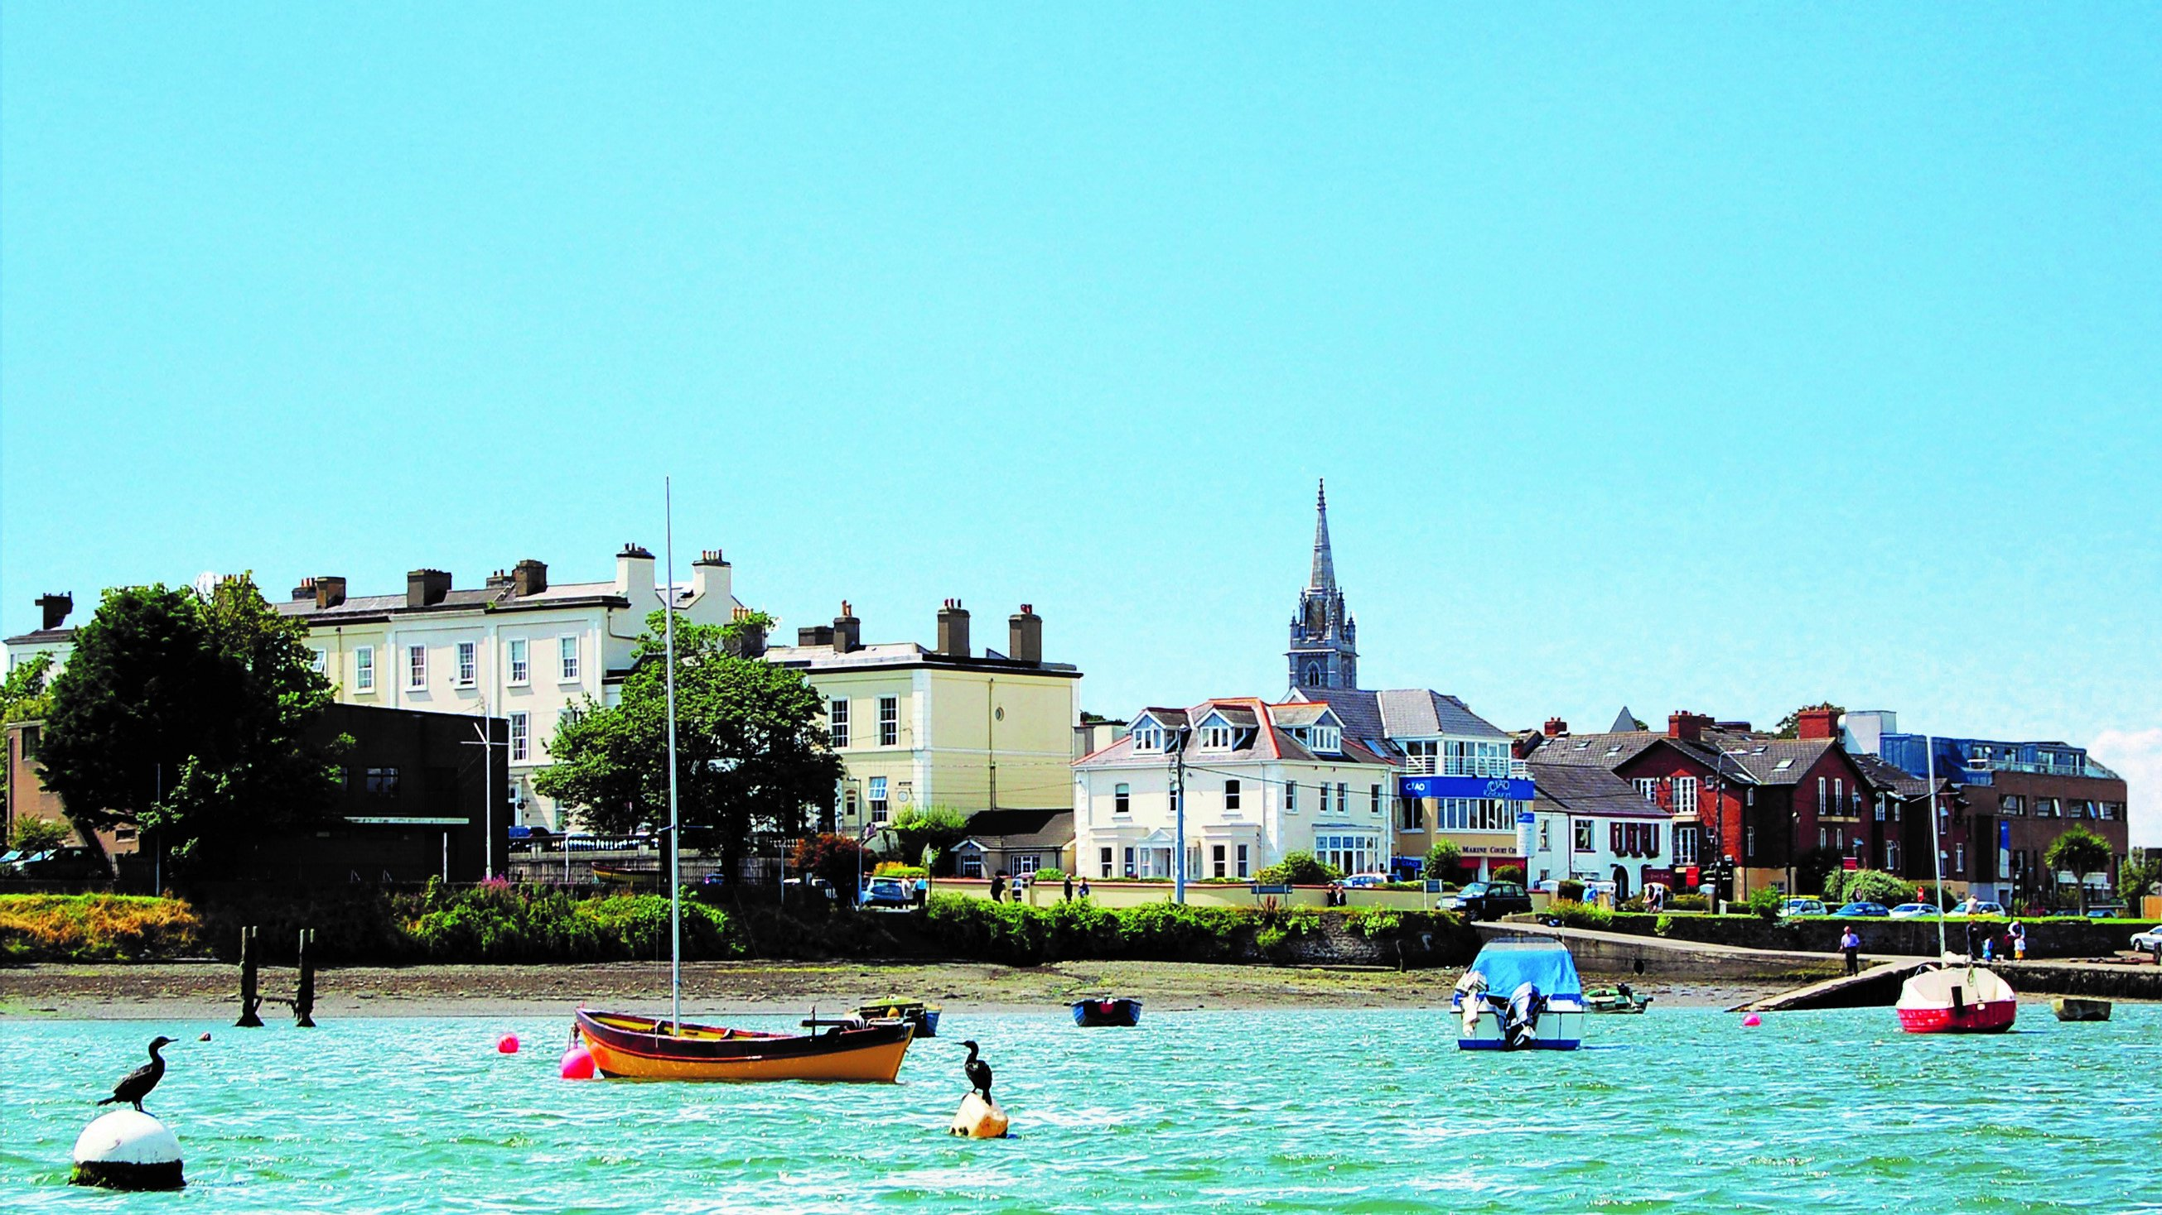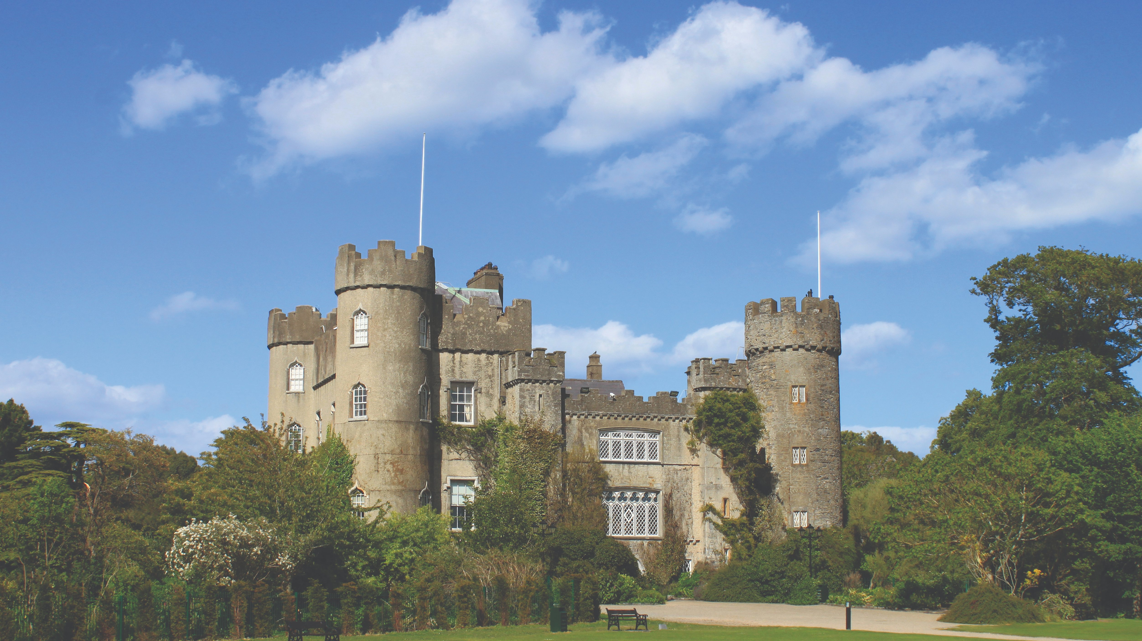

Irish College of English — language school in Ireland
6 Church Road, Malahide, County Dublin, Ireland, from 11 to 17 age

Course intensity | 15
Accommodation | Host family
Room type | Twin
Bathroom facilities | Shared
Meals | Breakfast, Lunch and Dinner
Excursions per week | 6
Weekday excursions | 5
Full day excursions | 1

Description

Why choose this program

Infrastructure

Sport infrastructure

Hobbies and clubs

What else included in the program price

Recommended arrival city

Дублин

Sample timetable
 | Morning | Afternoon | Evening
Day 1 | English Classes | Dublin City Professional Walking Tour | Free Time with Host Family or Friends
Day 2 | English Classes | National Gallery | Disco
Day 3 | English Classes | Irish Music Session in a Pub | Free Time with Host Family or Friends
Day 4 | English Classes | Howth Cliff Walk | Disco
Day 5 | English Classes | Malahide Castle Tour | Free Time with Host Family or Friends
Day 6 | Full Day Trip to Glenalough | Full Day Trip to Glenalough | Free Time with Host Family or Friends
Day 7 | Host Family and Friends Free Day | Host Family and Friends Free Day | Free Time with Host Family or Friends

Price: €1,819.23

Dates: 2020-07-05 - 2020-07-19

Group leader: Grigoreva Marina, +7 (951) 981 06 38, kay_girl@mail.ru

