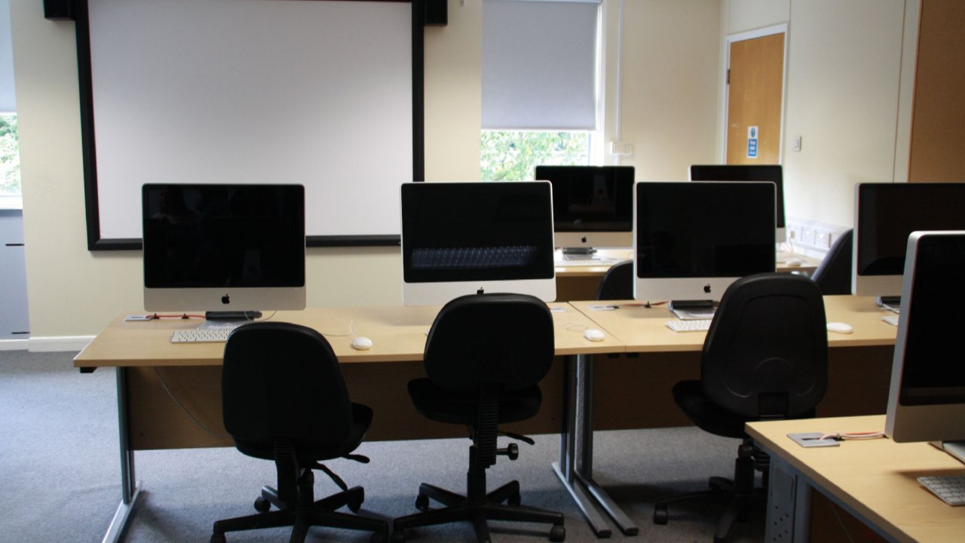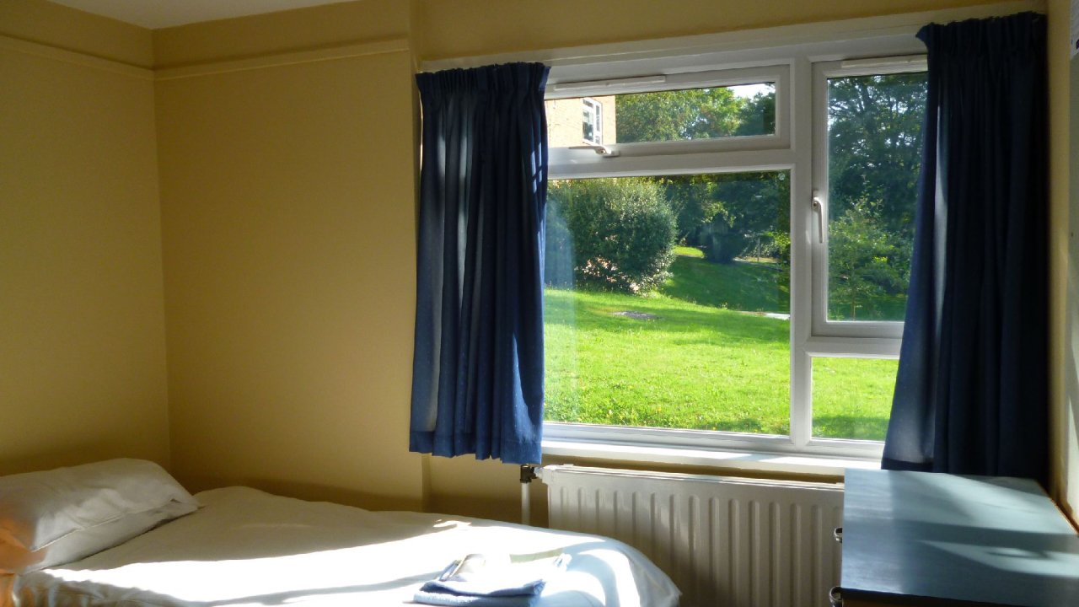

IP Winchester — summer school in the UK
Winchester, Винчестер, UK, from 10 to 17 age

Course intensity | 15
Accommodation | Residence
Room type | Single
Bathroom facilities | Shared
Meals | Breakfast, Lunch and Dinner
Excursions per week | 3
Weekday excursions | 2
Full day excursions | 1

Description

Why choose this program

Infrastructure

Sport infrastructure

Hobbies and clubs

What else included in the program price

Recommended arrival city

Лондон

Sample timetable
 | Morning | Afternoon | Evening
Day 1 | Meet & greet | Chill out | Movie Night
Day 2 | IP dance workshop | Sport | Quiz
Day 3 | Lessons | Half day excursion to Salisbury | Welcome theme party
Day 4 | Lessons | Sport and Healthy & Beauty | Games Night
Day 5 | Lessons | Half day excursion to Bournemouth | Bonfire Night
Day 6 | Lessons | Sport and Arts & Crafts | IP’s Got talents
Day 7 | Lessons | Sport and Arts & Crafts | Party

Price: €1,859.11

Dates: 2020-06-27 - 2020-07-11

Group leader: Kazakova Irina, +8 (952) 021 57 15, kazirinka05@mail.ru

