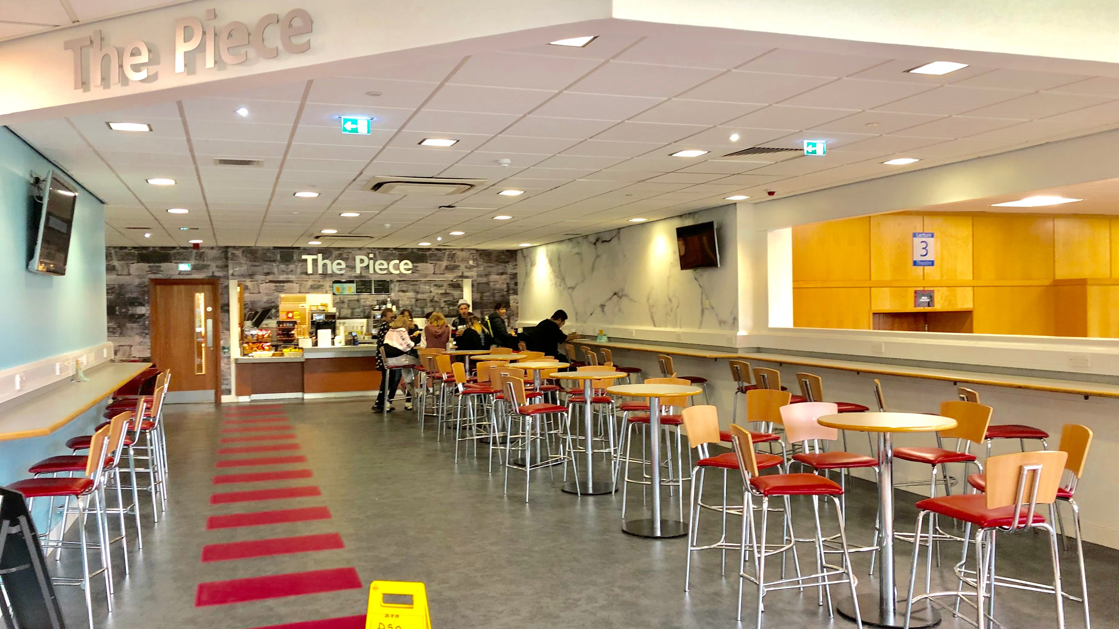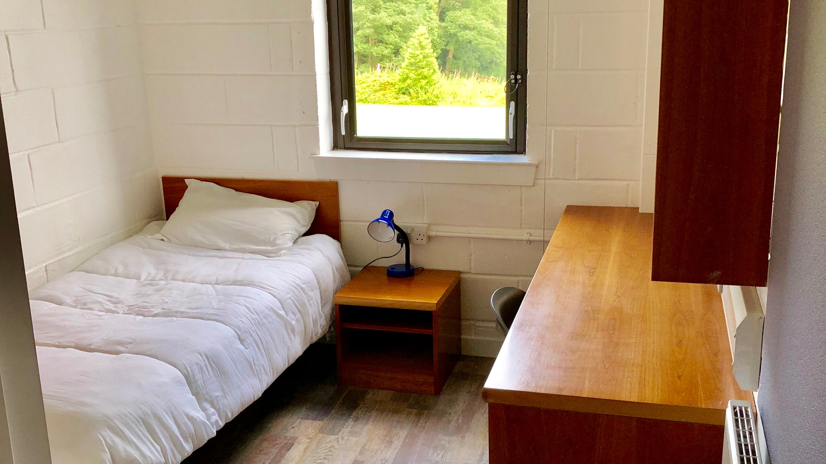

MLA Edinburgh Heriot Watt University — summer school in the UK
Heriot Watt University, Third Gait, Edinburgh, UK, from 10 to 17 age

Course intensity | 15
Accommodation | Campus
Room type | Single
Bathroom facilities | En-suite
Meals | Breakfast, Lunch and Dinner
Excursions per week
Weekday excursions | 6
Full day excursions | 3

Description

Why choose this program

Infrastructure

Sport infrastructure

Hobbies and clubs

What else included in the program price

Recommended arrival city

Эдинбург

Sample timetable
 | Morning | Afternoon | Evening
Day 1 | Arrival | Orientation Learning MLA Summer Song | Welcome party
Day 2 | Lessons | Half Day Walking Tour National Gallery Scott Monument Princes Street | Karaoke
Day 3 | Lessons | Half Day Royal Yacht Britannia* Ocean Terminal | Selfie Scavenger Hunt Chit Chat Club
Day 4 | Lessons | Sport & Leisure | Fashion Night
Day 5 | Lessons | Half Day Edinburgh Castle* Princes Street Garden | Hawaiian Disco Party
Day 6 | Lessons | Full Day Royal Botanic Garden New Town National Portrait Gallery Hard Rock Cafe Shop & Dinner | Full Day Royal Botanic Garden New Town National Portrait Gallery Hard Rock Cafe Shop & Dinner
Day 7 | Full Day Stirling Walking Tour Stirling Castle* William Wallace Monument Stop | Full Day Stirling Walking Tour Stirling Castle* William Wallace Monument Stop | Movie night

Price: €3,101.43

Dates: 2020-07-02 - 2020-07-22

Group leader: Gabelkova Anna, 79165557555, annagabelkova@rambler.ru

