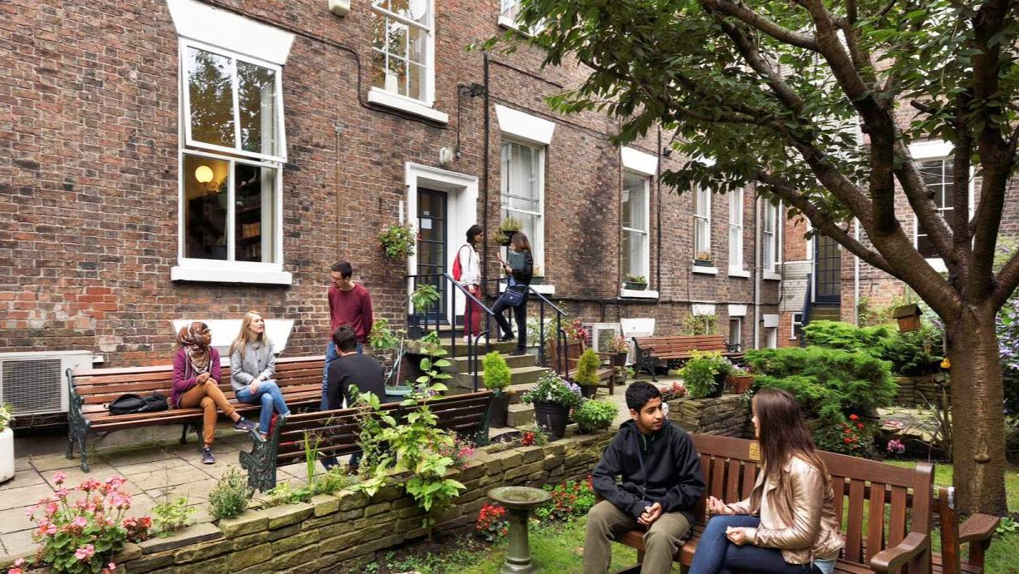

Liverpool School of English — language school in the UK
50-54 Mount Pleasant, Liverpool, UK, from 12 to 19 age

Course intensity | 15
Accommodation | Host family
Room type | Twin
Bathroom facilities | Shared
Meals | Breakfast, Lunch and Dinner
Excursions per week | 1
Weekday excursions | 1
Full day excursions | 0

Description

Why choose this program

Infrastructure

Sport infrastructure

Hobbies and clubs

What else included in the program price

Recommended arrival city

Лондон

Sample timetable
 | Morning | Afternoon | Evening
Day 1 |  | Arrival day - check in to homestay | Evening with homestay hosts
Day 2 | Induction and placement test | Afternoon city tour and scavenger hunt | Evening with homestay hosts
Day 3 | English Lesson | Free time with Group Leader | Evening with homestay hosts
Day 4 | English Lesson | The Museum of Liverpool | Evening with homestay hosts
Day 5 | English Lesson | Free time with Group Leader | Evening with homestay hosts
Day 6 | English Lesson | The Walker Art Gallery | Evening with homestay hosts
Day 7 | Day with your hosts | Day with your hosts | Day with your hosts

Price: €588.50

Dates: 2020-03-29 - 2020-04-05

Group leader: , , mirgorodskay.maria@mil.ru

