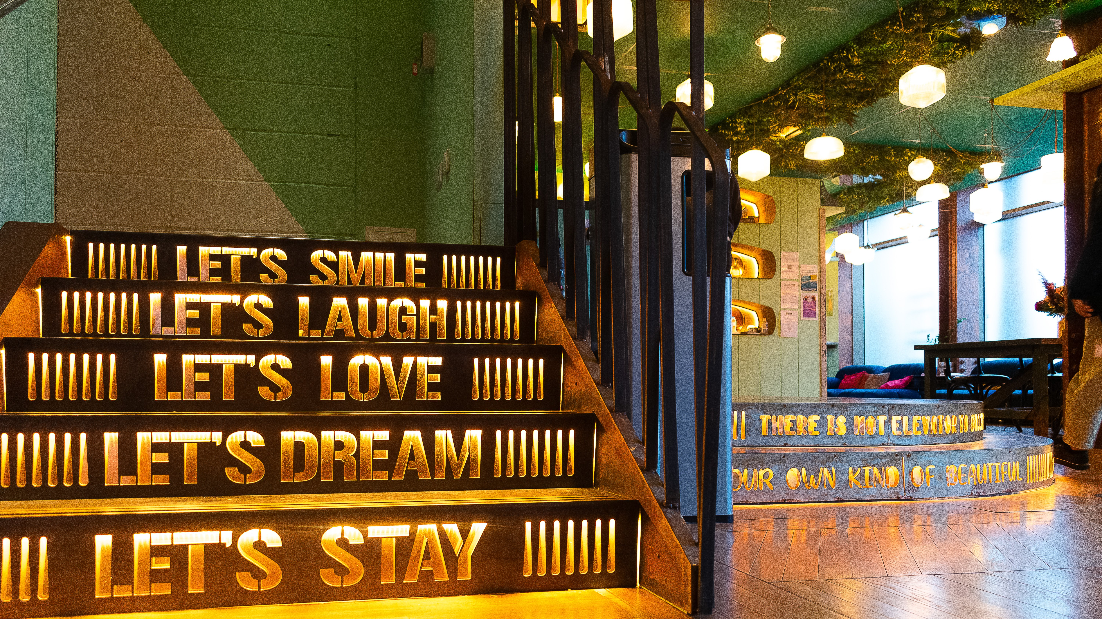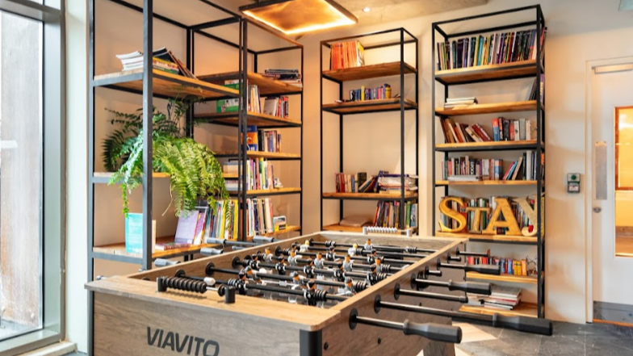

SCL International College North Acton — London language school, UK
200 Western Avenue, London, W3 6FW, from 12 to 17 age

Course intensity | 20
Accommodation | Campus
Room type | Multi-bedded
Bathroom facilities | En-suite
Meals | Breakfast, Lunch and Dinner
Excursions per week | 6
Weekday excursions | 5
Full day excursions | 1

Description

Why choose this program

Infrastructure

Sport infrastructure

Hobbies and clubs

What else included in the program price

Recommended arrival city

Лондон

Sample timetable
 | Morning | Afternoon | Evening
Day 1 | Arrival
Day 2 | Tower Bridge Walk | Football Coaching with Watford FC Sports Trust | Arts & Crafts
Day 3 | Camden Town Market | Football Coaching with Watford FC Sports Trust | Games Night
Day 4 | Science Museum & Hyde Park | Football Coaching with Watford FC Sports Trust | Karaoke
Day 5 | Wembley Stadium Tour | Football Coaching with Watford FC Sports Trust | Disco
Day 6 | Tate Modern | Football Coaching with Watford FC Sports Trust | Movie Night
Day 7 | Cambridge & Punting (inc. travel & entrance ticket) | Cambridge & Punting (inc. travel & entrance ticket) | Quiz night

Price: €1,123.38

Dates: 2019-04-28 - 2019-05-04

Group leader: Giunai Dzhafarova, +7 (977) 584 99 95, gunaye4ka@mail.ru

