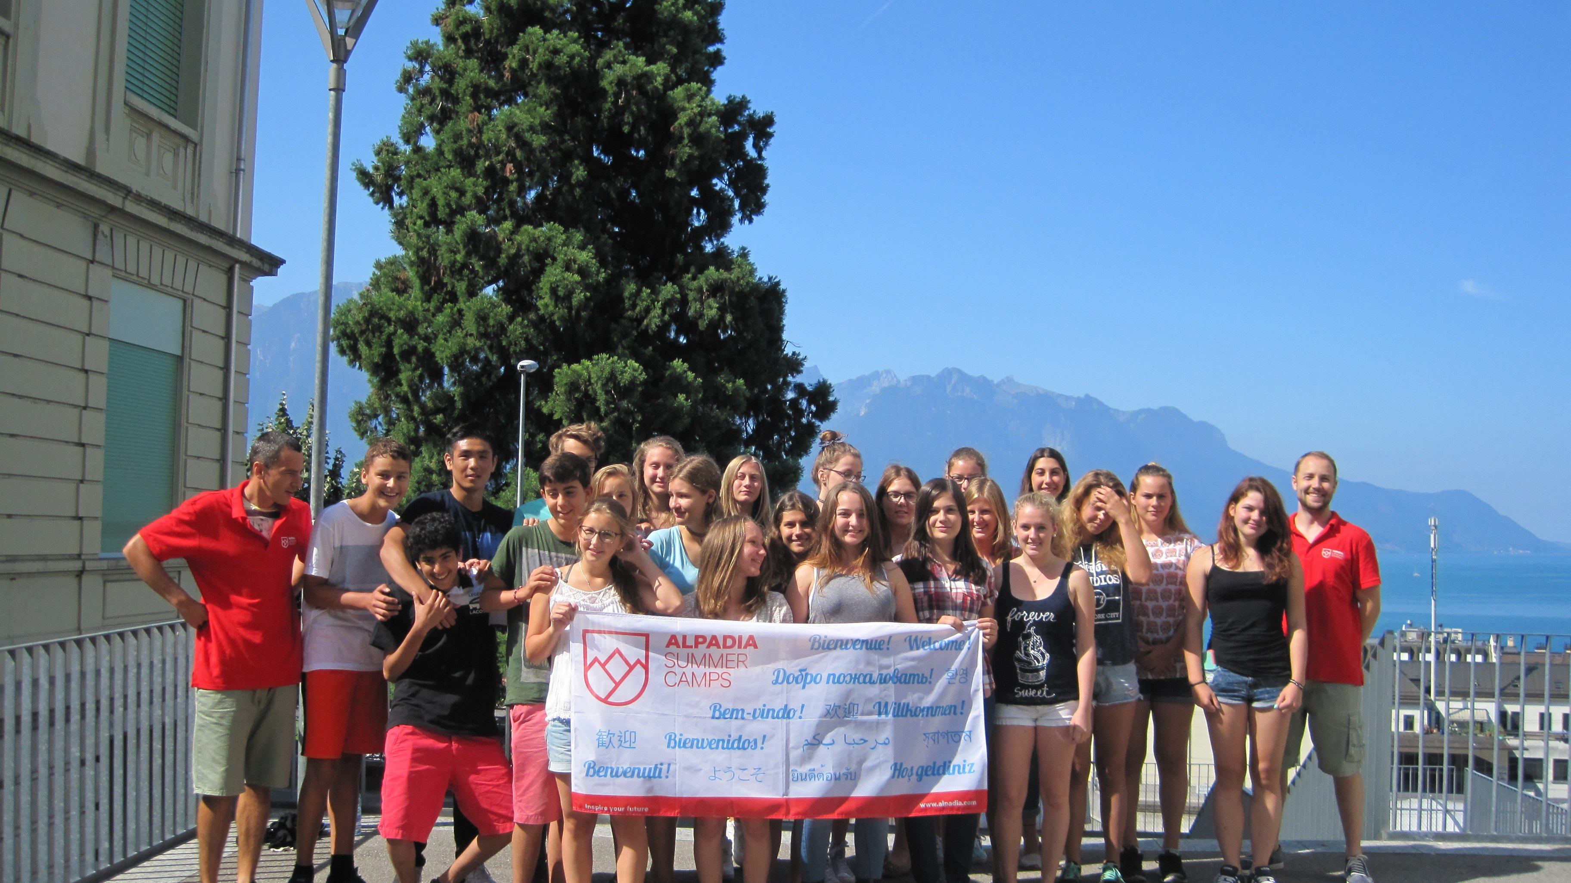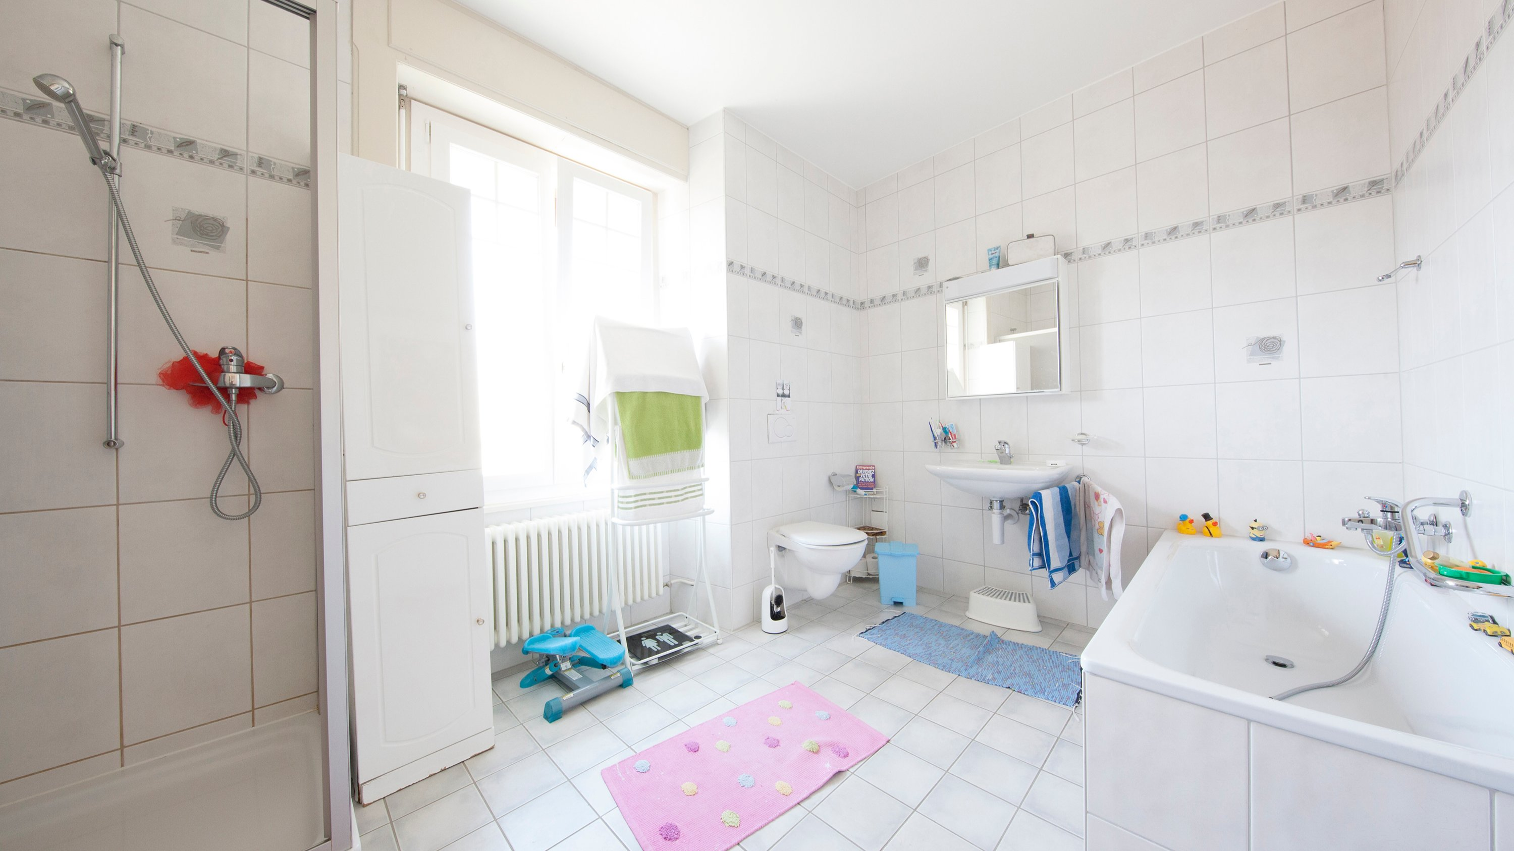

ALPADIA Montreux — language school in Switzerland
Rue de la Gare 33, 1820 Montreux, Switzerland, from 13 to 17 age

Course intensity | 20
Accommodation | Host family
Room type | Single
Bathroom facilities | Shared
Meals | Breakfast, Lunch and Dinner
Excursions per week | 2
Weekday excursions | 1
Full day excursions | 1

Description

Why choose this program

Infrastructure

Sport infrastructure

Hobbies and clubs

What else included in the program price

Recommended arrival city

Женева

Sample timetable
 | Morning | Afternoon | Evening
Day 1 | Arrival day | Day with host family | Evening with host family
Day 2 | Classes | Package activities | Games night
Day 3 | Classes | Package activities | Jazz festival or evening in Vevey/Lausanne
Day 4 | Classes | Excursion to Château de Chillon or Aquaparc | Movie night
Day 5 | Classes | Package activities | BBQ
Day 6 | Classes & weekly test | Package activities | Evening with host family
Day 7 | Free time | Excursion to Gruyères & Cailler Chocolate Factory | Evening with host family
Day 8 | Free day
Day 9 | Classes | Package activities | Evening with host family
Day 10 | Classes | Package activities | BBQ
Day 11 | Classes | Package activities | Evening with host family
Day 12 | Classes | Package activities | Pizza party
Day 13 | Classes | Kayaking or pedalo boating on Lake Geneva | Disco
Day 14 | Departure

Price: €2,920.47

Dates: 2019-07-28 - 2019-08-10

Group leader: Фамилия Имя Отчество, +7 (111) 111 11 11,

