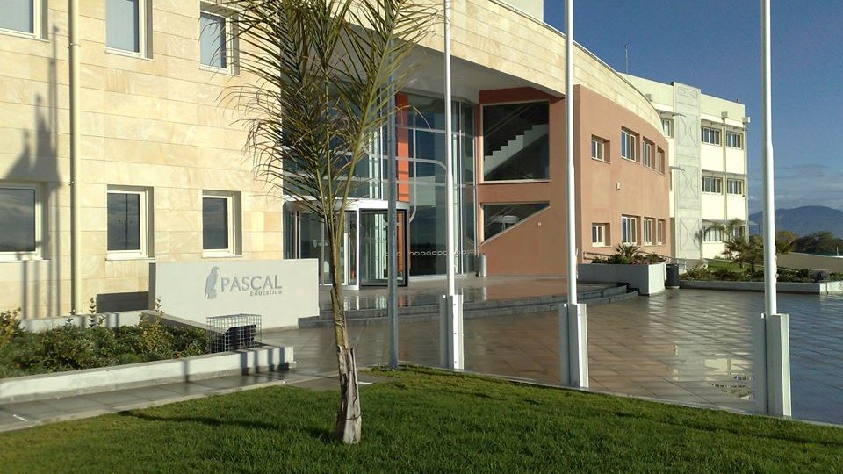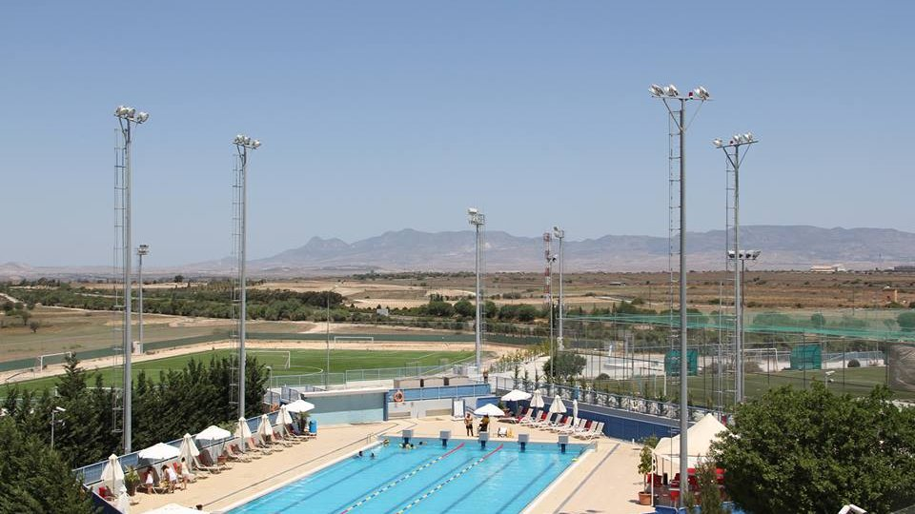

English School Pascal — language school in Cyprus
A9, Nicosia, from 12 to 17 age

Course intensity | 25
Accommodation | Residence
Room type | Quadraple
Bathroom facilities | En-suite
Meals | Breakfast, Lunch and Dinner
Excursions per week | 1
Weekday excursions | 1
Full day excursions

Description

Why choose this program

Infrastructure

Sport infrastructure

Hobbies and clubs

What else included in the program price

Recommended arrival city

Никосия

Sample timetable
 | Morning | Afternoon | Evening
Day 1 |  | Arrival, check in to the residence, tour of the boarding facilities | Welcome evening at the residence
Day 2 | Introduction, lessons, tour of the school | Half-day excursion | Free time (ex. gym next door to the residence)
Day 3 | Lessons | Free time (ex. trip to Nicosia city centre, Ledra street) | Evening activity at the residence
Day 4 | Lessons | Free time (ex. Cinema) | Free time (ex. Bowling)
Day 5 | Lessons | Free time (ex. trip to Nicosia city centre, the Cyprus Museum) | Evening activity at the residence
Day 6 | Lessons | Free time (ex. Shopping) | Free time (ex. Luna park)
Day 7 | Free time | Departure

Price: €797.68

Dates: 2020-05-03 - 2020-05-09

Group leader: Leonteva Anna Anatolyevna, +7 (916) 902 08 27, leonteva1284@yandex.ru

