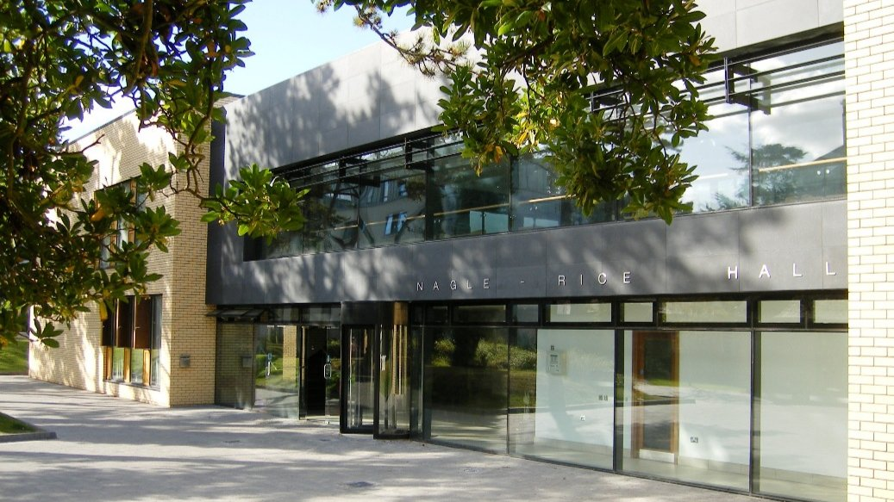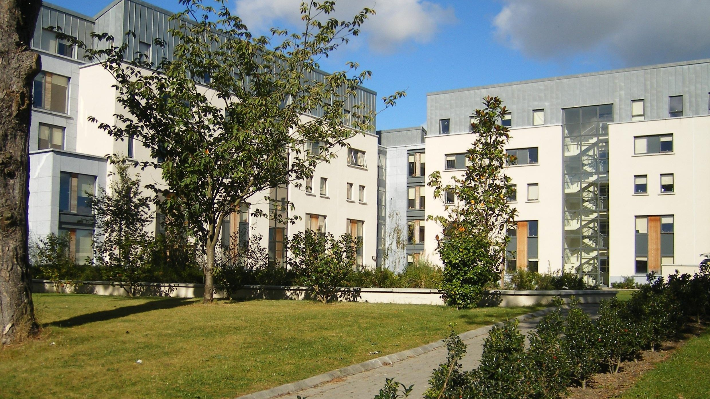

Emerald Dublin Marino College — summer school in Ireland
Griffith Avenue, Dublin 9, Ireland, from 11 to 17 age

Course intensity | 15
Accommodation | Campus
Room type | Single
Bathroom facilities | En-suite
Meals | Breakfast, Lunch and Dinner
Excursions per week | 3
Weekday excursions | 2
Full day excursions | 1

Description

Why choose this program

Infrastructure

Sport infrastructure

Hobbies and clubs

What else included in the program price

Recommended arrival city

Дублин

Sample timetable
 | Morning | Afternoon | Evening
Day 1 | Lessons | Activities / Excursions | Activity
Day 2 | Lessons | Activities / Excursions | Activity
Day 3 | Lessons | Activities / Visit to GAA Museum | Activity
Day 4 | Lessons | Activities / Excursions | Activity
Day 5 | Lessons | Activities / Excursion to Dublin Castle | Activity
Day 6 | Full day Excursion to Kilkenny Castle & Dunmore Caves | Full day Excursion to Kilkenny Castle & Dunmore Caves | Activity
Day 7 | Free Time | Free time | Activity

Price: €3,069.53

Dates: 2019-06-23 - 2019-07-14

Group leader: URIBE MOLINA MELBA, +7 (968) 826 96 65, mel.uribem@gmail.com

