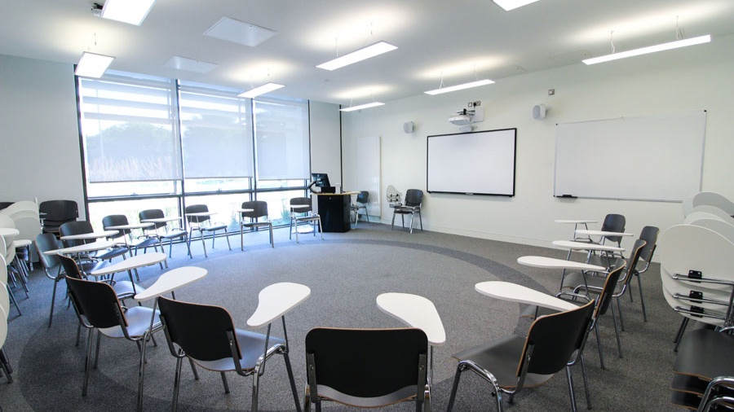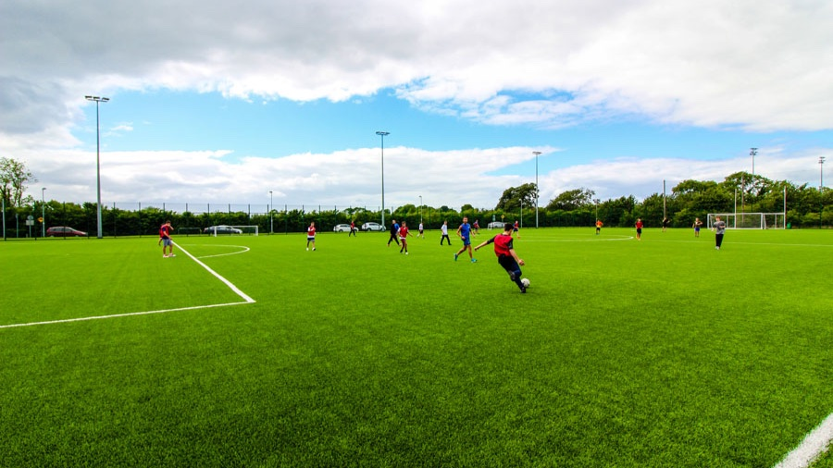

APOLLO Maynooth University
Mariavilla, Maynooth, Co. Kildare, Ireland, from 11 to 17 age

Course intensity | 15
Accommodation | Campus
Room type | Single
Bathroom facilities | En-suite
Meals | Breakfast, Lunch and Dinner
Excursions per week | 4
Weekday excursions | 3
Full day excursions | 1

Description

Why choose this program

Infrastructure

Sport infrastructure

Hobbies and clubs

What else included in the program price

Recommended arrival city

Дублин

Sample timetable
 | Morning | Afternoon | Evening
Day 1 | Arrivals / Departures | Arrivals / Departures | Getting to know games
Day 2 | Lessons | Walking tour of Maynooth & Campus | Obstacle Course
Day 3 | lessons | Trip to City center including walking tour | Cluedo Games Night
Day 4 | Lessons | Sports / Apollo Arts / Apollo Focus | UV Lights Disco
Day 5 | Lessons | Trip to Croke Park GAA Stadium | Table Quiz
Day 6 | Lessons | Sports / Apollo Arts / Apollo Focus | Certificate Ceremony & Karaoke
Day 7 | Belfast including Titanic Experience | Belfast including Titanic Experience | Movie Night
Day 8 | Bray Cliff Walk | City Trip | Games Night
Day 9 | Photo Scavenger Hunt & Gaelic Sports | Lessons | Roller Disco
Day 10 | Epic Ireland Museum | Lessons | Irish Quiz
Day 11 | Sports/Apollo Focus lesson | Lessons | Black & White Disco
Day 12 | National Museum | Lessons | Apollo’s Got Talent
Day 13 | Sports/Apollo Focus lesson | Lessons | Certificate Ceremony & Party
Day 14 | Glendalough & Wicklow Gaol | Glendalough & Wicklow Gaol | Music Video Awards

Price: €2,867.64

Dates: 2020-07-26 - 2020-08-09

Group leader: Popova Daria, +7 (915) 078 25 85, varyushka2009@gmail.com

