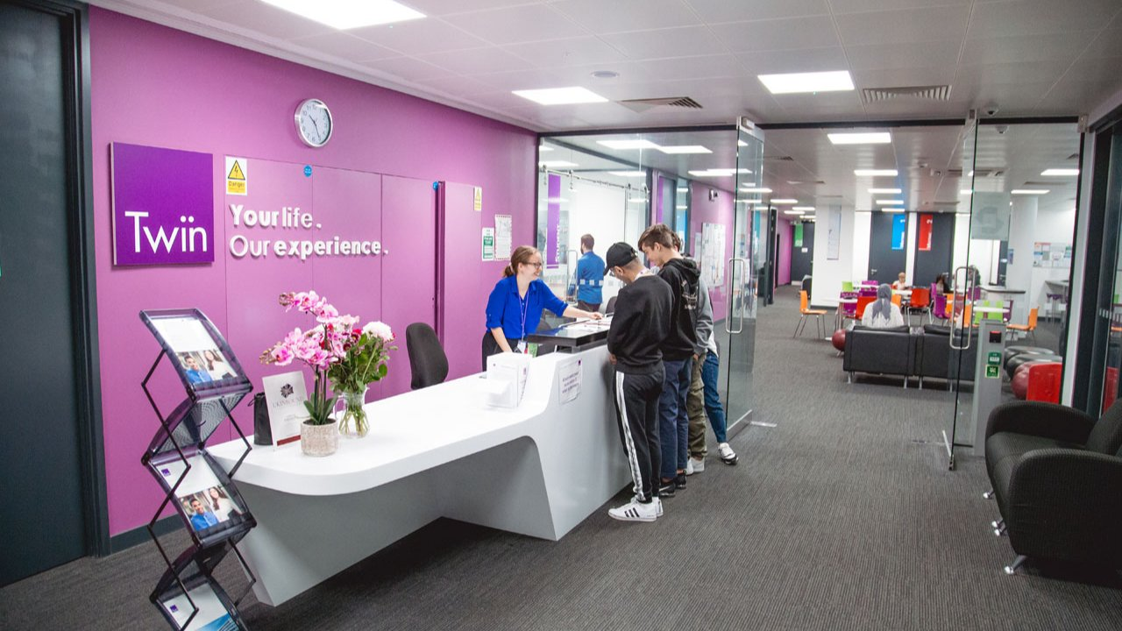

Twin English School London — language school in the UK
London SE10 9GB, UK, from 10 to 99 age

Course intensity | 15
Accommodation | Host family
Room type | Twin
Bathroom facilities | Shared
Meals | Breakfast, Lunch and Dinner
Excursions per week | 6
Weekday excursions | 5
Full day excursions | 1

Description

Why choose this program

Infrastructure

Sport infrastructure

Hobbies and clubs

What else included in the program price

Recommended arrival city

Лондон

Sample timetable
 | Morning | Afternoon | Evening
Day 1 | Arrival | Settling in | Free time
Day 2 | Testing and English Lessons | Walking Tour: Royal London Walk | Free time
Day 3 | English Lessons | English Lessons | free time OR Christmas Pantomime - optional
Day 4 | Christmas Day – No Lessons! Enjoy Lazy Late Morning | Enjoy Christmas Day with your host family | Enjoy Christmas Day with your host family
Day 5 | Boxing Day – No Lessons! | Morning and Afternoon - Find Out 70% Discounts on Christmas Sale at Oxford Street | Free time
Day 6 | English Lessons | English Lessons | Ice skating at Canary Wharf
Day 7 | Full day coach excursion to Oxford | Walking tour around the city and visit to Corpus Christi College of Oxford University | Free time

Price: €1,625.29

Dates: 2019-12-22 - 2020-01-05

Group leader: Ponomareva Natalia, +7 (903) 274 90 51, ponomarevang.edu@yandex.ru

