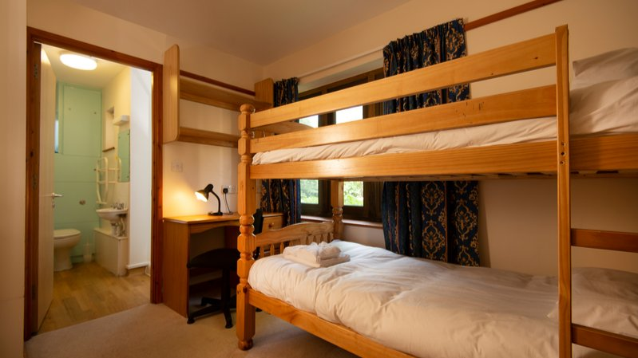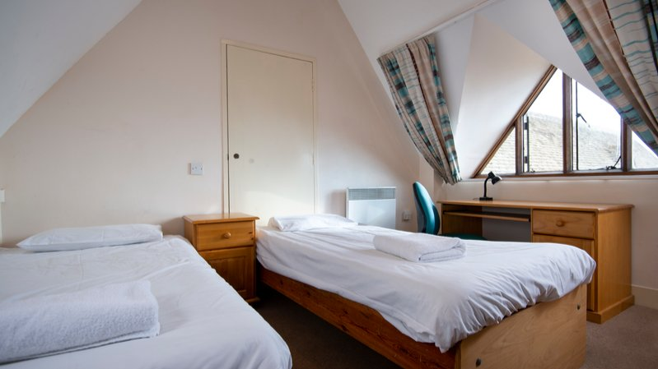

Oxford International Royal Agricultural University — summer school in the UK
Royal Agricultural College, Cirencester, UK, from 8 to 17 age

Course intensity | 15
Accommodation | Campus
Room type | Triple
Bathroom facilities | Shared
Meals | Breakfast, Lunch and Dinner
Excursions per week | 3
Weekday excursions | 1
Full day excursions | 2

Description

Why choose this program

Infrastructure

Sport infrastructure

Hobbies and clubs

What else included in the program price

Recommended arrival city

Лондон

Sample timetable
 | Morning | Afternoon | Evening
Day 1 | Arrival | Arrival | Campus tour and ice-breaker activities
Day 2 | Placement Test, Welfare Induction and Lessons | Orientation of Cirencester | Welcome Disco
Day 3 | Lessons | Onsite Activities | Onsite Activities
Day 4 | Full day excursion to Bristol with Banksy graffiti walking tour | Choice of entrance including SS Great Britain, We The Curious and Aerospace Bristol | Onsite Activities
Day 5 | iPad Treasure Hunt | Lessons | Karaoke/Lip Sync Battle
Day 6 | Onsite Activities | Lessons | Outdoor Cinema
Day 7 | Full day excursion to Oxford OR Stratford-upon-Avon | Entrance to an Oxford College OR Shakespeare's Birthplace | Onsite Activities
Day 8 | Lessons | Lessons | International evening
Day 9 | Half day to Cirencester | Lessons | Disco
Day 10 | Onsite Activities | Lessons | Onsite Activities
Day 11 | Lessons | Onsite Activities | Talent Show
Day 12 | Lessons | Cirencester Photo Challenge | Disco
Day 13 | Full day exploring London | Full day exploring London | Overnight in London
Day 14 | Full day exploring London | Entrance to British Museum | Overnight in Residence

Price: €1,089.38

Dates: 2019-07-01 - 2019-07-08

Group leader: Тамара, +7 (926) 767 59 38, bagira1983611@bk.ru

