Riviera French Institute — language school in France

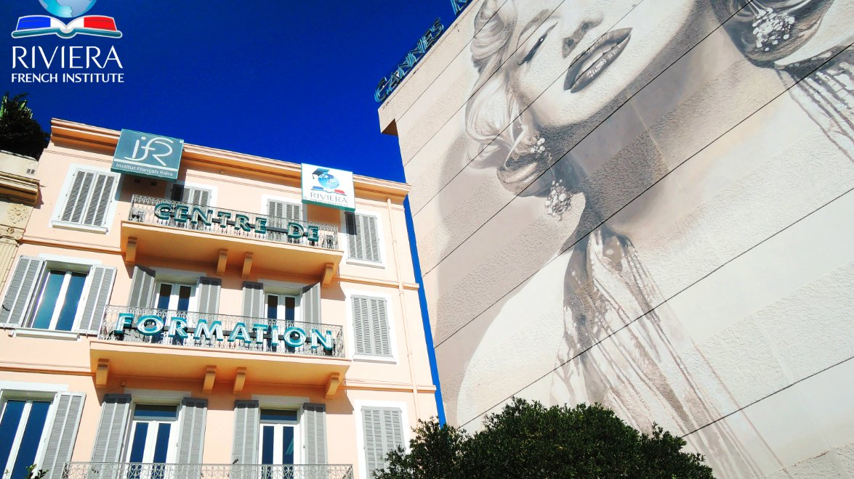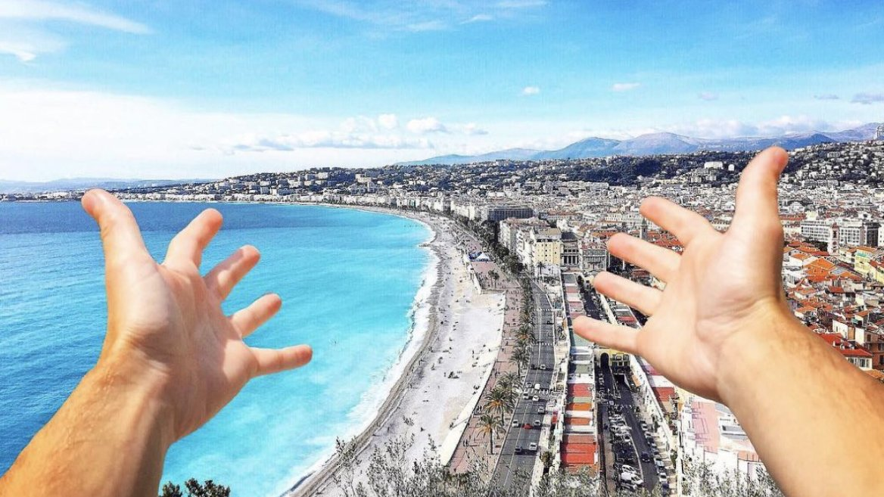

15 Boulevard d'Alsace, Cannes, France, from 6 to 18 age

Course intensity | 12
Accommodation | Host family
Room type | Twin
Bathroom facilities | Shared
Meals | Breakfast, Lunch and Dinner
Excursions per week | 1
Weekday excursions | 0
Full day excursions | 0

Description

Why choose this program

Infrastructure

Sport infrastructure

Hobbies and clubs

What else included in the program price

Recommended arrival city

Ницца

Sample timetable
 | Morning | Afternoon | Evening
Day 1 |  | Arrival in the host family
Day 2 | 4 general French group lessons (3H00) from 9.00 to 10.30 and from 10.45 to 12.15. | Guided tour of Nice or Cannes with RFI Group Leader
Day 3 | 4 general French group lessons (3H00) from 9.00 to 10.30 and from 10.45 to 12.15.
Day 4 | 4 general French group lessons (3H00) from 9.00 to 10.30 and from 10.45 to 12.15.
Day 5 | 4 general French group lessons (3H00) from 9.00 to 10.30 and from 10.45 to 12.15. | Departure. The host-family will drop off at departure
Day 6

Day 7

For booking please go to www.travelclass.org

