Ycode — language school in Russia

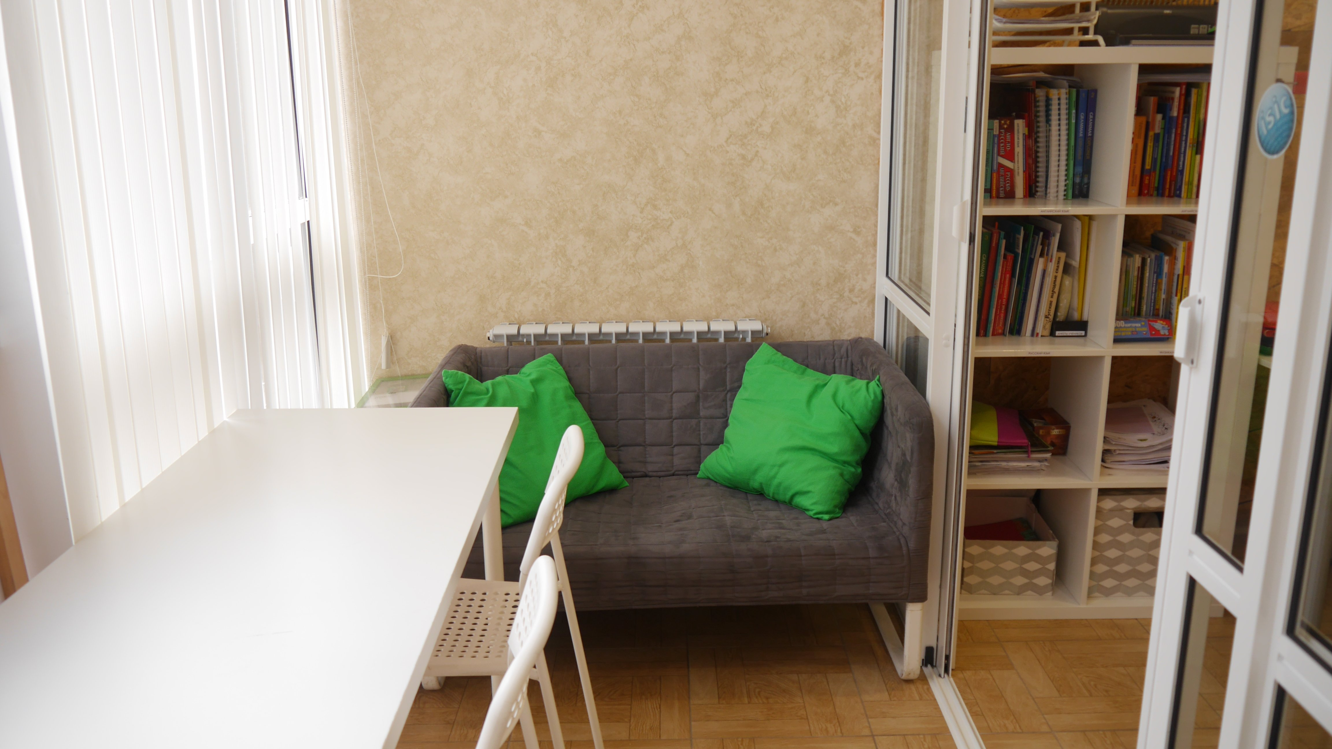

Сочи, Краснодарский край, Россия, from 4 to 99 age

Course intensity | 15
Accommodation | Hostel
Room type | Multi-bedded
Bathroom facilities | Shared
Meals | Breakfast + Dinner
Excursions per week | 5
Weekday excursions | 4
Full day excursions | 1

Description

Why choose this program

Infrastructure

Sport infrastructure

Hobbies and clubs

What else included in the program price

Recommended arrival city

Сочи

Sample timetable
 | Morning | Afternoon | Evening
Day 1 | Russian intensive course | Free time | Walking city tour
Day 2 | Russian Intensive course | Olympic park excursion | Dinner, free time
Day 3 | Russian intensive course | Akhun Tower Excursion | Dinner, free time
Day 4 | Russian intensive course | Park Dendrarium | Dinner, free time
Day 5 | Russian intensive course | Free time | Barbeque
Day 6 | Tea Plantation excursion | Tea plantation excursion | Dinner, Free time
Day 7 | Free time | Free time | Departure

For booking please go to www.travelclass.org

