SCL International College North Acton — London language school, UK

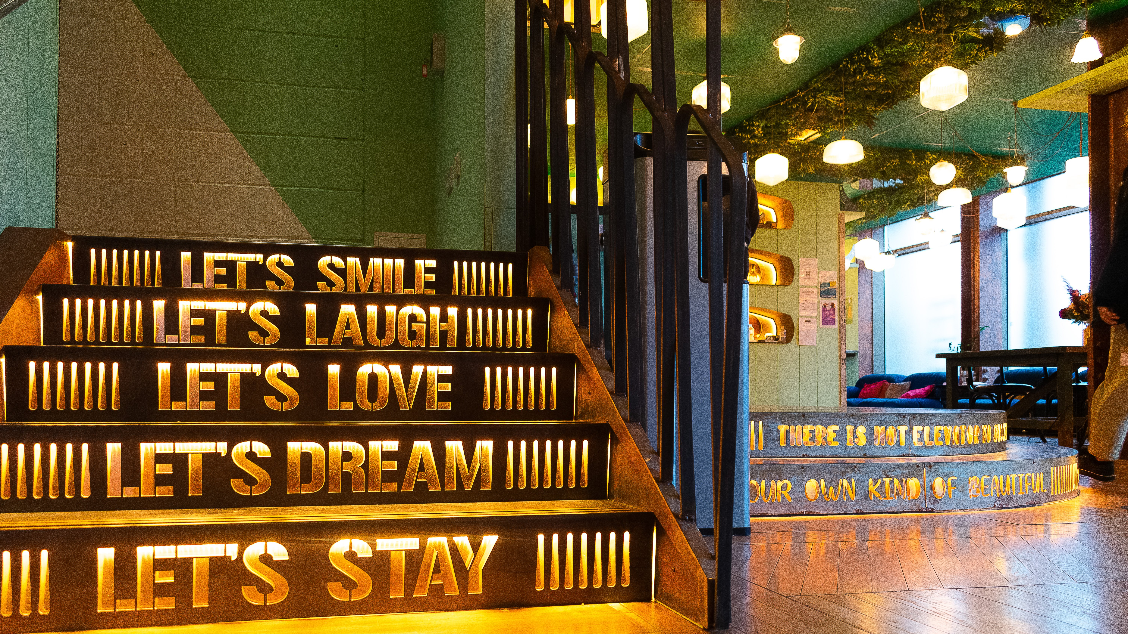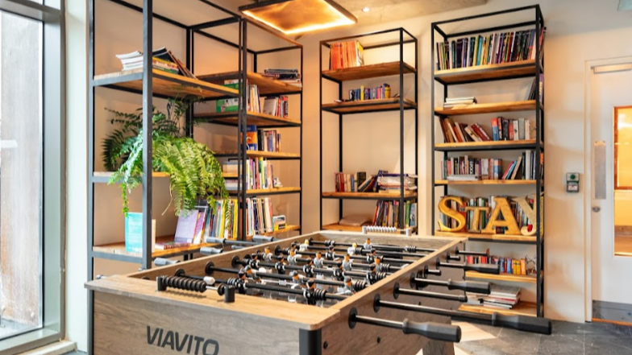

200 Western Avenue, London, W3 6FW, from 12 to 17 age

Course intensity | 15
Accommodation | Campus
Room type | Twin
Bathroom facilities | En-suite
Meals | Breakfast + Dinner
Excursions per week | 0
Weekday excursions
Full day excursions

Description

Why choose this program

Infrastructure

Sport infrastructure

Hobbies and clubs

What else included in the program price

Recommended arrival city

Лондон

Sample timetable
 | Morning | Afternoon | Evening
Day 1

Day 2

Day 3

Day 4

Day 5

Day 6

Day 7

For booking please go to www.travelclass.org

