ACCORD Paris — language school in France

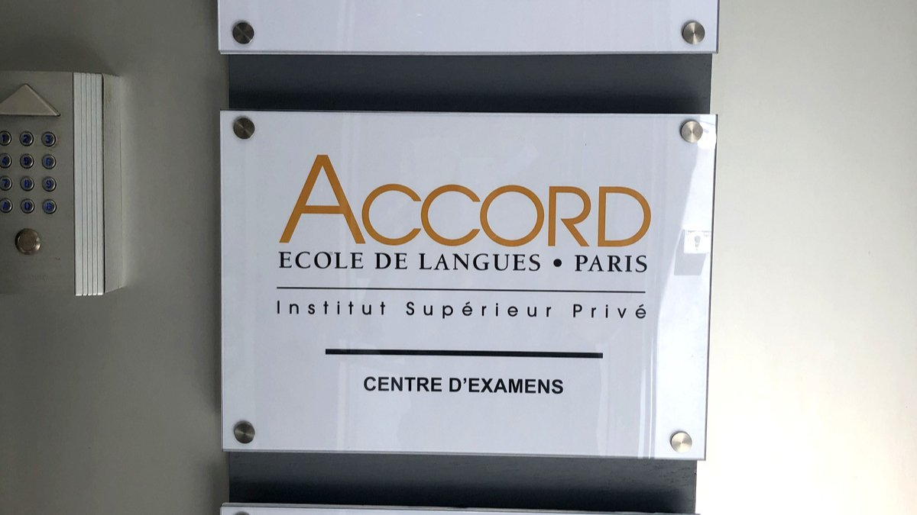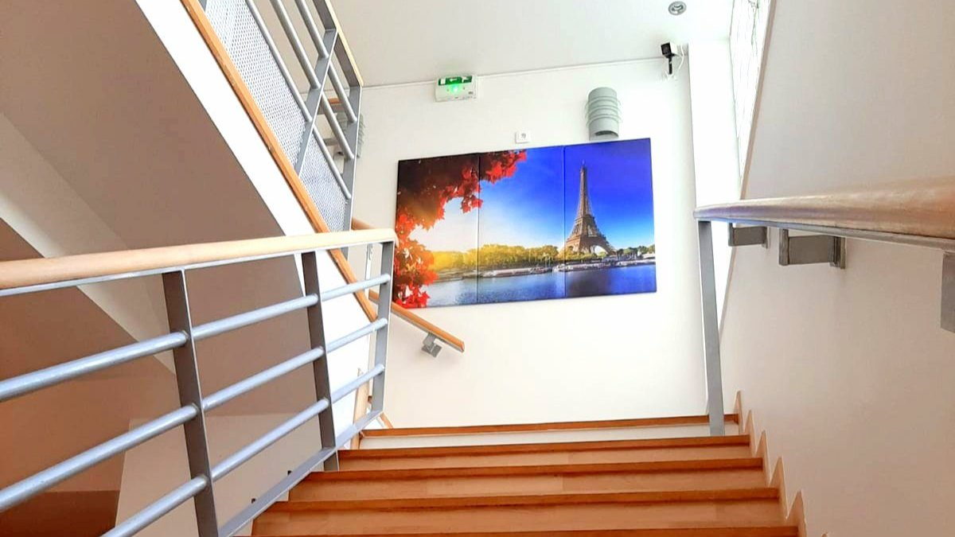

3bis Rue Jean-Pierre Bloch, Paris, France, from 16 to 75 age

Course intensity | 15
Accommodation | Host family
Room type | Single
Bathroom facilities | Shared
Meals | Breakfast + Dinner
Excursions per week | 5
Weekday excursions | 5
Full day excursions

Description

Why choose this program

Infrastructure

Sport infrastructure

Hobbies and clubs

What else included in the program price

Recommended arrival city

Париж

Sample timetable
 | Morning | Afternoon | Evening
Day 1 | French course (Monday morning) | Louvre museum | in the host family
Day 2 | French course (Tuesday) | Montmartre | in the host family
Day 3 | French course | The Champs Elysées, the Concorde place and the Tuileries gardens | in the host family
Day 4 | French course | Boat cruise on the Seine river | in the host family
Day 5 | French course (Friday) | The Ile de la Cité, the Latin quarter and the Luxembourg gardens | in the host family
Day 6

Day 7

For booking please go to www.travelclass.org

