Riviera French Institute — language school in France

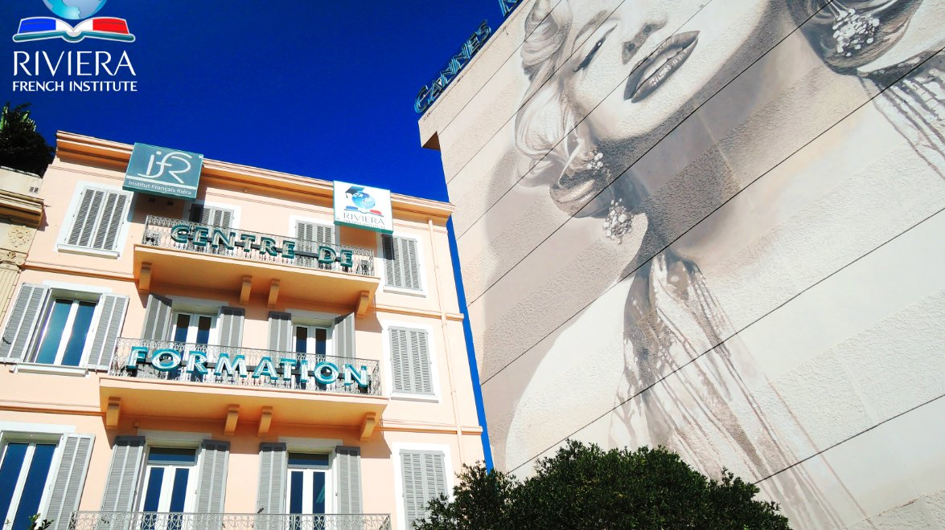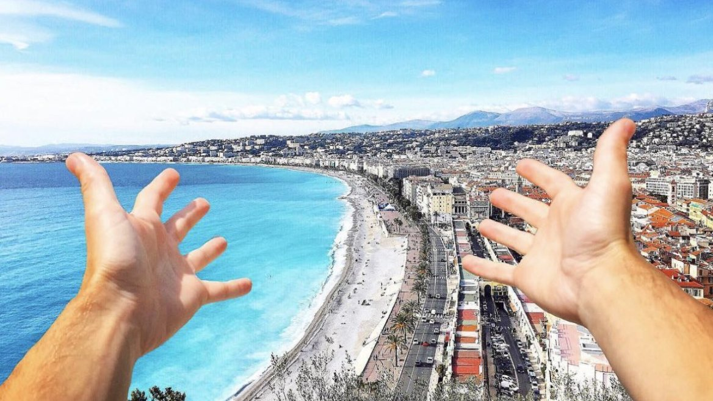

15 Boulevard d'Alsace, Cannes, France, from 6 to 18 age

Course intensity | 15
Accommodation | Host family
Room type | Twin
Bathroom facilities | Shared
Meals | Breakfast, Lunch and Dinner
Excursions per week | 0
Weekday excursions | 0
Full day excursions | 0

Description

Why choose this program

Infrastructure

Sport infrastructure

Hobbies and clubs

What else included in the program price

Recommended arrival city

Ницца

Sample timetable
 | Morning | Afternoon | Evening
Day 1 | Arrival in the host family | Discovery of family life and habits
Day 2 | General French or English group lessons (1H30) from 9.00 to 10.30 | Multi-sports program from 11.00 A.M to 16.00 P.M. | Homestay
Day 3 | General French or English group lessons (1H30) from 9.00 to 10.30 | Multi-sports program from 11.00 A.M to 16.00 P.M. | Homestay
Day 4 | General French or English group lessons (1H30) from 9.00 to 10.30 | Multi-sports program from 11.00 A.M to 16.00 P.M. | Homestay
Day 5 | General French or English group lessons (1H30) from 9.00 to 10.30 | Multi-sports program from 11.00 A.M to 16.00 P.M. | Homestay
Day 6 | General French or English group lessons (1H30) from 9.00 to 10.30 | Multi-sports program from 11.00 A.M to 16.00 P.M. | Homestay
Day 7 |  | Departure

For booking please go to www.travelclass.org

