KKCL Harrow — language school in the UK

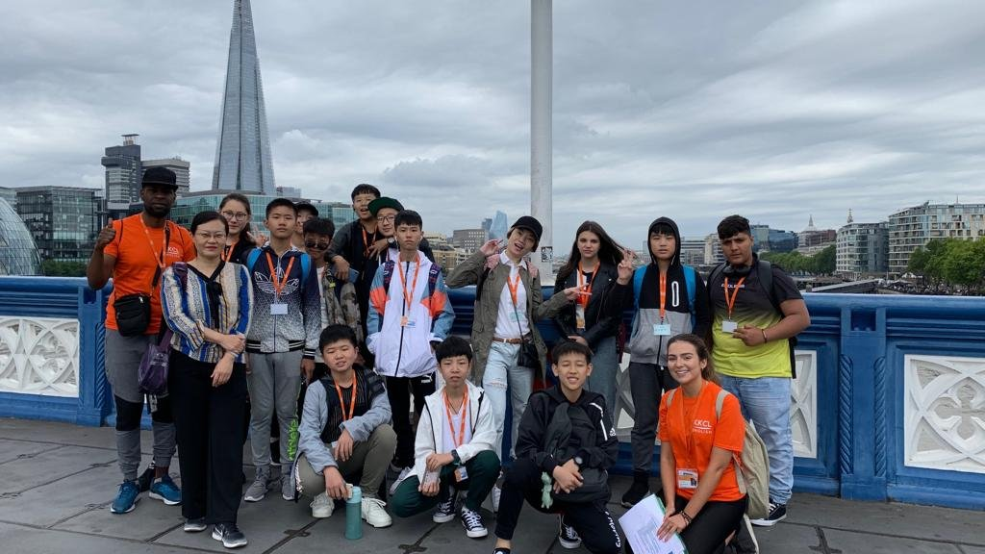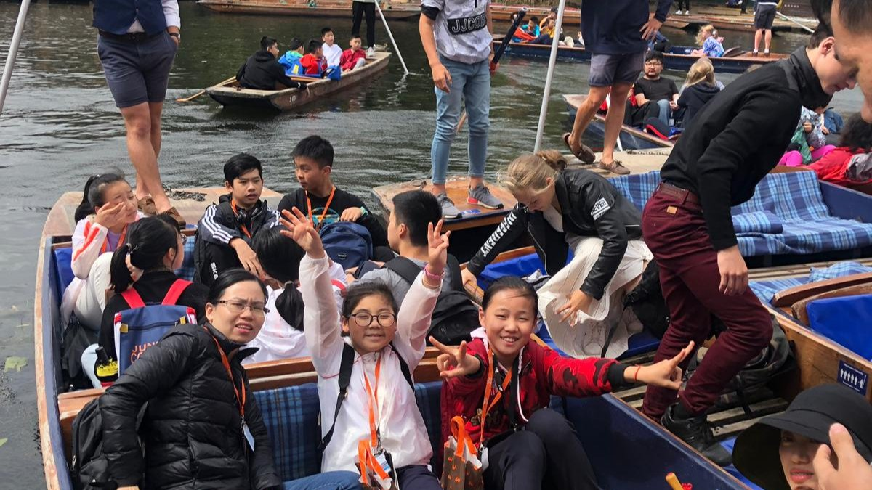

103-105 Greenford Road, Harrow, UK, from 7 to 17 age

Course intensity | 15
Accommodation | Host family
Room type | Twin
Bathroom facilities | Shared
Meals | Breakfast, Lunch and Dinner
Excursions per week
Weekday excursions
Full day excursions

Description

Why choose this program

Infrastructure

Sport infrastructure

Hobbies and clubs

What else included in the program price

Recommended arrival city

Лондон

Sample timetable
 | Morning | Afternoon | Evening
Day 1 | Arrival | Rest at Homestay | Family Time with Homestay
Day 2 | Level Test and Induction or Lessons | Go Create! English | Family Time with Homestay
Day 3 | Full Day Excursion > National Gallery > Trafalgar Square | > Heart of London Walking Tour | Family Time with Homestay
Day 4 | Go Create! English | Go Create! English | Family Time with Homestay
Day 5 | City Visit > Day-trip to Outside London | Oxford/Cambridge/Bath/Brighton | Family Time with Homestay
Day 6 | Go Create! English | Sport & Games | Family Time with Homestay
Day 7 | Full Day Excursion > British Museum > Oxford Street | >Piccadilly Circus > Parks and Palaces | Family Time with Homestay
Day 8 | Full Day Excursion >Natural History Museum | >Kensington Palace (external) >Harrod's | Family Time with Homestay
Day 9 | Go Create! English | Go Create! English | Family Time with Homestay
Day 10 | Full Day Excursion >Camden Town | >Regent's Park >Hampstead Heath | Family Time with Homestay
Day 11 | Go Create! English | Go Create! English | Family Time with Homestay
Day 12 | City Visit > Day-trip to Outside London | Oxford/Cambridge/Bath/Brighton | Family Time with Homestay
Day 13 | Go Create! English | Sport & Games | Family Time with Homestay
Day 14 | Full Day Excursion >Boat trip to Greenwich* | >National Maritime Museum | Family Time with Homestay

For booking please go to www.travelclass.org

