Cavendish School of English Malta — language school in Malta

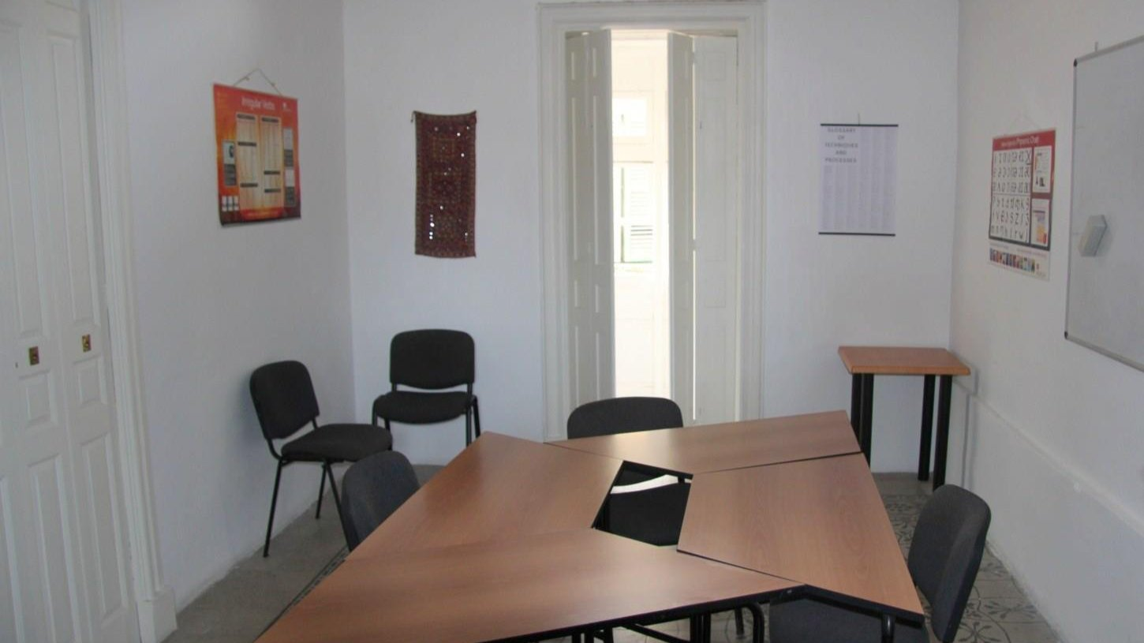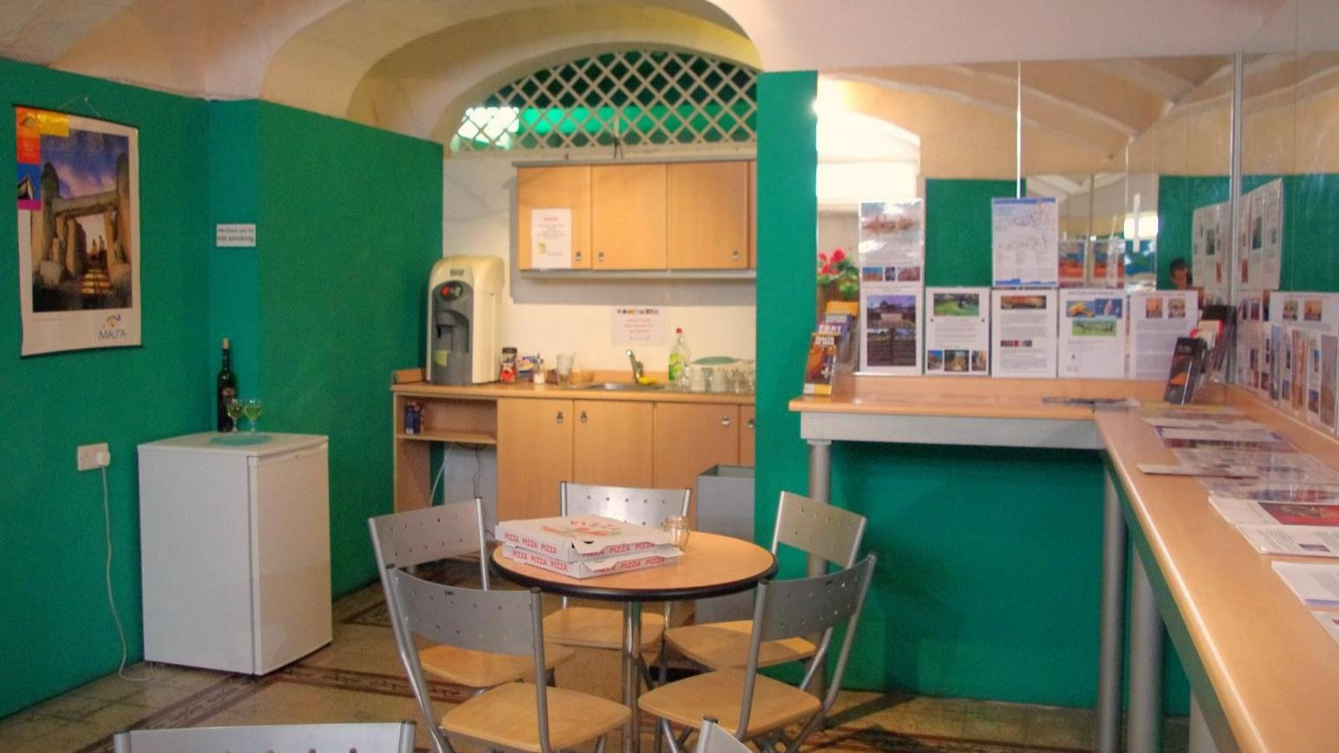

124 Melita Street, Valletta, Malta, from 10 to 99 age

Course intensity | 18
Accommodation | Host family
Room type | Twin
Bathroom facilities | Shared
Meals | Breakfast, Lunch and Dinner
Excursions per week | 6
Weekday excursions | 5
Full day excursions | 1

Description

Why choose this program

Infrastructure

Sport infrastructure

Hobbies and clubs

What else included in the program price

Recommended arrival city

Валлетта

Sample timetable
 | Morning | Afternoon | Evening
Day 1 | Arrival day
Day 2 | Lessons | Guided tour of Valletta | Lasermaxx laser tag games
Day 3 | Lessons | Grand Harbour cruise | Go-Kart racing
Day 4 | Full day in Blue Lagoon | Full day in Blue Lagoon | Party
Day 5 | Blue Grotto boats tour + Popeye Village | Blue Grotto boats tour + Popeye Village | Blue Grotto boats tour + Popeye Village
Day 6 | Lessons | Splash and Fun Waterpark | Cinema
Day 7 | Hop-on/hop-off Tour of Malta | Hop-on/hop-off Tour of Malta | Hop-on/hop-off Tour of Malta

For booking please go to www.travelclass.org

