BWS Germanlingua Munich — language school in Germany

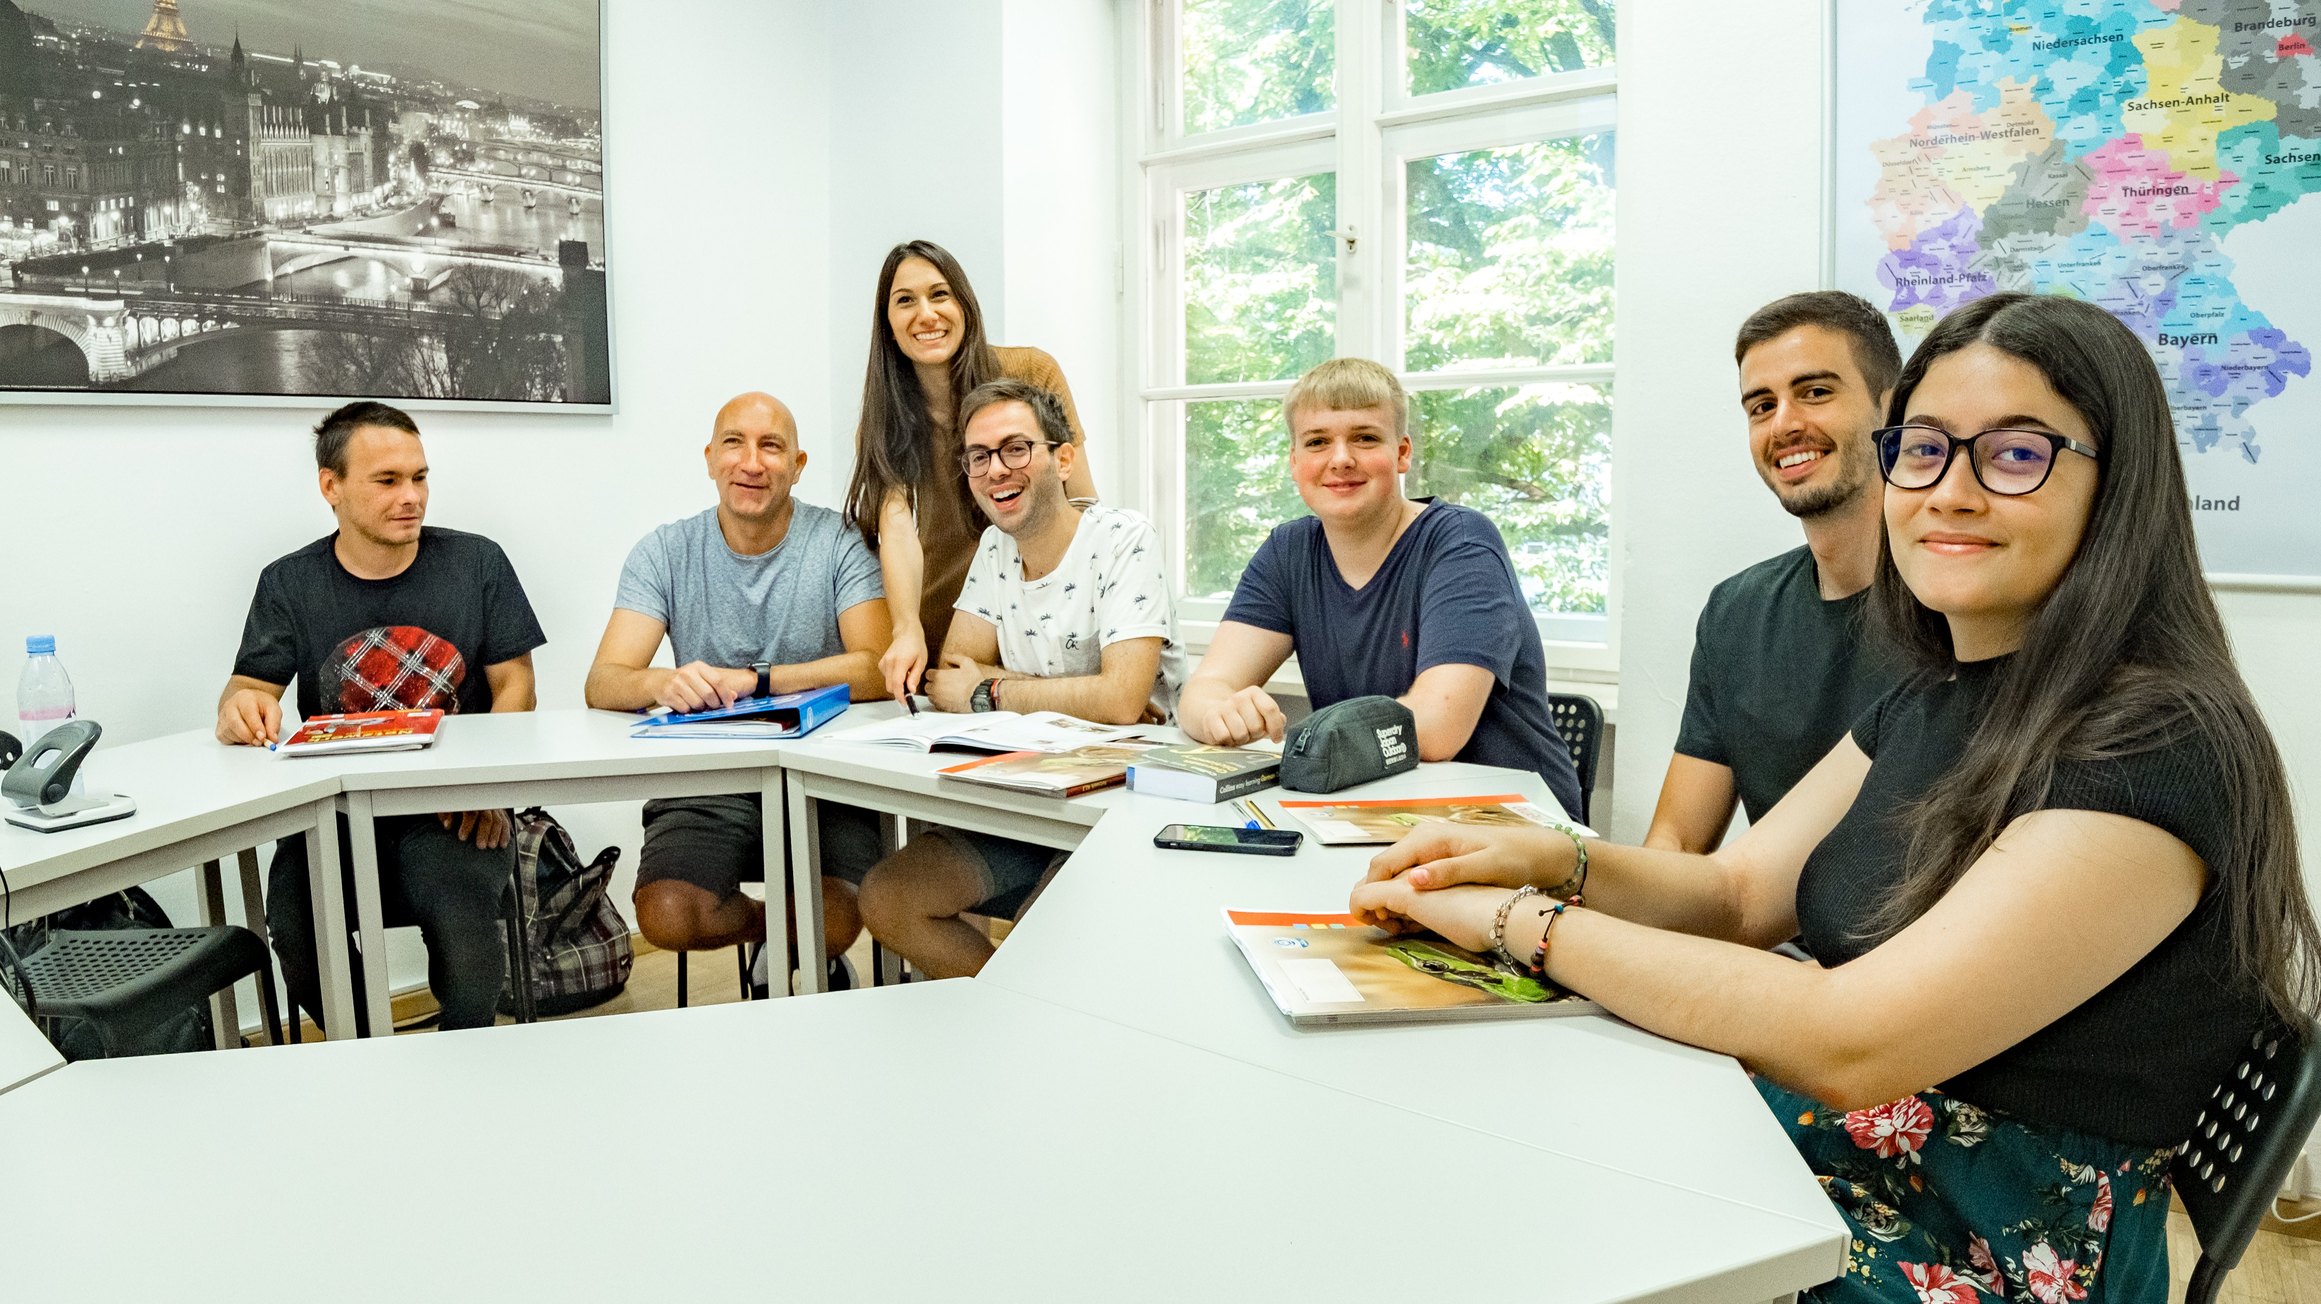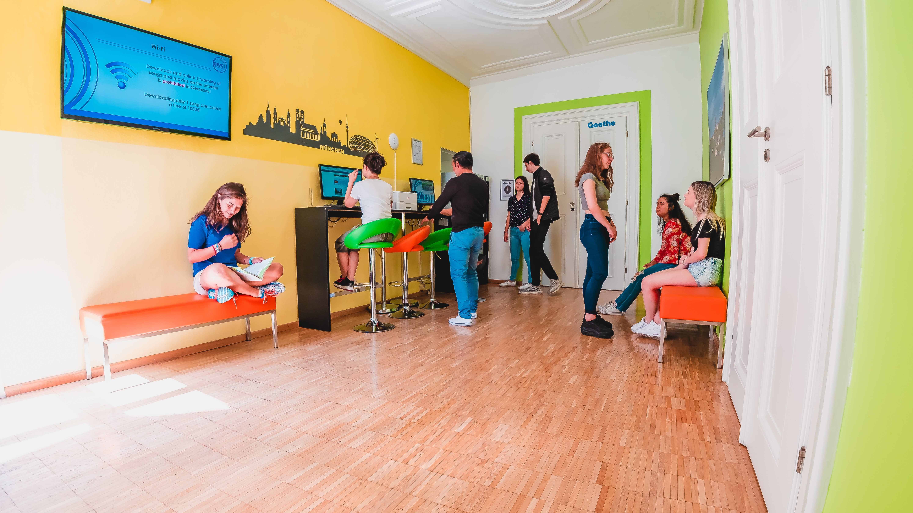

Hackenstraße 7, 80331 München, Deutschland, from 16 to 99 age

Course intensity | 15
Accommodation
Room type | Twin
Bathroom facilities | Shared
Meals | Breakfast + Dinner
Excursions per week | 3
Weekday excursions | 2
Full day excursions | 1

Description

Why choose this program

Infrastructure

Sport infrastructure

Hobbies and clubs

What else included in the program price

Recommended arrival city

Мюнхен

Sample timetable
 | Morning | Afternoon | Evening
Day 1 | Arrival
Day 2 | Classes | Cultural activities | Host-family
Day 3 | Classes | Free time | Host-family
Day 4 | Classes | Social gathering | Host-family
Day 5 | Classes | Free time | Host-family
Day 6 | Classes | Trip | Host-family
Day 7 | Free day with a family

For booking please go to www.travelclass.org

