CES Dublin — language school in Ireland

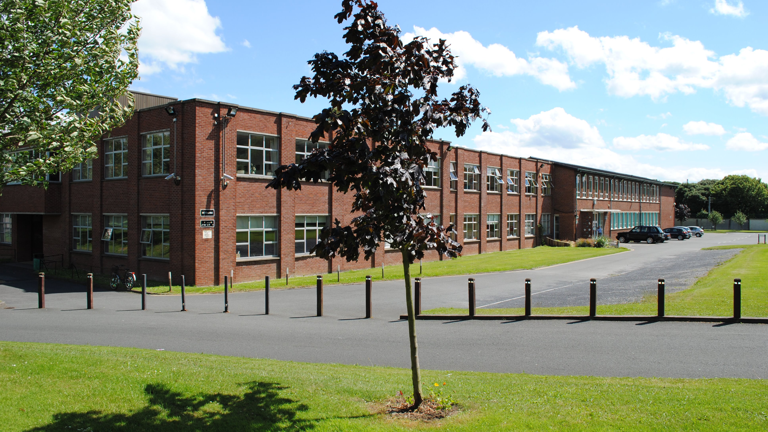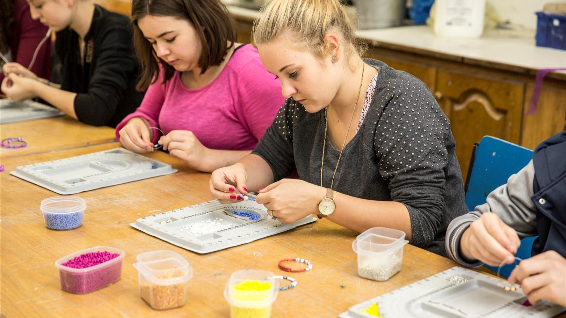

31 Dame Street, Dublin 2, Ireland, from to age

Course intensity | 15
Accommodation | Host family
Room type | Twin
Bathroom facilities | Shared
Meals | Breakfast, Lunch and Dinner
Excursions per week | 2
Weekday excursions | 1
Full day excursions | 1

Description

Why choose this program

Infrastructure

Sport infrastructure

Hobbies and clubs

What else included in the program price

Recommended arrival city

Дублин

Sample timetable
 | Morning | Afternoon | Evening
Day 1 | ARRIVE AT HOMESTAY
Day 2 | English language placement test and welcome talk followed by class | Orientation tour of Dublin | Free evening with host family
Day 3 | Class | Sports on campus with arts & craft | Fish and Chips in Howth
Day 4 | Class | Visit to the National Gallery of Ireland | Visit to Malahide coastal village (Optional visit)
Day 5 | Class | Basketball competition / CES movie PM | CES Disco
Day 6 | Class | Free for shopping | Free evening with host family
Day 7 | Full day excursion to Powerscourt Gardens and Glendalough | Full day excursion to Powerscourt Gardens and Glendalough | Full day excursion to Powerscourt Gardens and Glendalough
Day 8 | Free time with family/group leader | Free time with family/group leader | Free time with family/group leader
Day 9 | Class | Visit to Trinity College | Free evening with host family
Day 10 | Class | Sports on campus with mixed football competition | Bowling (Optional, entry fee not included)
Day 11 | Class | Visit to the National History Museum | Irish music and dance evening
Day 12 | Class | CES Olympics / Movie time | CES Disco
Day 13 | Class | Presentations of certificates | Free evening with host family
Day 14 | Full day excursion to Kilkenny Castle | Full day excursion to Kilkenny Castle | Full day excursion to Kilkenny Castle

For booking please go to www.travelclass.org

