Bayswater English in Cyprus — summer school in Cyprus

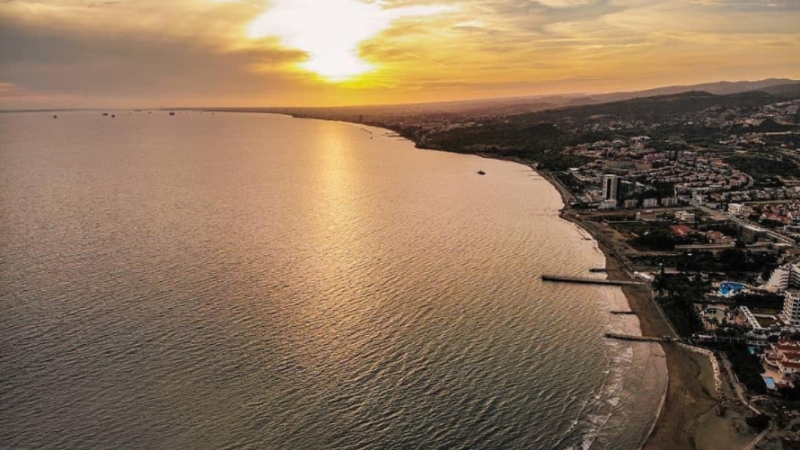

English in Cyprus, Vasileos Konstantinou, Лимассол, Кипр, from 10 to 17 age

Course intensity | 15
Accommodation | Hotel
Room type | Twin
Bathroom facilities | En-suite
Meals | Breakfast, Lunch and Dinner
Excursions per week
Weekday excursions
Full day excursions

Description

Why choose this program

Infrastructure

Sport infrastructure

Hobbies and clubs

What else included in the program price

Recommended arrival city

Ларнака

Sample timetable
 | Morning | Afternoon | Evening
Day 1 | Arrival
Day 2 | English Lessons | Limassol Old Port and Castle | Free time or optional activities
Day 3 | English Lessons | Games/Arts & Crafts | Free time or optional activities
Day 4 | English Lessons | Omodos Mountain Village | Free time or optional activities
Day 5 | English Lessons | Games/Arts & Crafts | Free time or optional activities
Day 6 | English Lessons | Games/Arts & Crafts | Free time or optional activities
Day 7 | Full day excursion to Nicosia | Full day excursion to Nicosia | Full day excursion to Nicosia

For booking please go to www.travelclass.org

