Kingswood West Runton — language school in the UK

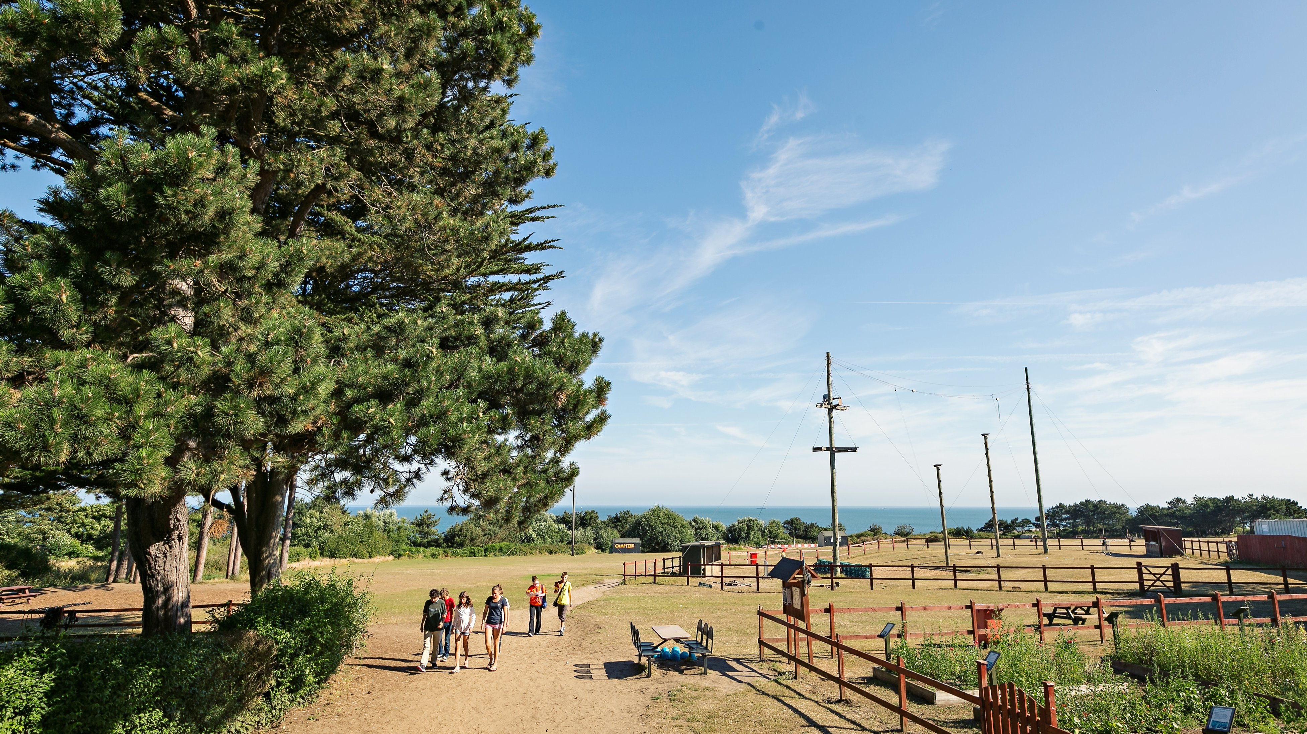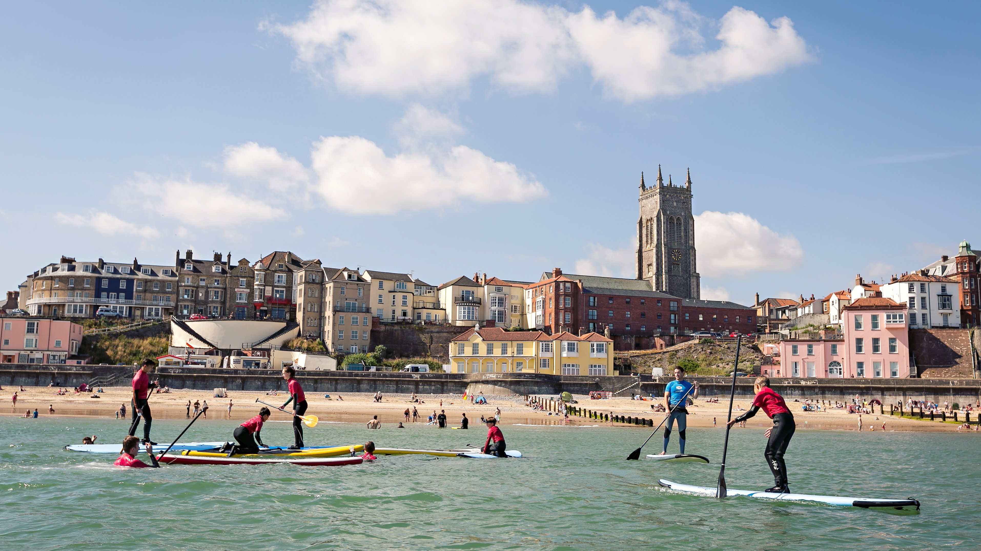

Cromer, UK, from 8 to 17 age

Course intensity | 15
Accommodation | Residence
Room type | Multi-bedded
Bathroom facilities | Shared
Meals | Breakfast, Lunch and Dinner
Excursions per week | 2
Weekday excursions | 1
Full day excursions | 1

Description

Why choose this program

Infrastructure

Sport infrastructure

Hobbies and clubs

What else included in the program price

Recommended arrival city

Лондон

Sample timetable
 | Morning | Afternoon | Evening
Day 1 | Arrival | Activities | Activities
Day 2 | Lessons | Activities | Activities
Day 3 | Lessons | Activities | Activities
Day 4 | Lessons | Excursion to Canterbury Cathedral | Activities
Day 5 | Lessons | Activities | Activities
Day 6 | Lessons | Activities | Activities
Day 7 | Excursion to London | Excursion to London | Activities

For booking please go to www.travelclass.org

