Bayswater University of Brighton — summer school in the UK

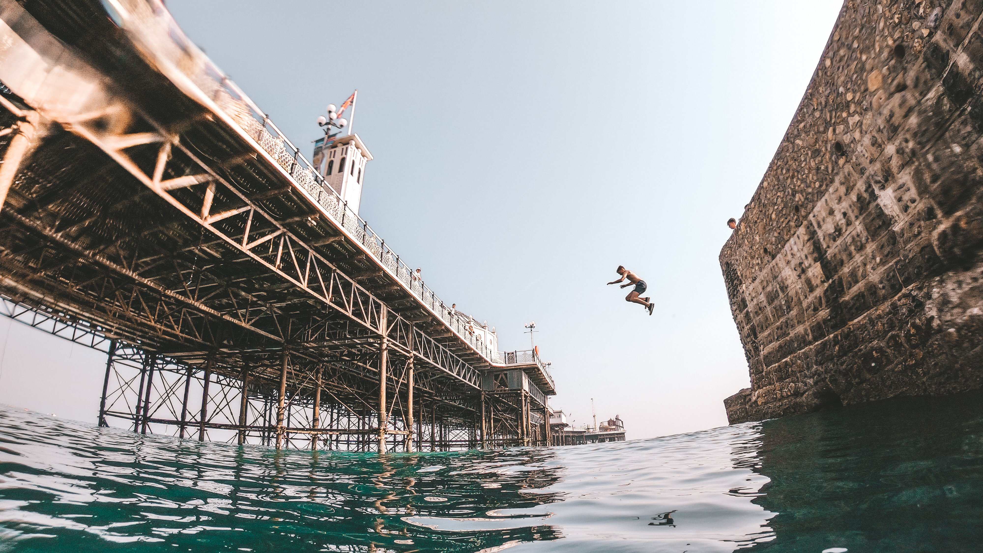

Queensdown School Road, Brighton BN2 4GP, UK, from 12 to 17 age

Course intensity | 15
Accommodation | Campus
Room type | Single
Bathroom facilities | En-suite
Meals | Breakfast, Lunch and Dinner
Excursions per week | 3
Weekday excursions | 2
Full day excursions | 1

Description

Why choose this program

Infrastructure

Sport infrastructure

Hobbies and clubs

What else included in the program price

Recommended arrival city

Лондон

Sample timetable
 | Morning | Afternoon | Evening
Day 1 | Arrival day | Arrival day | Arrival day
Day 2 | English lessons | Brighton orientation walk | T-shirt making workshop
Day 3 | English lessons | Activities on campus | Robot Wars
Day 4 | English lessons | Royal Pavilion | Lip Sync Battle
Day 5 | Full day excursion to London including Thames Cruise | Full day excursion to London including Thames Cruise | Dinner in London
Day 6 | Optional full day excursion | Optional full day excursion | Treasure Hunt
Day 7 | Activities on campus | English lessons | LSC Championship

For booking please go to www.travelclass.org

