ATC Bray Dunluice House — language school in Ireland

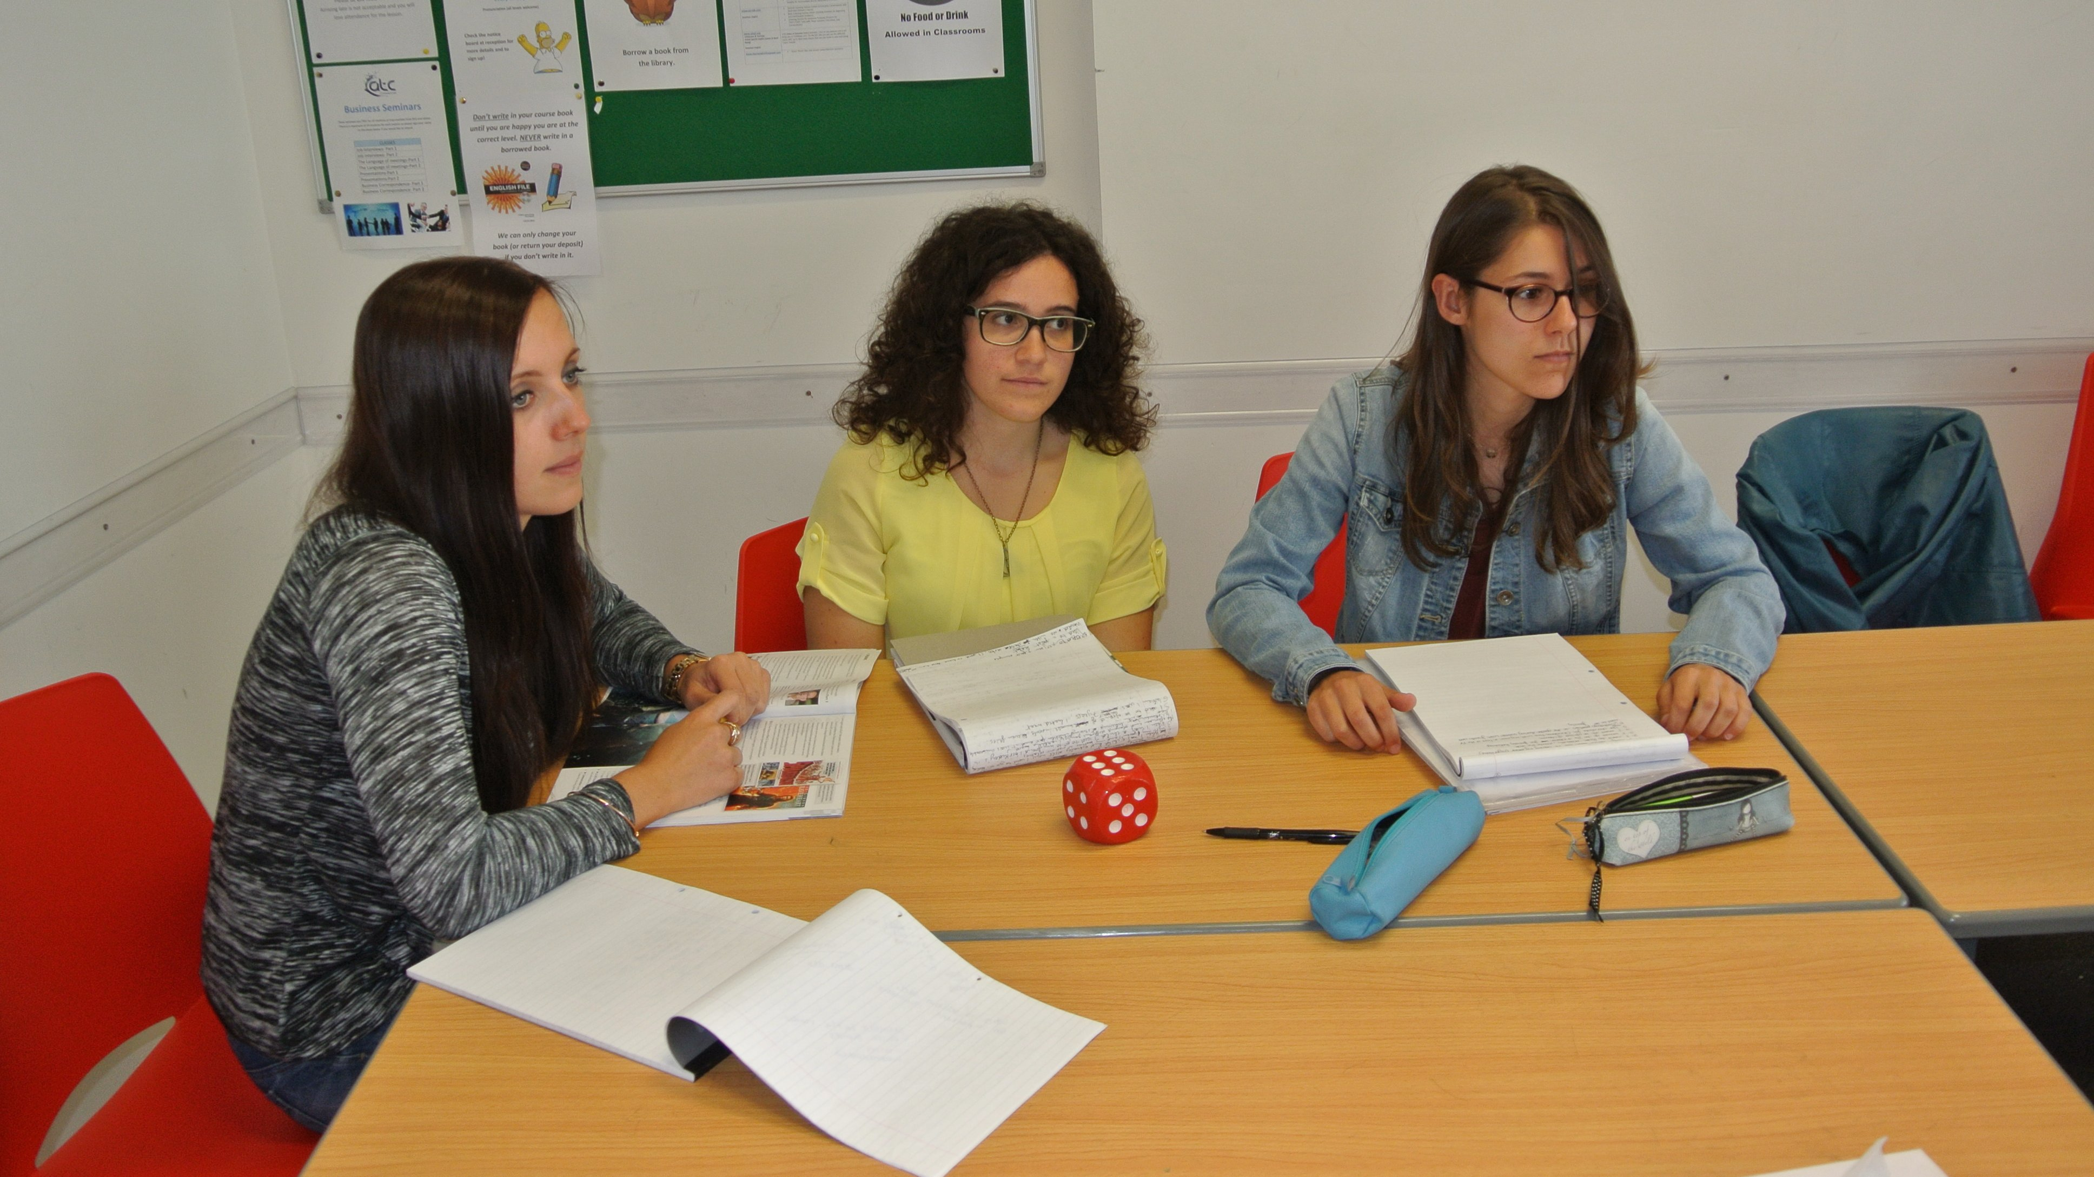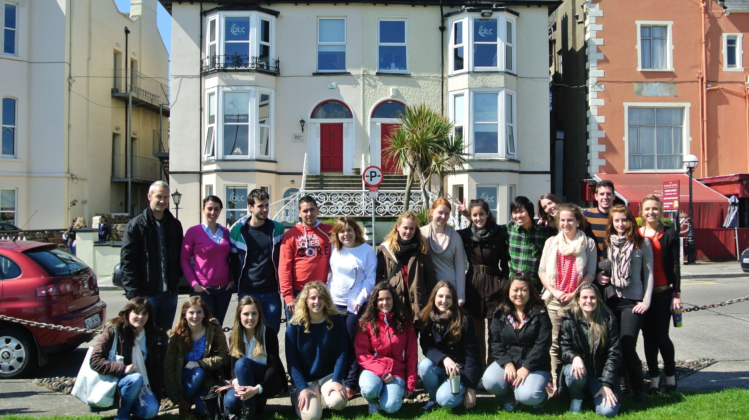

Dunluice House, Strand Road, Newcourt, Bray, County Wicklow, Ireland, from 16 to 17 age

Course intensity | 15
Accommodation | Host family
Room type | Twin
Bathroom facilities | Shared
Meals | Breakfast, Lunch and Dinner
Excursions per week | 1
Weekday excursions | 0
Full day excursions | 1

Description

Why choose this program

Infrastructure

Sport infrastructure

Hobbies and clubs

What else included in the program price

Recommended arrival city

Дублин

Sample timetable
 | Morning | Afternoon | Evening
Day 1 | Classes | Walking tour of Bray | Host Family
Day 2 | Classes | Free time | Host Family
Day 3 | Classes | Free time | Host Family
Day 4 | Classes | Free time | Host Family
Day 5 | Classes | Free time | Host Family
Day 6 | Full Day Excursion - Glendalough & Powerscourt Gardens | Full Day Excursion - Glendalough & Powerscourt Gardens | Host Family
Day 7 | Free day with your host family | Free day with your host family | Free day with your host family

For booking please go to www.travelclass.org

