EC Brighton - language school in the UK

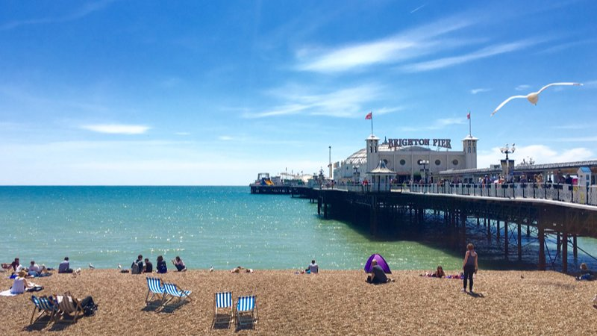

EC Brighton English Language School, Manchester Street, Kemptown, Brighton, UK, from 16 to 99 age

Course intensity | 22
Accommodation
Room type | Single
Bathroom facilities
Meals
Excursions per week
Weekday excursions
Full day excursions

Description

Why choose this program

Infrastructure

Sport infrastructure

Hobbies and clubs

What else included in the program price

Recommended arrival city

Лондон

Sample timetable
 | Morning | Afternoon | Evening
Day - | - | - | -

For booking please go to www.travelclass.org

