Birchwater Education — language school in Ireland

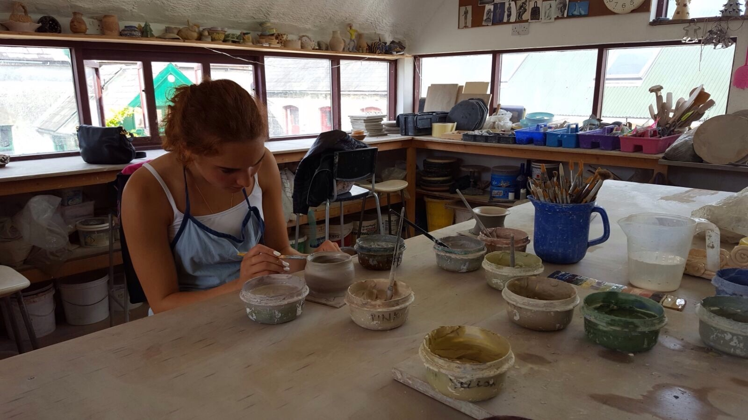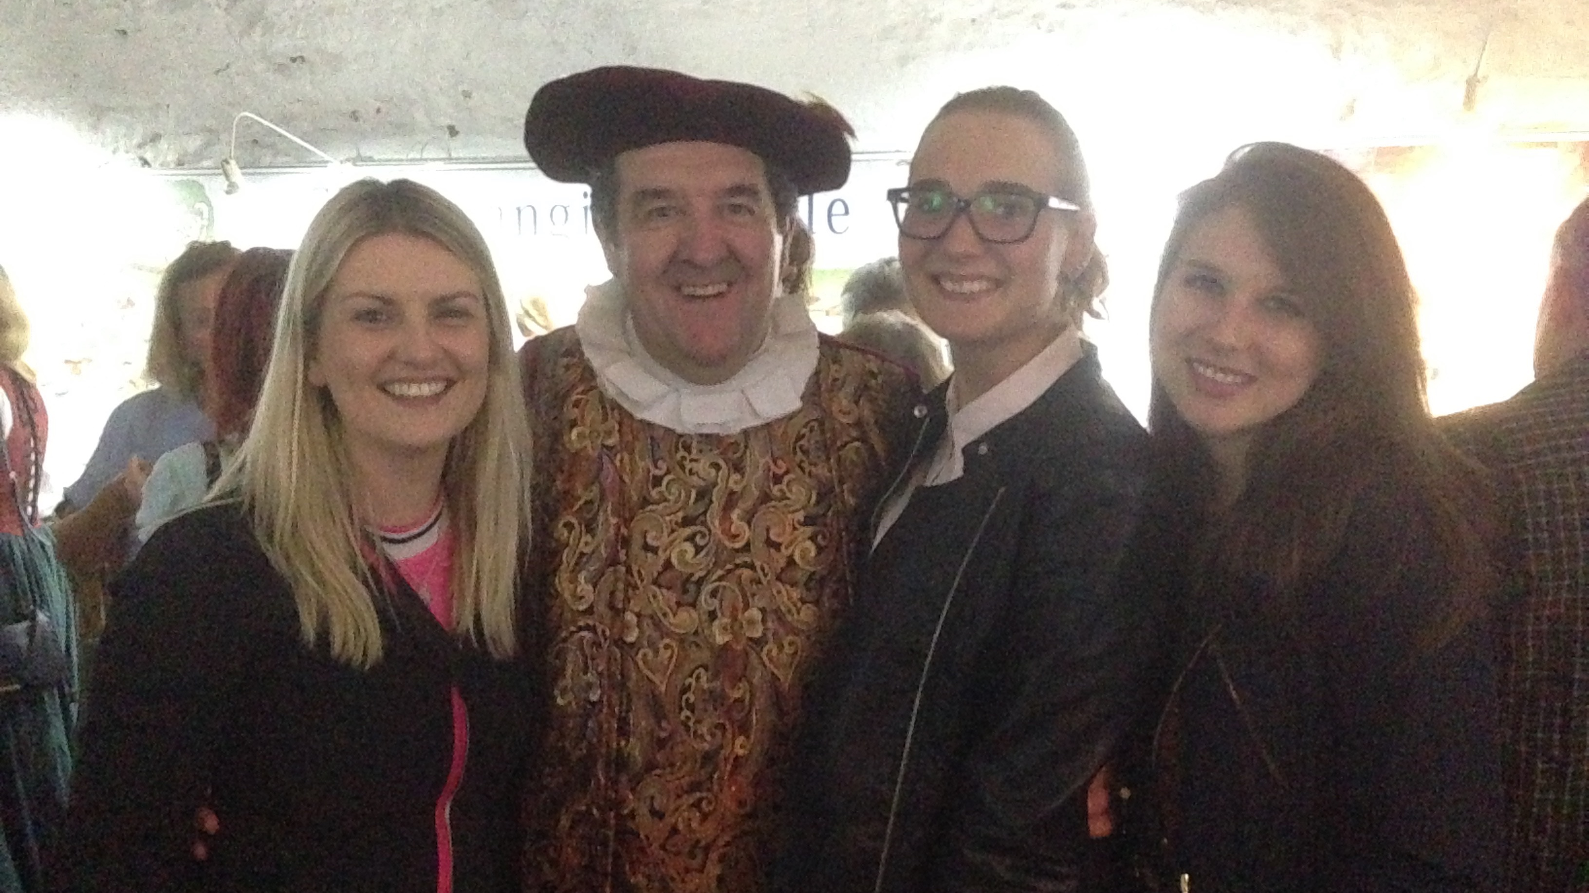

20 The Crescent, Limerick, Ireland, from 11 to 17 age

Course intensity | 15
Accommodation | Residence
Room type | Multi-bedded
Bathroom facilities | Shared
Meals | Breakfast, Lunch and Dinner
Excursions per week | 3
Weekday excursions | 2
Full day excursions | 1

Description

Why choose this program

Infrastructure

Sport infrastructure

Hobbies and clubs

What else included in the program price

Recommended arrival city

Дублин

Sample timetable
 | Morning | Afternoon | Evening
Day 1 | Tuition | Kayaking | Evening Elective
Day 2 | Tuition | walking tour | Evening elective
Day 3 | Tuition | Sport | Evening elective
Day 4 | Tuition | arts and crafts | Evening elective
Day 5 | Tuition | 1/2 day excursion to King Johns Castle | Evening Elective
Day 6 | Full Day Excursion to Cliffs of Moher | Full Day Excursion to Cliffs of Moher | Full Day Excursion to Cliffs of Moher
Day 7 | Rest Day | Rest Day | Evening elective

For booking please go to www.travelclass.org

