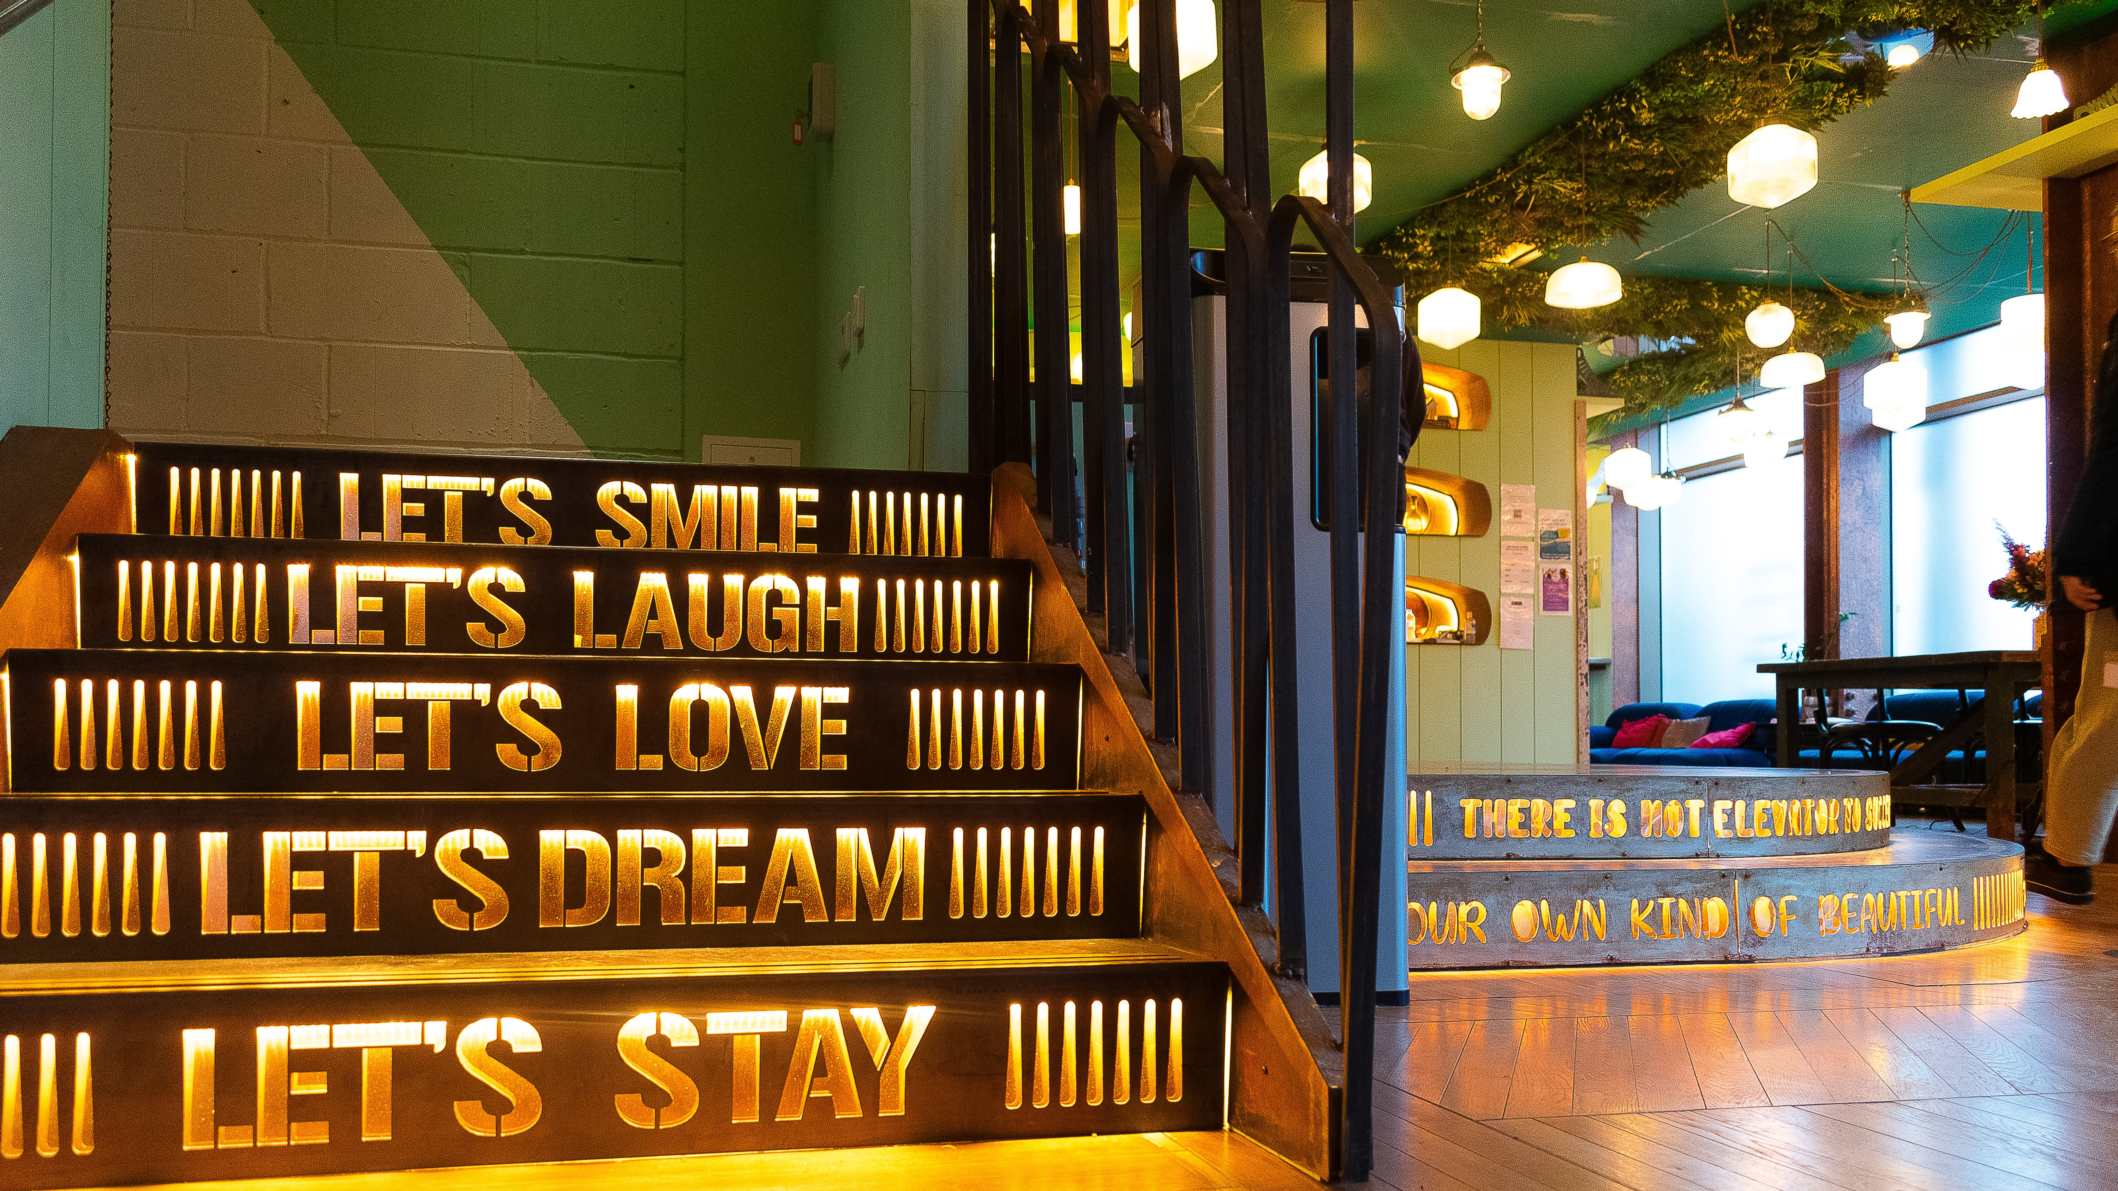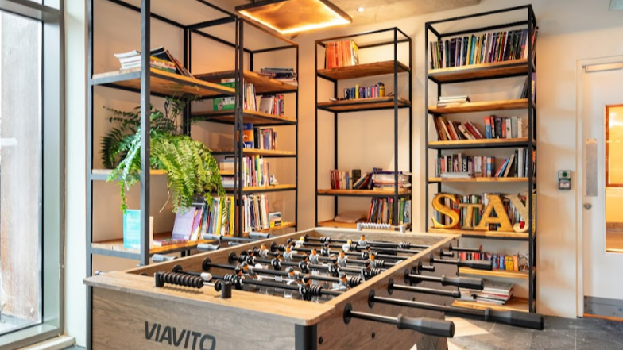

Stay Campus London Colindale — scuola di lingue nel Regno Unito
200 Western Avenue, London, W3 6FW, from 12 to 17 age

Course intensity | 15
Accommodation | Residenza
Room type | Twin
Bathroom facilities | In suite
Meals | Colazione, pranzo e cena
Excursions per week | 3
Weekday excursions | 3
Full day excursions | 0

Description

Why choose this program

Infrastructure

Sport infrastructure

Hobbies and clubs

What else included in the program price

Recommended arrival city

Лондон

Sample timetable
 | Morning | Afternoon | Evening
Day 1 | Arrivo | Arrivo | Cena
Day 2 | Lezioni | Galleria Nazionale & Trafalgar Square | Discoteca
Day 3 | Lezioni | Borough Market e Southbank | Bingo
Day 4 | Lezioni | Museo britannico | Film
Day 5 | Lezioni | Da Covent Garden a Piccadilly Circus | Karaoke
Day 6 | Lezioni | Museo della scienza e Hyde Park | Cena
Day 7 | Cambridge & Punting | Cambridge & Punting | Cena

Price: € 1.043,85

Dates: 2020-06-28 - 2020-07-04

Group leader: Dudesh Olga, +7 (977) 986 28 00, olga.doudesh@gmail.com

