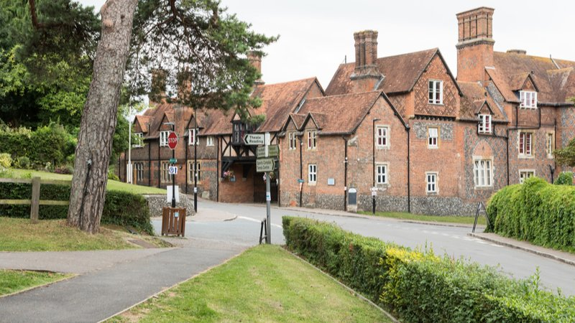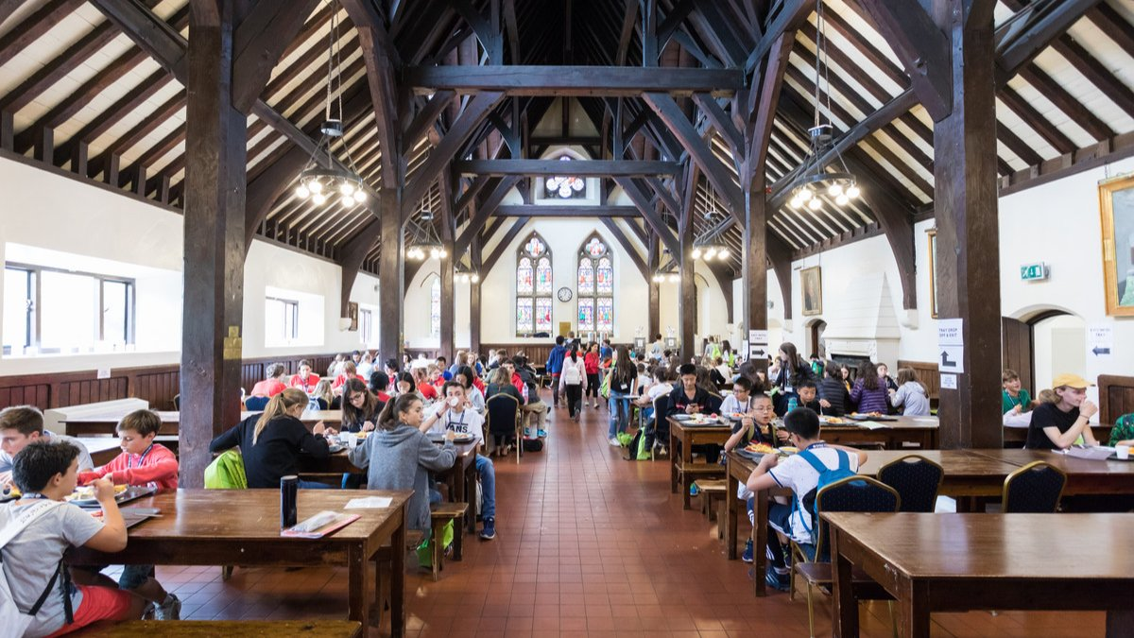

Oxford International Bradfield College — language school in the UK
Bradfield College, Bradfield, Reading, UK, from 9 to 17 age

Course intensity | 15
Accommodation | Campus
Room type | Multi-bedded
Bathroom facilities | En-suite
Meals | Breakfast, Lunch and Dinner
Excursions per week | 3
Weekday excursions | 1
Full day excursions | 2

Description

Why choose this program

Infrastructure

Sport infrastructure

Hobbies and clubs

What else included in the program price

Recommended arrival city

Лондон

Sample timetable
 | Morning | Afternoon | Evening
Day 1 | Arrivals and registrations | Arrivals and registrations | Campus tour and ice-breaker activities
Day 2 | Half day excursion to Reading with walking tour and Reading Photo Challenge | Placement Test and Lessons | Welcome Disco
Day 3 | Onsite activities | Lessons | Onsite Activities
Day 4 | Lessons | Lessons | Onsite Activities
Day 5 | Full day excursion to Oxford with walking tour of the city | Entrance to an Oxford college | Karaoke/Lip Sync Battle
Day 6 | Onsite Activities | Lessons | Onsite Activities
Day 7 | Extended full day excursion to London with Thameside walking tour | Visit to TATE Modern and shopping in Covent Garden | Onsite Activities
Day 8 | Lessons | Onsite Activities | Onsite Activities
Day 9 | Lessons | iPad Treasure Hunt | Disco
Day 10 | Full day excursion to London with Politics and Royalty walking tour | Entrance to the National Gallery and shopping in Covent Garden | Evening in London with late return to campus
Day 11 | Lessons | Onsite Activities | International evening
Day 12 | Lessons | Lessons | Talent Show
Day 13 | Half day excursion to Reading | Onsite Activities | Farewell Disco
Day 14 | Optional Excursion | Optional Excursion | Onsite Activities

Price: 2 529,66 €

Dates: 2020-07-02 - 2020-07-16

Group leader: Larisa Gareeva, +7 (917) 460 82 01, larisagareeva@mail.ru

