English Sunny School of Cyprus — language school in Cyprus

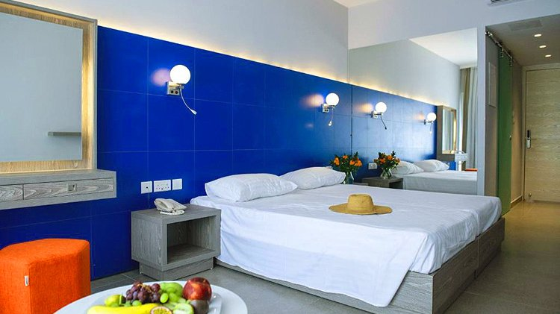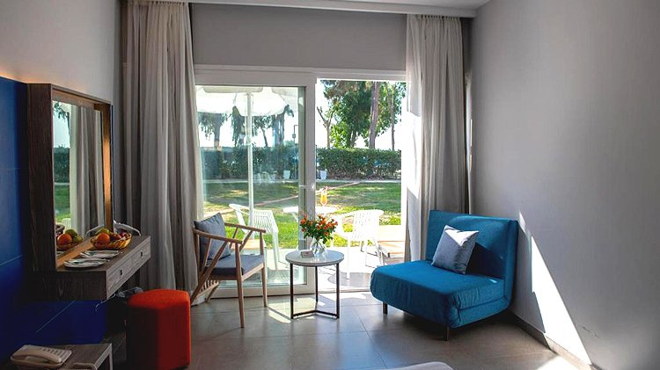

Spyrou Kyprianou 73, Limassol, Cyprus, from 13 to 18 age

Course intensity | 15
Accommodation | Hotel
Room type | Triple
Bathroom facilities | En-suite
Meals | Breakfast, Lunch and Dinner
Excursions per week | 2
Weekday excursions | 1
Full day excursions | 1

Description

Why choose this program

Infrastructure

Sport infrastructure

Hobbies and clubs

What else included in the program price

Recommended arrival city

Ларнака

Sample timetable
 | Morning | Afternoon | Evening
Day 1 | Lessons | Beach Volleyball | Social games
Day 2 | Lessons | Conversation club | Hip hop / Latino dance classes
Day 3 | Lessons | Banana ride | Miming
Day 4 | Lessons | Excursion to Curium Beach | Sport evening
Day 5 | Lessons | Conversation club | Hip hop / Latino dance classes
Day 6 | Waterpark | Waterpark | Karaoke
Day 7 | Leisure day at the pool | Leisure day at the pool | Movie
Day 8 | Lessons | Beach Volleyball | Art. & Craft workshop
Day 9 | Lessons | Conversation club | Hip hop / Latino dance
Day 10 | Lessons | Governor's Beach | Sport evening
Day 11 | Lessons | Limassol Old Town | Quiz
Day 12 | Lessons | Conversation club | Hip hop / Latino dance
Day 13 | Full day excursion to Paphos & Curium | Full day excursion to Paphos & Curium | Pool Party
Day 14 | Leisure day at the pool | Leisure day at the pool | Movie

For booking please go to www.travelclass.org

