Ardmore Berkshire College — language school in the UK

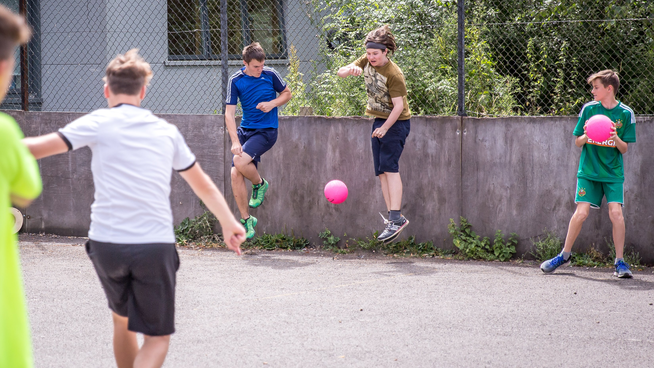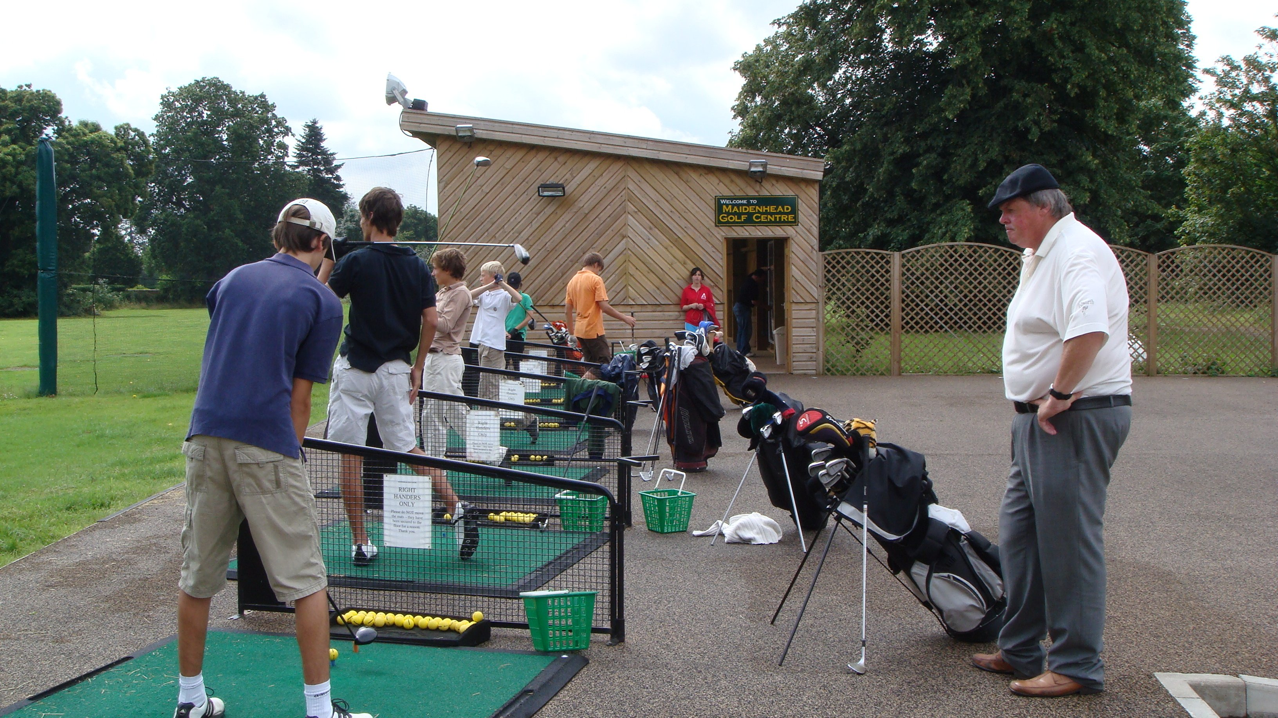

Hall Place Lane, Burchetts Green, Maidenhead, UK, from 9 to 17 age

Course intensity | 15
Accommodation | Campus
Room type | Multi-bedded
Bathroom facilities | Shared
Meals | Breakfast, Lunch and Dinner
Excursions per week | 0
Weekday excursions
Full day excursions

Description

Why choose this program

Infrastructure

Sport infrastructure

Hobbies and clubs

What else included in the program price

Recommended arrival city

Лондон

Sample timetable
 | Morning | Afternoon | Evening
Day 1 | Welcome to Ardmore
Day 2 | Registration and Lesson | Lessons | Dinner and free time
Day 3 | Registration and Lesson | Lessons | Dinner and free time
Day 4 | Registration and Lesson | Lessons | Dinner and free time
Day 5 | Registration and Lesson | Lessons | Dinner and free time
Day 6 | Registration and Lesson | Lessons | Dinner and free time
Day 7 | Goodbye Ardmore

For booking please go to www.travelclass.org

