Bayswater Education Bayswater College — language school in the UK

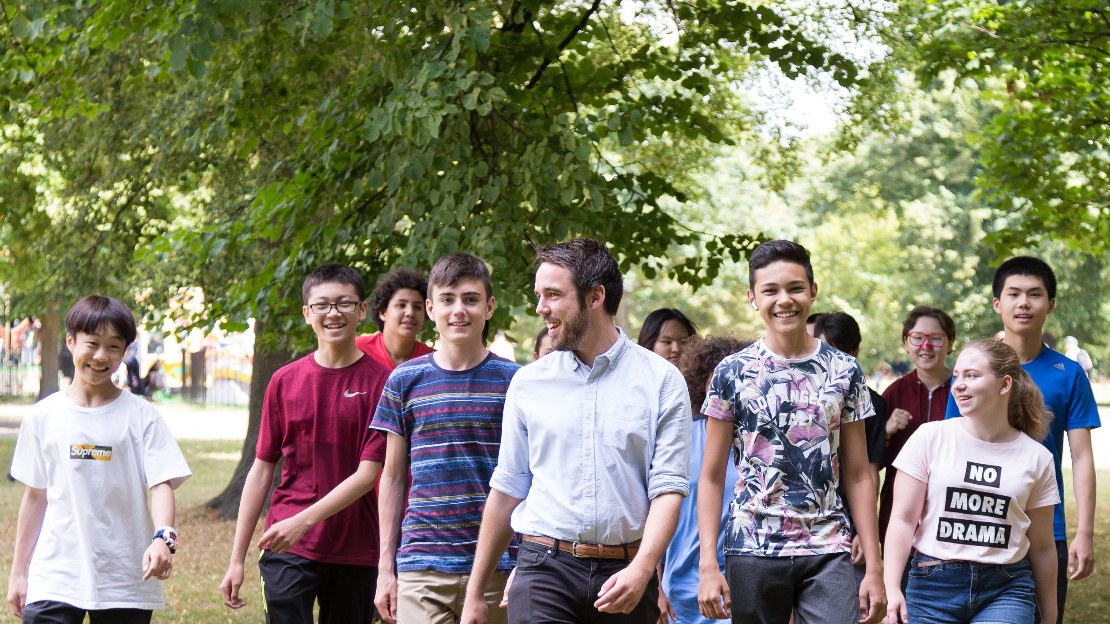

167 Queensway, London W2 4SB, UK, from 10 to 18 age

Course intensity | 15
Accommodation | Résidence
Room type | Twin
Bathroom facilities | En-suite
Meals | Breakfast, Lunch and Dinner
Excursions per week | 0
Weekday excursions | 0
Full day excursions | 0

Description

Why choose this program

Infrastructure

Sport infrastructure

Hobbies and clubs

What else included in the program price

Recommended arrival city

Лондон

Sample timetable
 | Morning | Afternoon | Evening
Day 1 |  | Arrival - private transfer to accommodation | Free time
Day 2 | Local area orientation tour | Lessons | Free time or optional activities
Day 3 | Free time or optional activities | Lessons | Free time or optional activities
Day 4 | Free time or optional activities | Lessons | Free time or optional activities
Day 5 | Free time or optional activities | Lessons | Free time or optional activities
Day 6 | Free time or optional activities | Lessons | Free time or optional activities
Day 7 | Free time or optional activities | Free time or optional activities | Free time or optional activities

For booking please go to www.travelclass.org

