ES Dubai — language school in the UAE

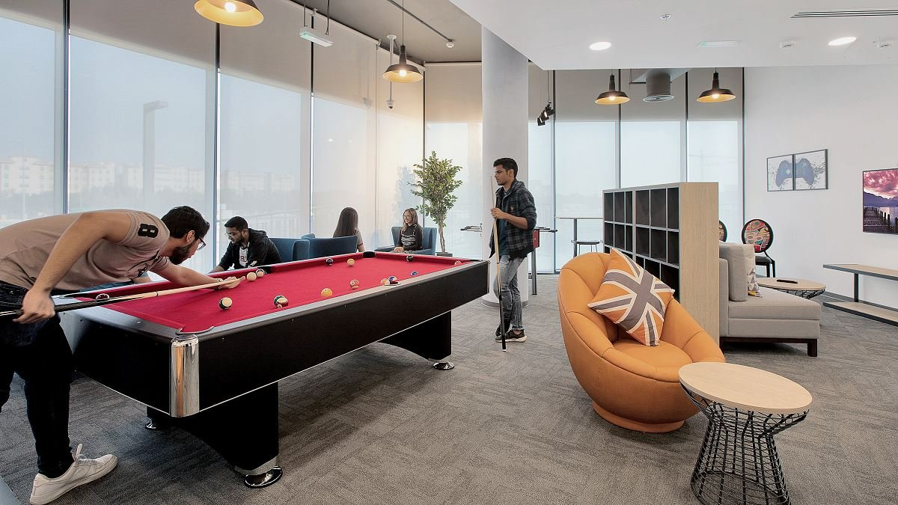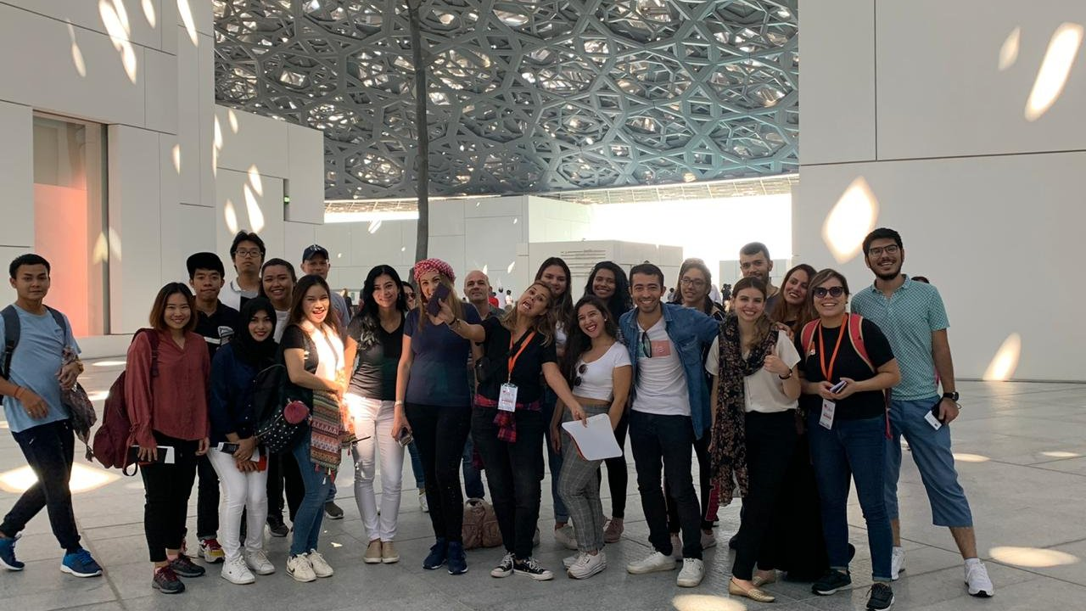

Mazaya Business Avenue BB1 - JLT - Dubai - United Arab Emirates, from 14 to 60 age

Course intensity | 15
Accommodation | Résidence
Room type | Twin
Bathroom facilities | En-suite
Meals | Breakfast, Lunch and Dinner
Excursions per week | 5
Weekday excursions | 5
Full day excursions | 1

Description

Why choose this program

Infrastructure

Sport infrastructure

Hobbies and clubs

What else included in the program price

Recommended arrival city

Дубай

Sample timetable
 | Morning | Afternoon | Evening
Day 1 | Arrival day
Day 2 | Miracle Garden | Miracle Garden | Dinner
Day 3 | FERRARI WORLD | FERRARI WORLD | Dinner
Day 4 | Lessons | DUBAI SIGHTSEEING TOUR | Games
Day 5 | Lessons | Sports | Dinner
Day 6 | Lessons | BURJ KHALIFA | Dinner
Day 7 | Lessons | YACHT PARTY | YACHT PARTY
Day 8 | Lessons | Sports | Dinner
Day 9 | Waterpark | Waterpark | Waterpark
Day 10 | HERITAGE VILLAGE TOUR | HERITAGE VILLAGE TOUR | Dinner
Day 11 | Lessons | BBQ | Disco
Day 12 | Lessons | Shopping | Dinner
Day 13 | ABU DHABI TOUR | ABU DHABI TOUR | ABU DHABI TOUR
Day 14 | Departure

For booking please go to www.travelclass.org

