ES Dubai — language school in the UAE

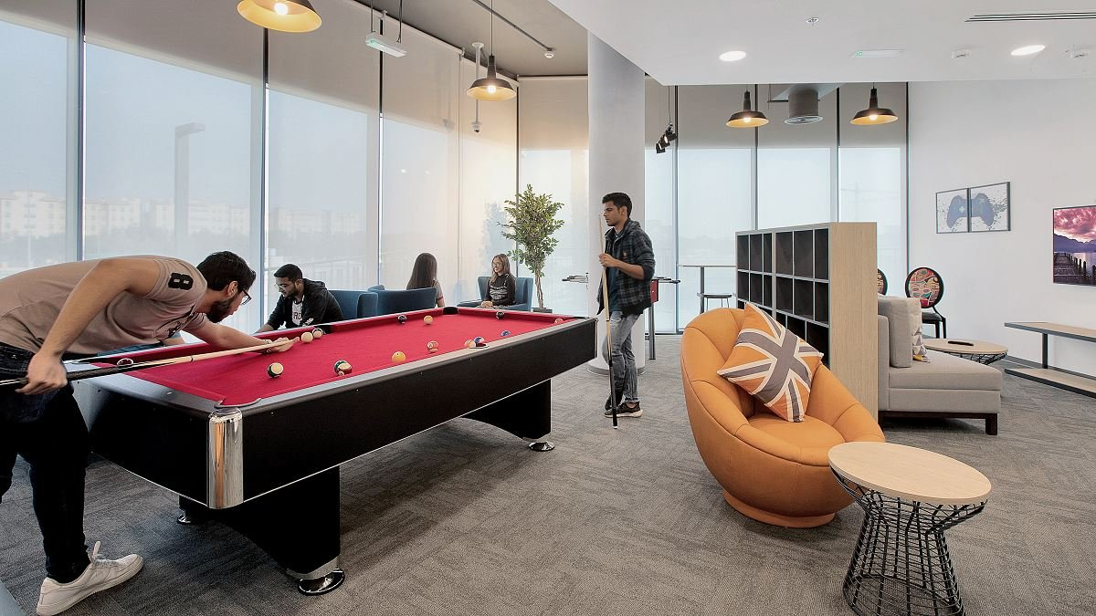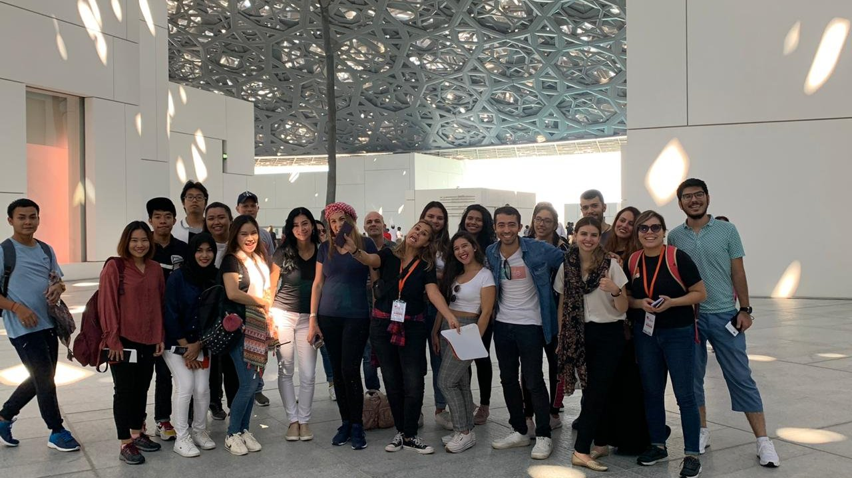

Mazaya Business Avenue BB1 - JLT - Dubai - United Arab Emirates, from 14 to 60 age

Course intensity | 15
Accommodation | Résidence
Room type | Twin
Bathroom facilities | En-suite
Meals | Breakfast, Lunch and Dinner
Excursions per week | 5
Weekday excursions | 5
Full day excursions | 1

Description

Why choose this program

Infrastructure

Sport infrastructure

Hobbies and clubs

What else included in the program price

Recommended arrival city

Дубай

Sample timetable
 | Morning | Afternoon | Evening
Day 1 | Arrival day
Day 2 | DESERT SAFARI | DESERT SAFARI | DINNER
Day 3 | FERRARI WORLD | FERRARI WORLD | DINNER
Day 4 | LESSONS | DUBAI SIGHTSEEING TOUR | GAMES
Day 5 | LESSONS | YACHT PARTY | YACHT PARTY
Day 6 | LESSONS | SPORTS | DINNER
Day 7 | LESSONS | SPORTS | DINNER
Day 8 | LESSONS | BURJ KHALIFA | DINNER
Day 9 | WILD WADI | WILD WADI | DINNER
Day 10 | HERITAGE VILLAGE TOUR | HERITAGE VILLAGE TOUR | DINNER
Day 11 | LESSONS | 5 STARS HOTEL BBQ | GAMES
Day 12 | LESSONS | SHOPPING | DINNER
Day 13 | ABU DHABI TOUR | ABU DHABI TOUR | ABU DHABI TOUR
Day 14 | DEPARTURE

For booking please go to www.travelclass.org

