Ardmore Berkshire College — language school in the UK

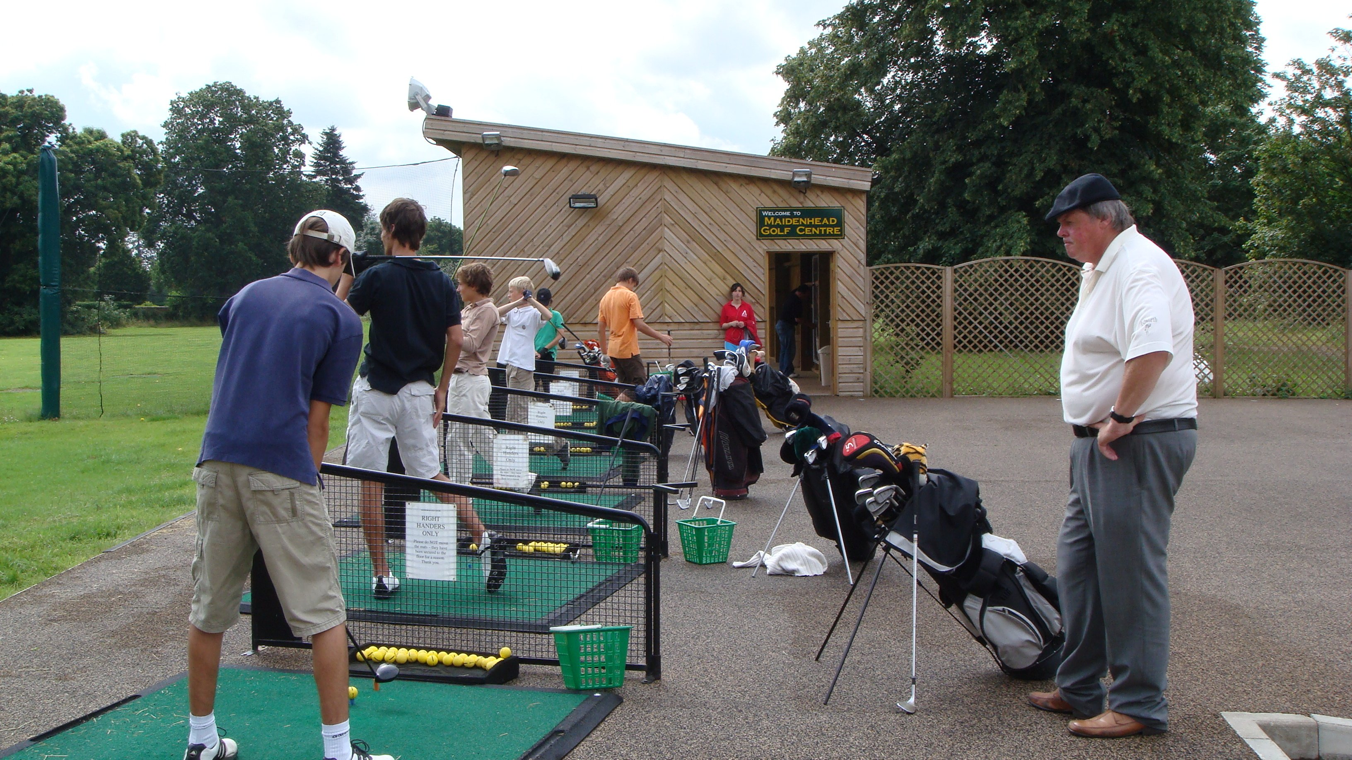

Hall Place Lane, Burchetts Green, Maidenhead, UK, from 9 to 17 age

Course intensity | 15
Accommodation | Résidence
Room type | Multi-bedded
Bathroom facilities | Shared
Meals | Breakfast, Lunch and Dinner
Excursions per week | 4
Weekday excursions | 3
Full day excursions | 1

Description

Why choose this program

Infrastructure

Sport infrastructure

Hobbies and clubs

What else included in the program price

Recommended arrival city

Лондон

Sample timetable
 | Morning | Afternoon | Evening
Day 1 | Arrival | Arrival | Arrival
Day 2 | Lessons- Entrance Exam | Half Day Excursion to Natural History Museum | Icebreaker Games
Day 3 | lessons | sports & leisure activities | Talent Show
Day 4 | lessons | Half Day Excursion to Windsor Castle | Karaoke
Day 5 | lessons | Sports and Leisure Activities | Rounders
Day 6 | Lessons | Half Day Excursion to London Southbank Walk | DIsco
Day 7 | Full Day Excursion to London, Thames River Cruise and Westminster Walking Tour | Full Day Excursion to London, Thames River Cruise and Westminster Walking Tour | Sports Tournament

For booking please go to www.travelclass.org

