Clubclass Language School — summer school in Malta

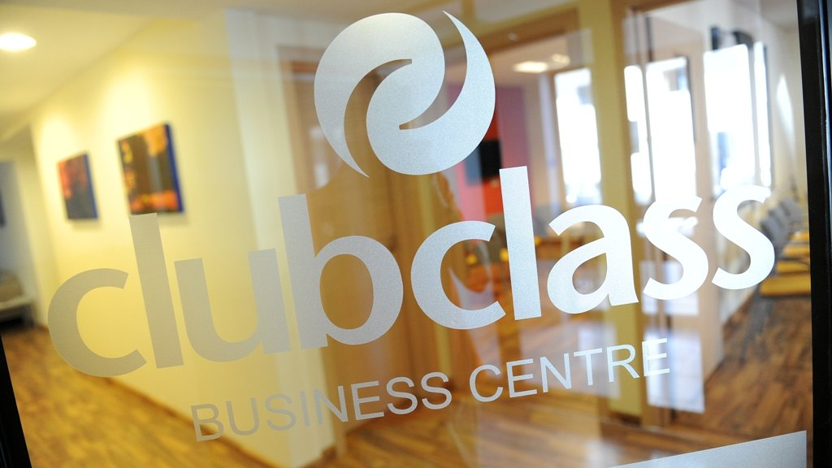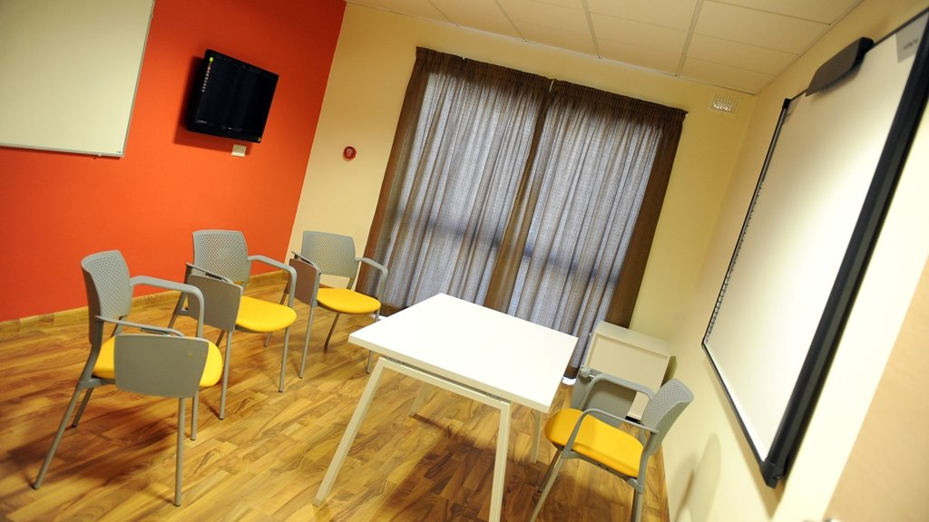

Swieqi, Malta, from 10 to 99 age

Course intensity | 15
Accommodation | Host family
Room type | Twin
Bathroom facilities | Shared
Meals | Breakfast, Lunch and Dinner
Excursions per week | 7
Weekday excursions | 5
Full day excursions | 2

Description

Why choose this program

Infrastructure

Sport infrastructure

Hobbies and clubs

What else included in the program price

Recommended arrival city

Luqa

Sample timetable
 | Morning | Afternoon | Evening
Day 1 | Lessons | Interactive science museum | Welcoming party
Day 2 | Lessons | Time on the beach | Themed night
Day 3 | Lessons | Excursion Valletta | Party FELTOM
Day 4 | Lessons | Historical quest in Medina | Talent show
Day 5 | Lessons | Malta National Aquarium | Quiz night
Day 6 | Excursion to Comino | Time on the beach | Excursion of the bay of Saint Paul
Day 7 | Excursion to the South of Malta | Time on the beach | Party

For booking please go to www.travelclass.org

