CES Leeds — language school in the UK

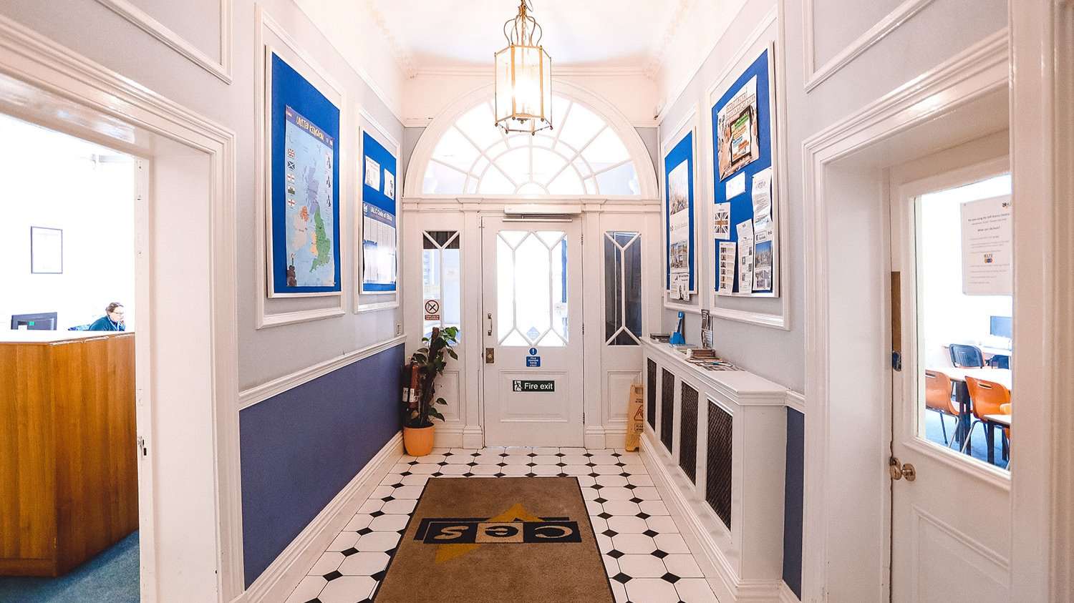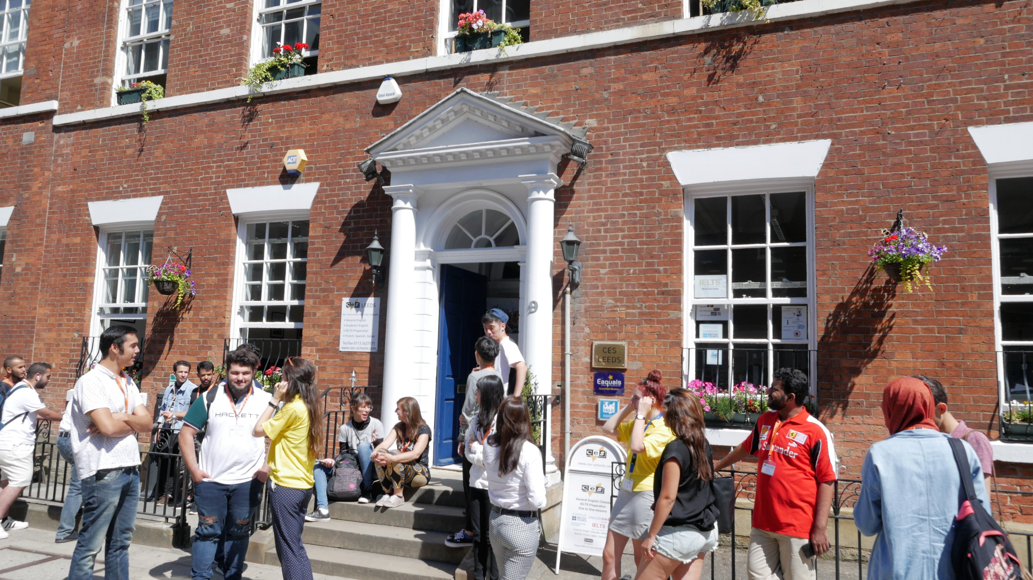

9 Park Place, Leeds, UK, from 12 to 99 age

Course intensity | 10
Accommodation | Host family
Room type | Twin
Bathroom facilities | Shared
Meals | Breakfast, Lunch and Dinner
Excursions per week | 3
Weekday excursions | 2
Full day excursions | 1

Description

Why choose this program

Infrastructure

Sport infrastructure

Hobbies and clubs

What else included in the program price

Recommended arrival city

Манчестер

Sample timetable
 | Morning | Afternoon | Evening
Day 1 | Classes | Orinetation tour | Family
Day 2 | Classes | Museum | Family
Day 3 | Classes | Tropical world excursion | Family
Day 4 | Classes | Bowling | Family
Day 5 | Classes | Sports centre | Junior disco
Day 6 | York excursion | York Excursion | Family
Day 7 | Family | Family | Family
Day 8 | Classes | Coubtry walk | Family
Day 9 | Classes | Sport activities | Family
Day 10 | Classes | Trip to Harrogate | Family
Day 11 | Classes | Sport activities | Family
Day 12 | Classes | Galleries | Disco
Day 13 | Trip to Manchester | Trip to Manchester | Trip to Manchester
Day 14 | Departure

For booking please go to www.travelclass.org

