CES Leeds — language school in the UK

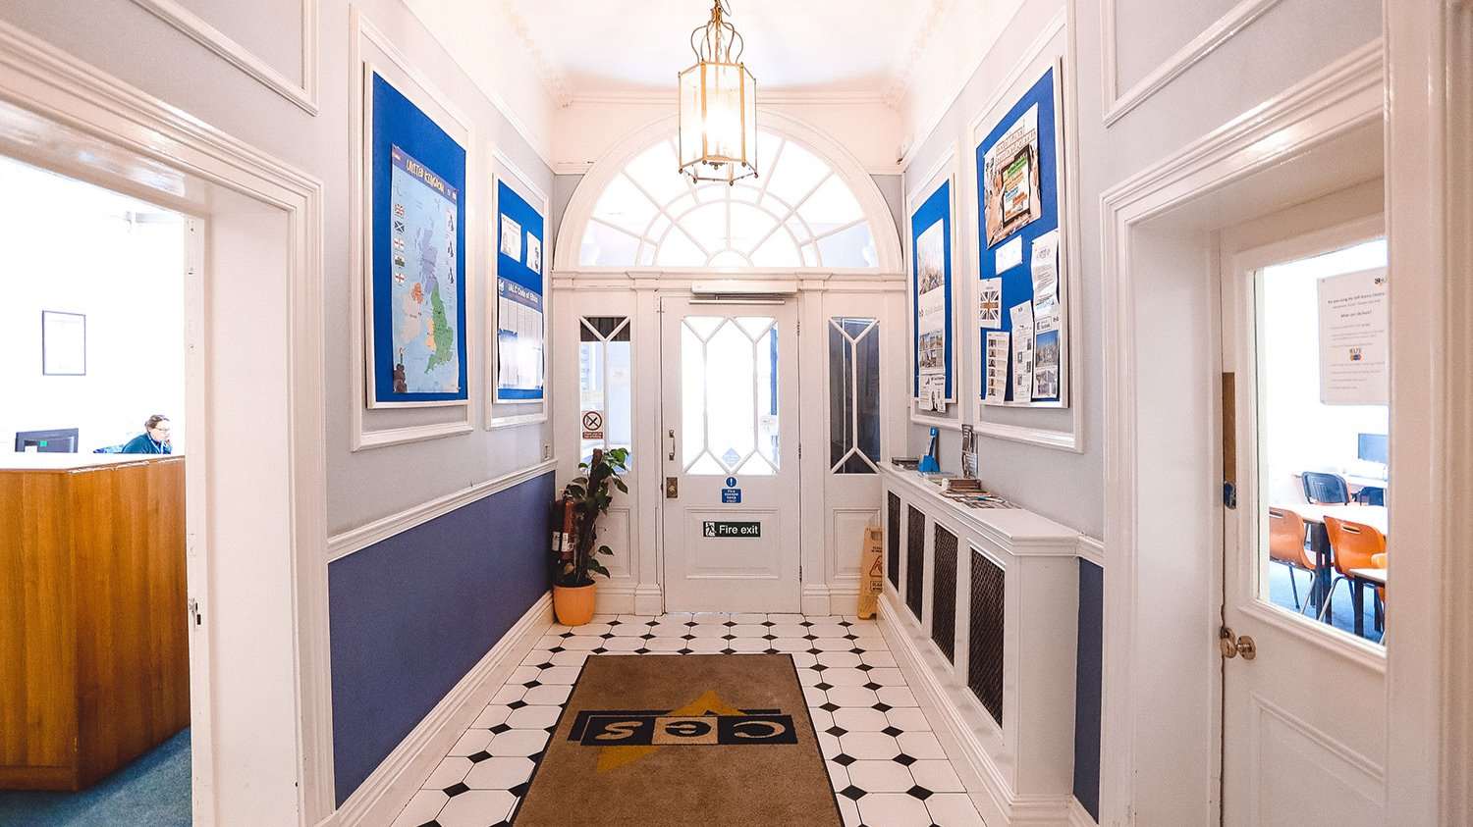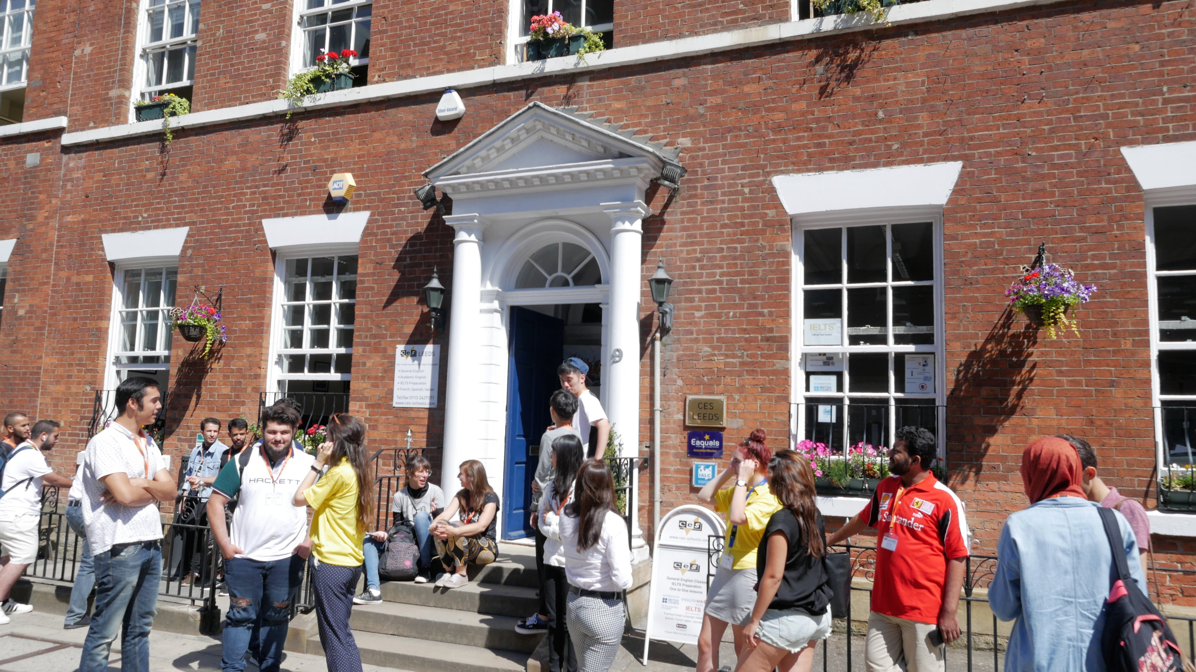

9 Park Place, Leeds, UK, from 12 to 99 age

Course intensity | 15
Accommodation | Host family
Room type | Twin
Bathroom facilities | Shared
Meals | Breakfast, Lunch and Dinner
Excursions per week | 3
Weekday excursions | 2
Full day excursions | 1

Description

Why choose this program

Infrastructure

Sport infrastructure

Hobbies and clubs

What else included in the program price

Recommended arrival city

Манчестер

Sample timetable
 | Morning | Afternoon | Evening
Day 1 | Placement Testing | Induction and Town Tour (Free) | Induction and Town Tour (Free)
Day 2 | Lessons | Leeds City Museum | Leeds City Museum
Day 3 | Lessons | Tropical World and Roundhay Park Half-day Excursion | Free time
Day 4 | Lessons | Bowling afternoon | Free time
Day 5 | Lessons | Movie Afternoon | Free time
Day 6 | York Full Day Excursion | York Full Day Excursion | York Full Day Excursion
Day 7 | Free day with your host family | Free day with your host family | Free day with your host family

For booking please go to www.travelclass.org

