Irish College of English Glenstal Abbey — summer school in Ireland

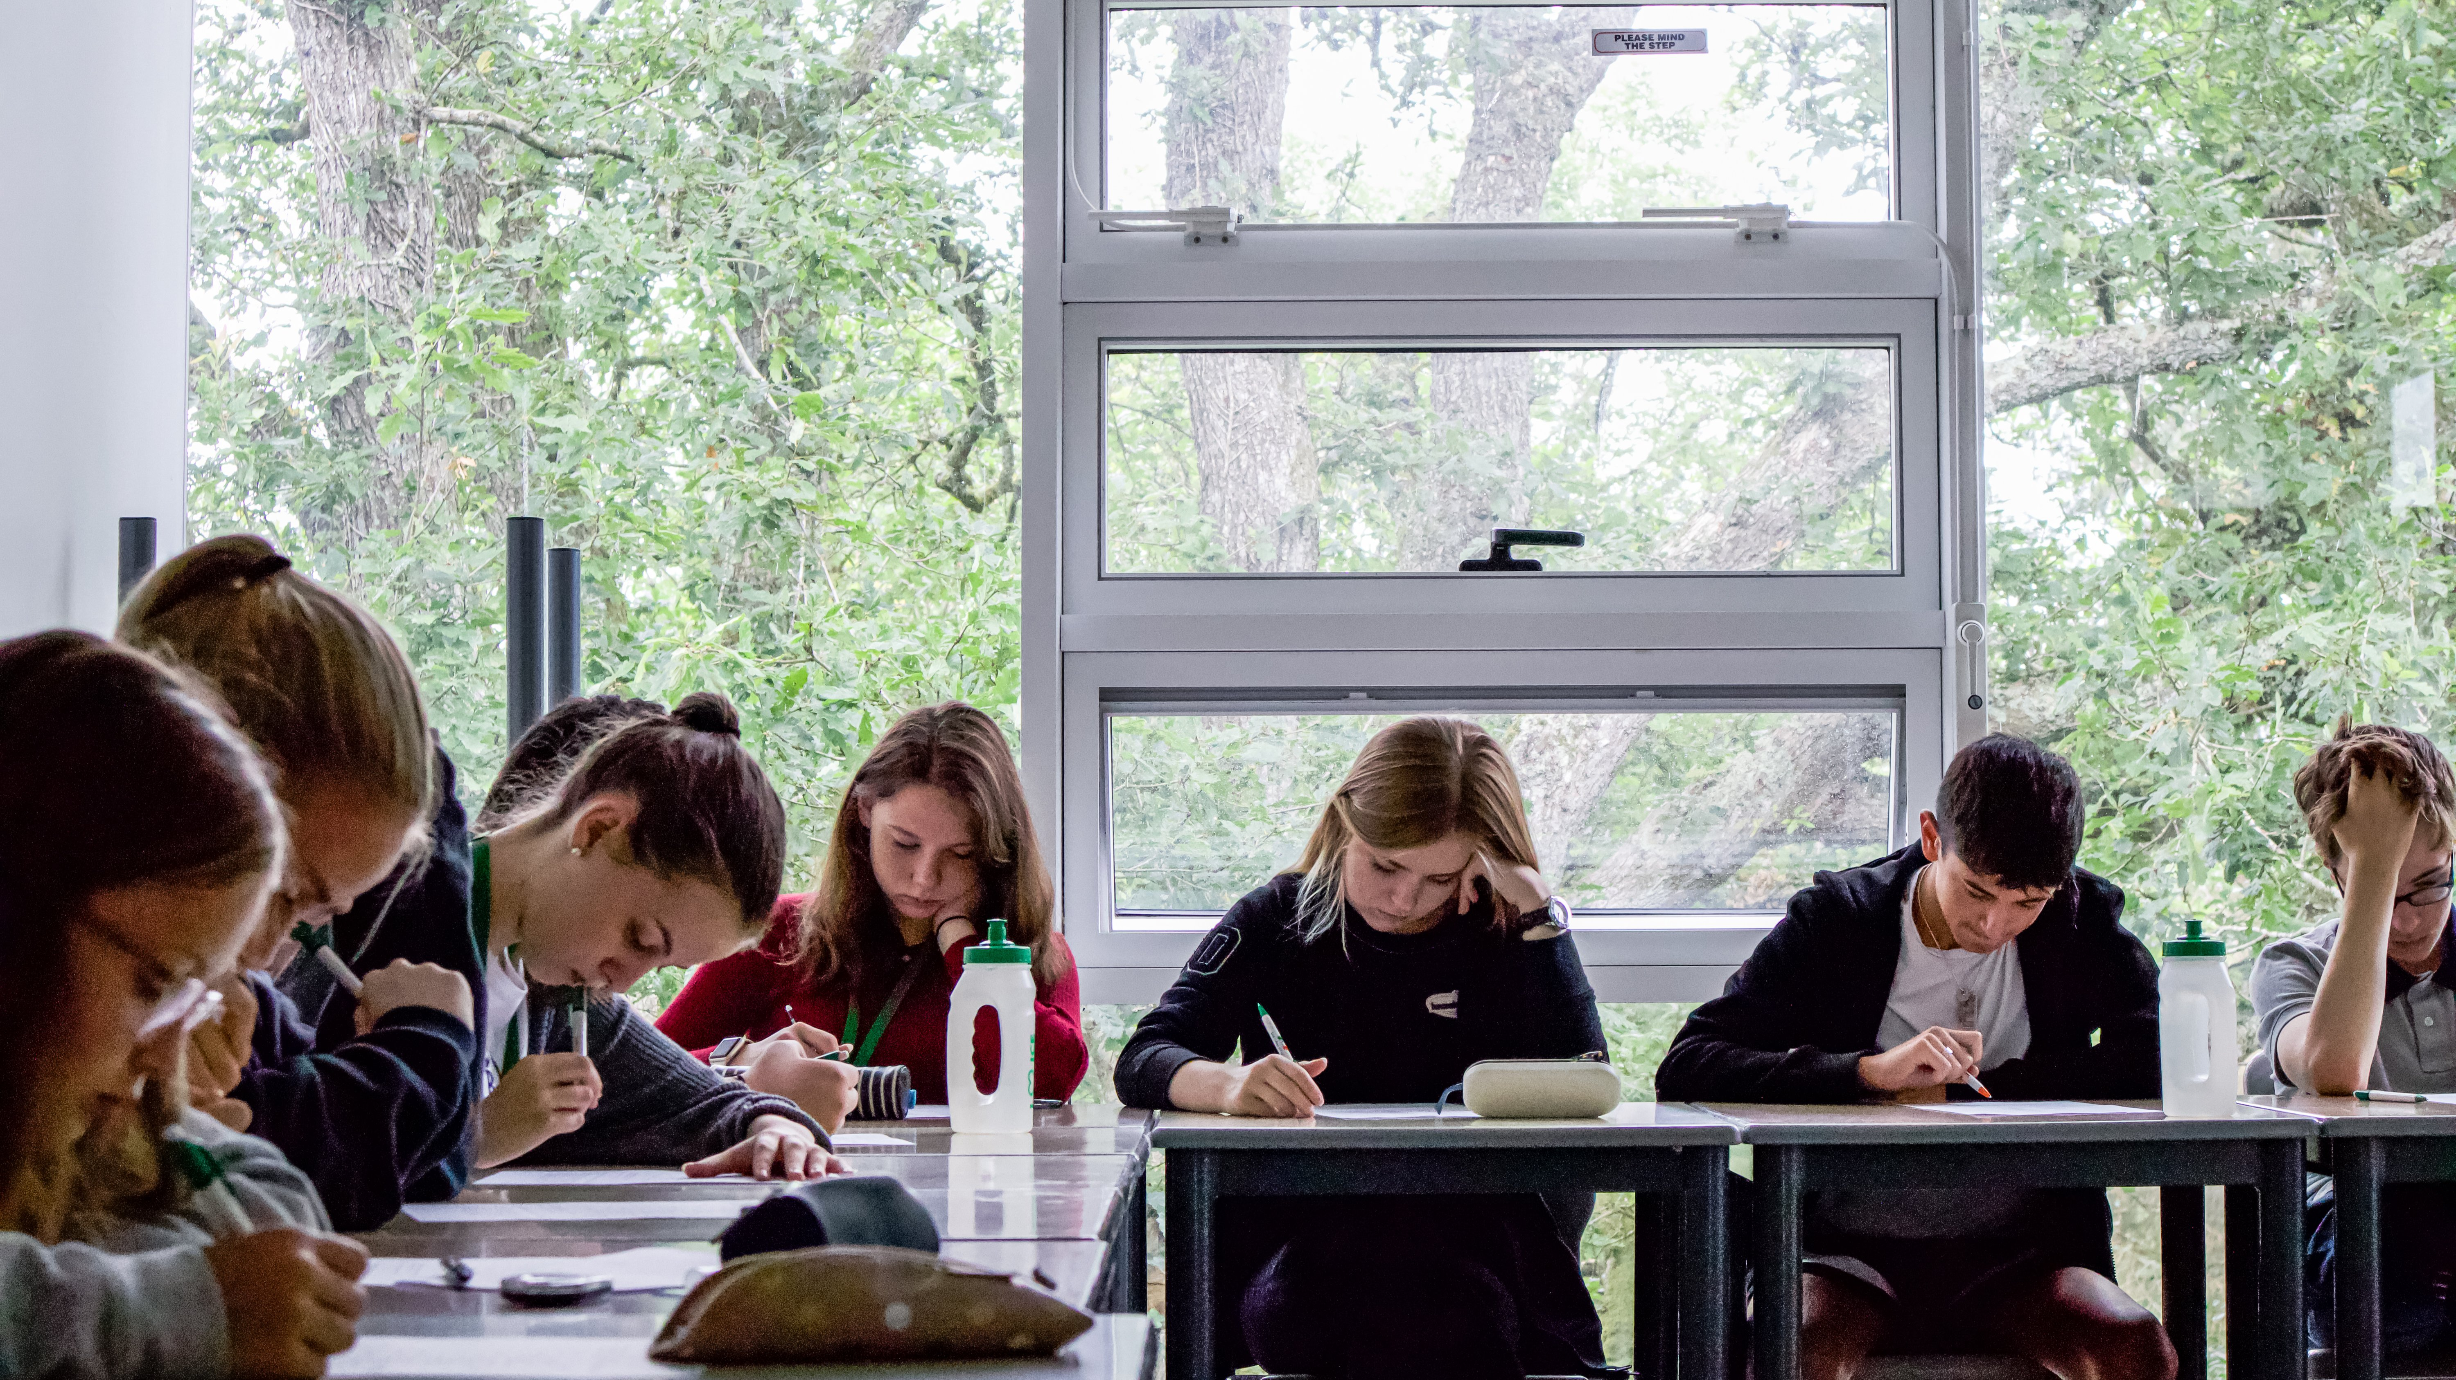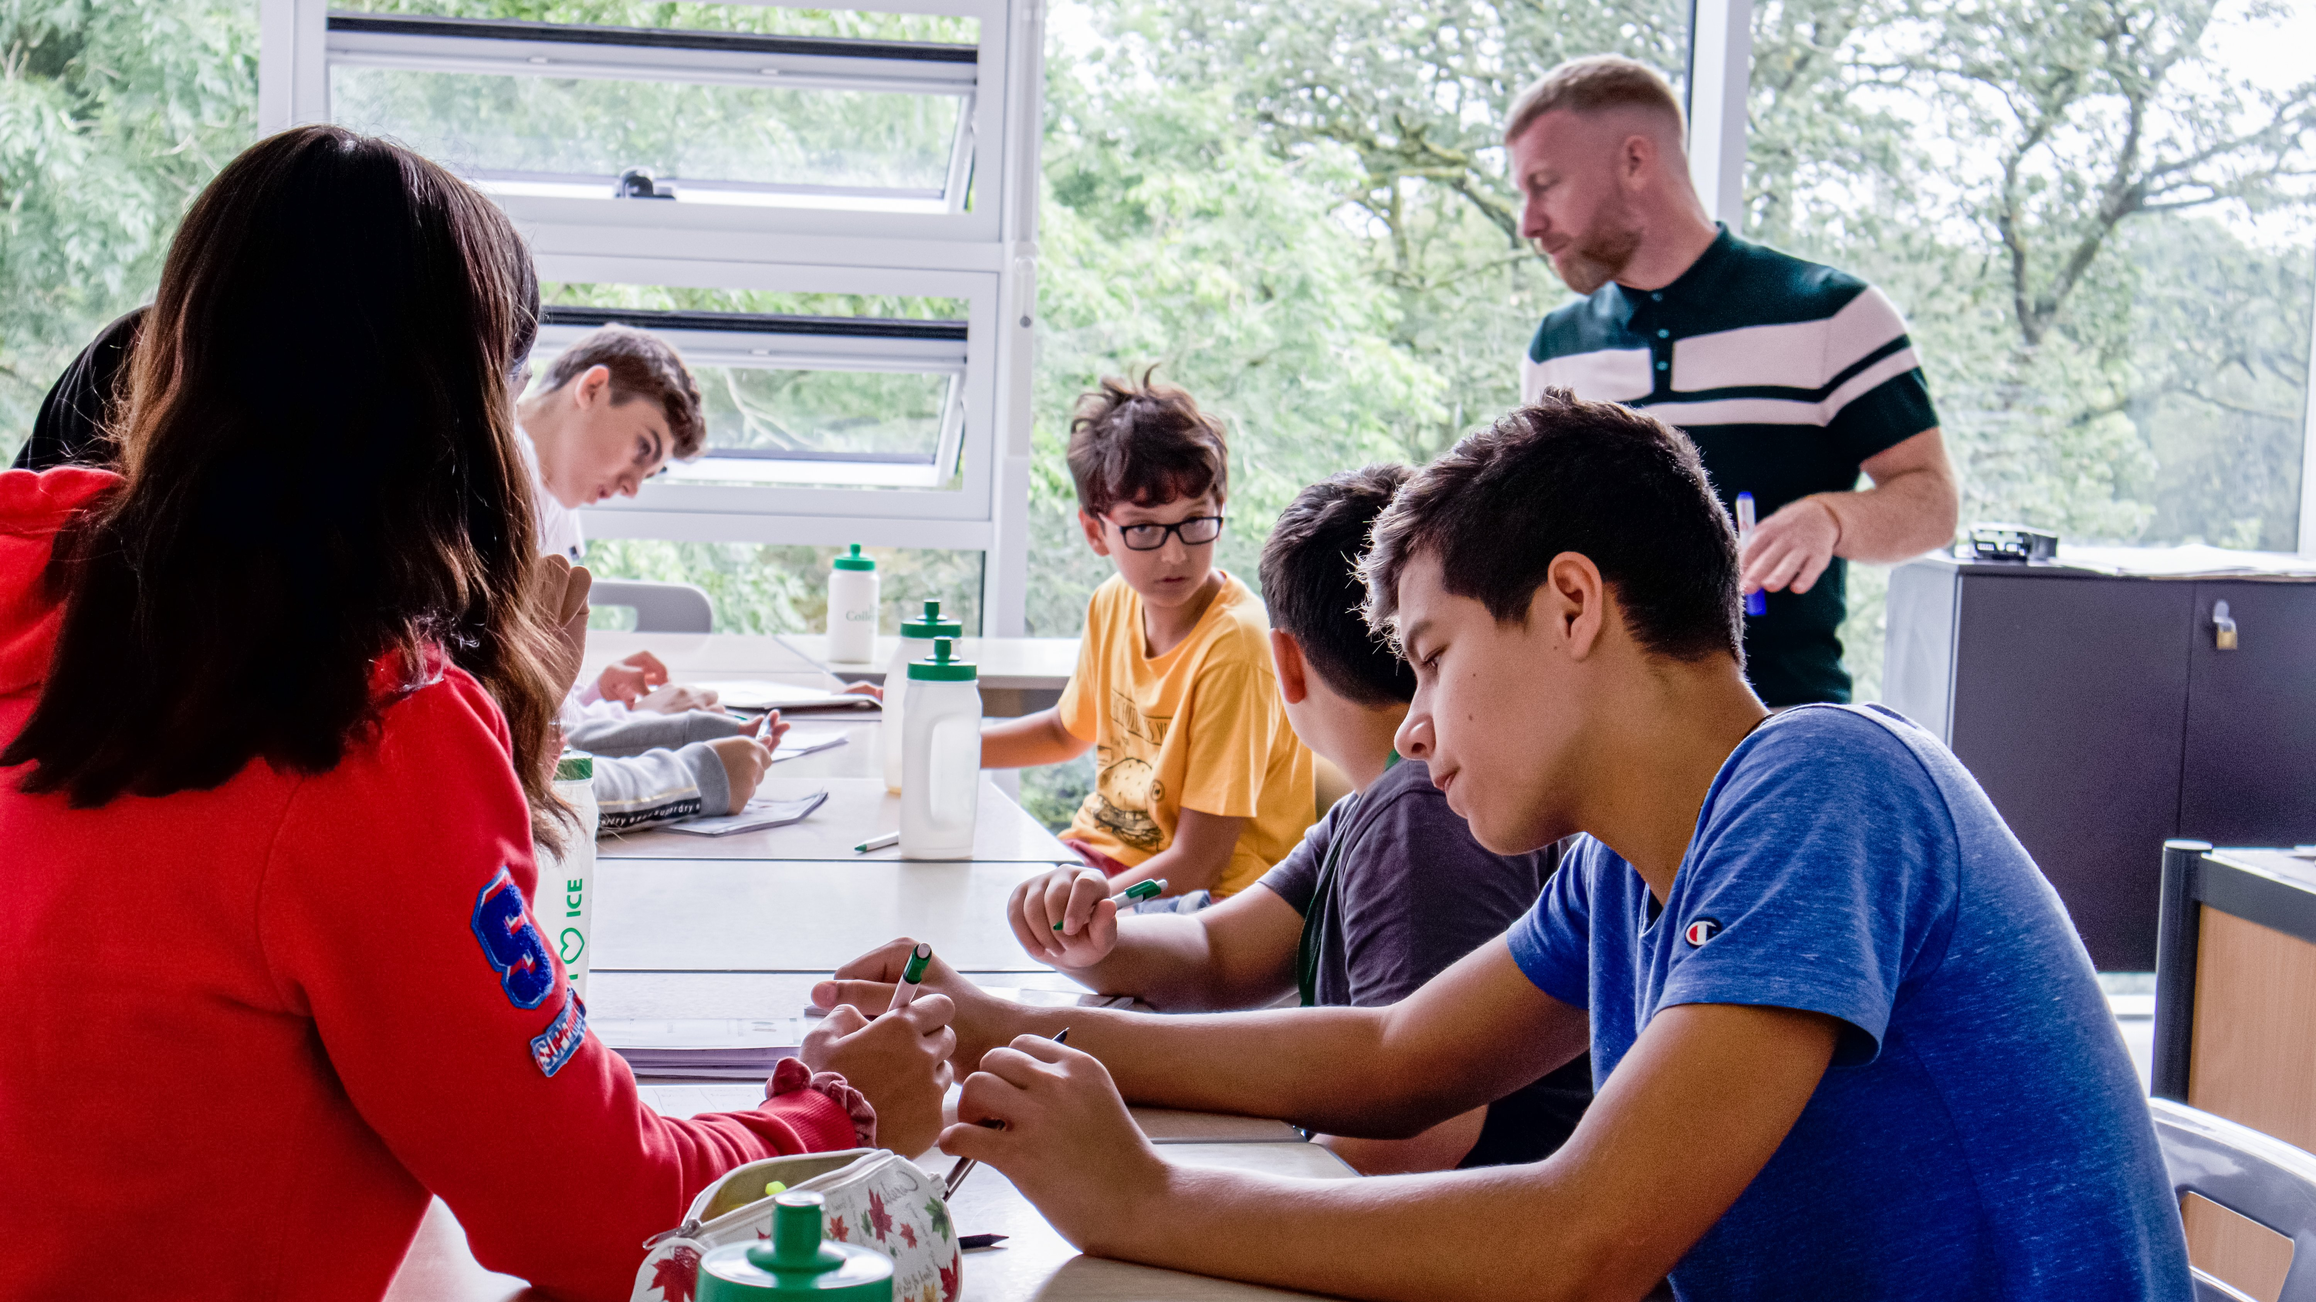

Glenstal Abbey, County Limerick, Ireland, from 11 to 17 age

Course intensity | 15
Accommodation | Résidence
Room type | Multi-bedded
Bathroom facilities | Shared
Meals | Breakfast, Lunch and Dinner
Excursions per week | 5
Weekday excursions
Full day excursions | 1

Description

Why choose this program

Infrastructure

Sport infrastructure

Hobbies and clubs

What else included in the program price

Recommended arrival city

Дублин

Sample timetable
 | Morning | Afternoon | Evening
Day 1 | English Classes | Kayaking | Evening Elective Learn a Skill
Day 2 | English Classes | Sports on Site | Team Building
Day 3 | English Classes | Bowling Off Site | Evening Elective Learn a Skill
Day 4 | English Classes | Survival Skills on Site | Movie Night
Day 5 | English Classes | Visit Limerick and Shopping | Evening Elective Learn a Skill
Day 6 | Full Day Trip to Unesco Cliffs of Moher | Full Day Trip to Unesco Cliffs of Moher | Disco
Day 7 | Full Day Trip to Ring of Kerry | Full Day Trip to Ring of Kerry | Quiz

For booking please go to www.travelclass.org

