MLA Dulwich College — language school in the UK

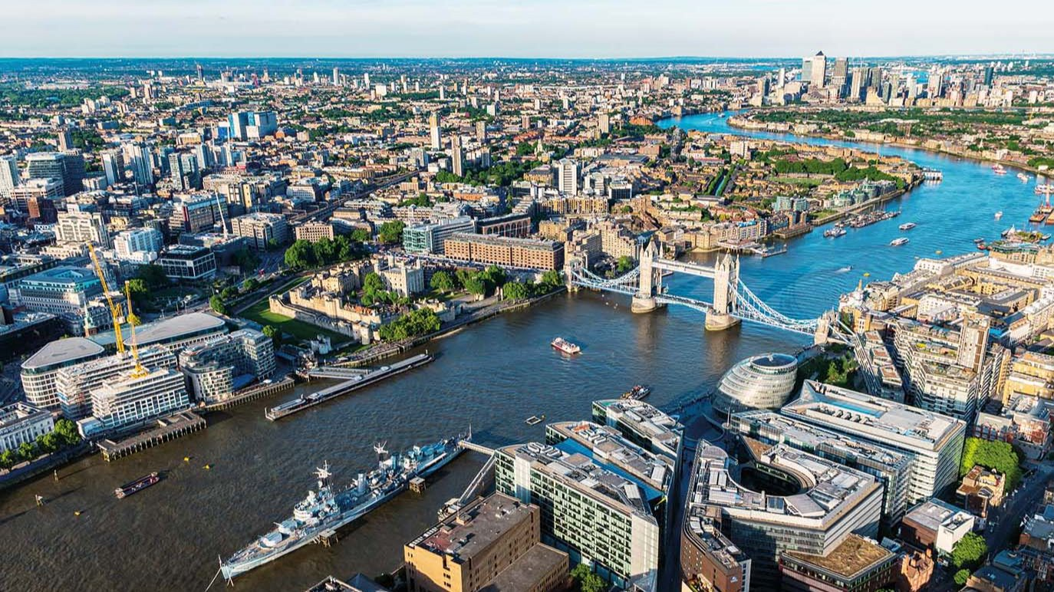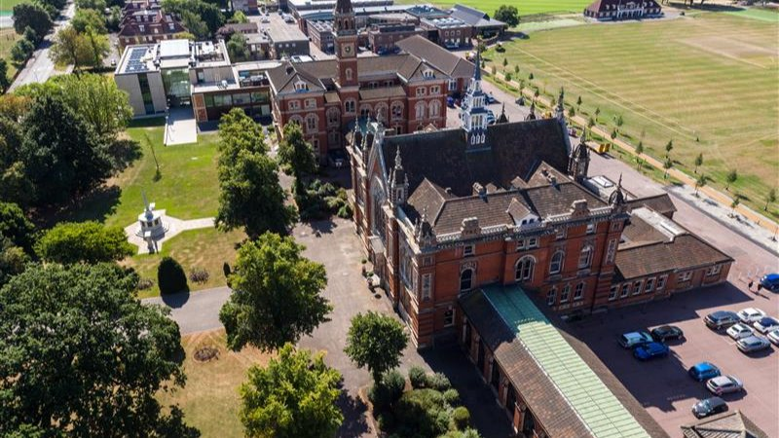

Dulwich College (Stop VQ), London, UK, from 10 to 18 age

Course intensity | 45
Accommodation | Host family
Room type | Twin
Bathroom facilities | En-suite
Meals | Breakfast, Lunch and Dinner
Excursions per week | 7
Weekday excursions | 5
Full day excursions | 2

Description

Why choose this program

Infrastructure

Sport infrastructure

Hobbies and clubs

What else included in the program price

Recommended arrival city

Лондон

Sample timetable
 | Morning | Afternoon | Evening
Day 1 | Arrival | Arrival | Welcome party
Day 2 | Orientation and testing | Walking tour | Movie
Day 3 | Lessons | Winchester Cathedral | British Disco
Day 4 | Lessons | Sport | Quiz
Day 5 | Lessons | Shopping at the Oracle | Karaoke
Day 6 | Lessons | Sport | Treasure hunt
Day 7 | Full day excursion to London | Full day excursion to London | Hard Rock cafe
Day 8 | Lessons | Lessons | Scavenger Hunt and chit chat
Day 9 | Full day Canterbury | Full day Canterbury | British Disco
Day 10 | Lessons | Lessons | Karaoke or sport
Day 11 | Full day London | Full day London | Musical
Day 12 | Lessons | Lessons | Kahoot Night
Day 13 | Half day Richmond Park | Sports & Leisure | Sherlock Holmes Experience
Day 14 | Full day London | Full day London | Disco

For booking please go to www.travelclass.org

