ATC Blackrock College — summer school in Ireland

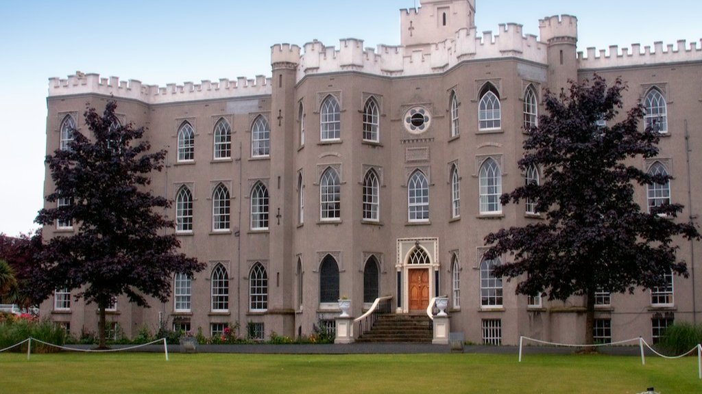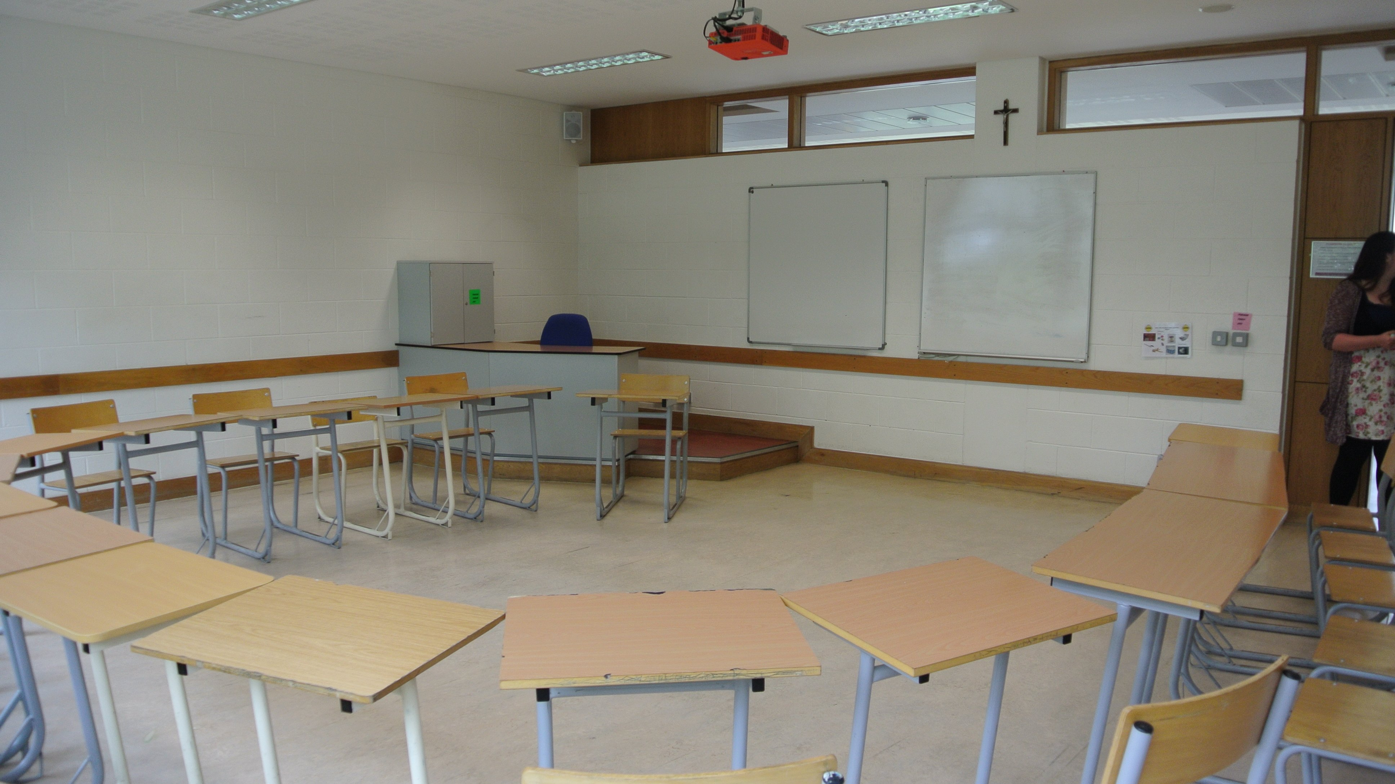

College House, Rock Road, Blackrock, County Dublin, Ireland, from 11 to 15 age

Course intensity | 15
Accommodation | Campus
Room type | Twin
Bathroom facilities | Shared
Meals | Breakfast, Lunch and Dinner
Excursions per week | 2
Weekday excursions | 1
Full day excursions | 1

Description

Why choose this program

Infrastructure

Sport infrastructure

Hobbies and clubs

What else included in the program price

Recommended arrival city

Дублин

Sample timetable
 | Morning | Afternoon | Evening
Day 1 | Arrival Day! | Welcome to ATC | Mixer Games
Day 2 | Lessons | Sports Day | Quiz Night
Day 3 | Lessons | Arts and Crafts. Drama or Irish Sports | Trash Fashion
Day 4 | Lessons | Chocolate Factory | ATC Quiz night
Day 5 | Lessons | Arts and Crafts. Drama or Irish Sports | ATC Olympics
Day 6 | Full Day Tour - Glendalough | Wicklow Gaol | Black and White Disco
Day 7 | Full Day Tour - Bray | Full Day Tour - Bray | Karaoke
Day 8 | Free day
Day 9 | English Classes | STEM | Karaoke
Day 10 | English Classes | Half day excursion | Quiz
Day 11 | English Classes | STEM | Fashion Show
Day 12 | English Classes | STEM | Games
Day 13 | English Classes | STEM | Games
Day 14 | Full day excursion | Full day excursion | Full day excursion

For booking please go to www.travelclass.org

