BELS Malta — language school in Malta

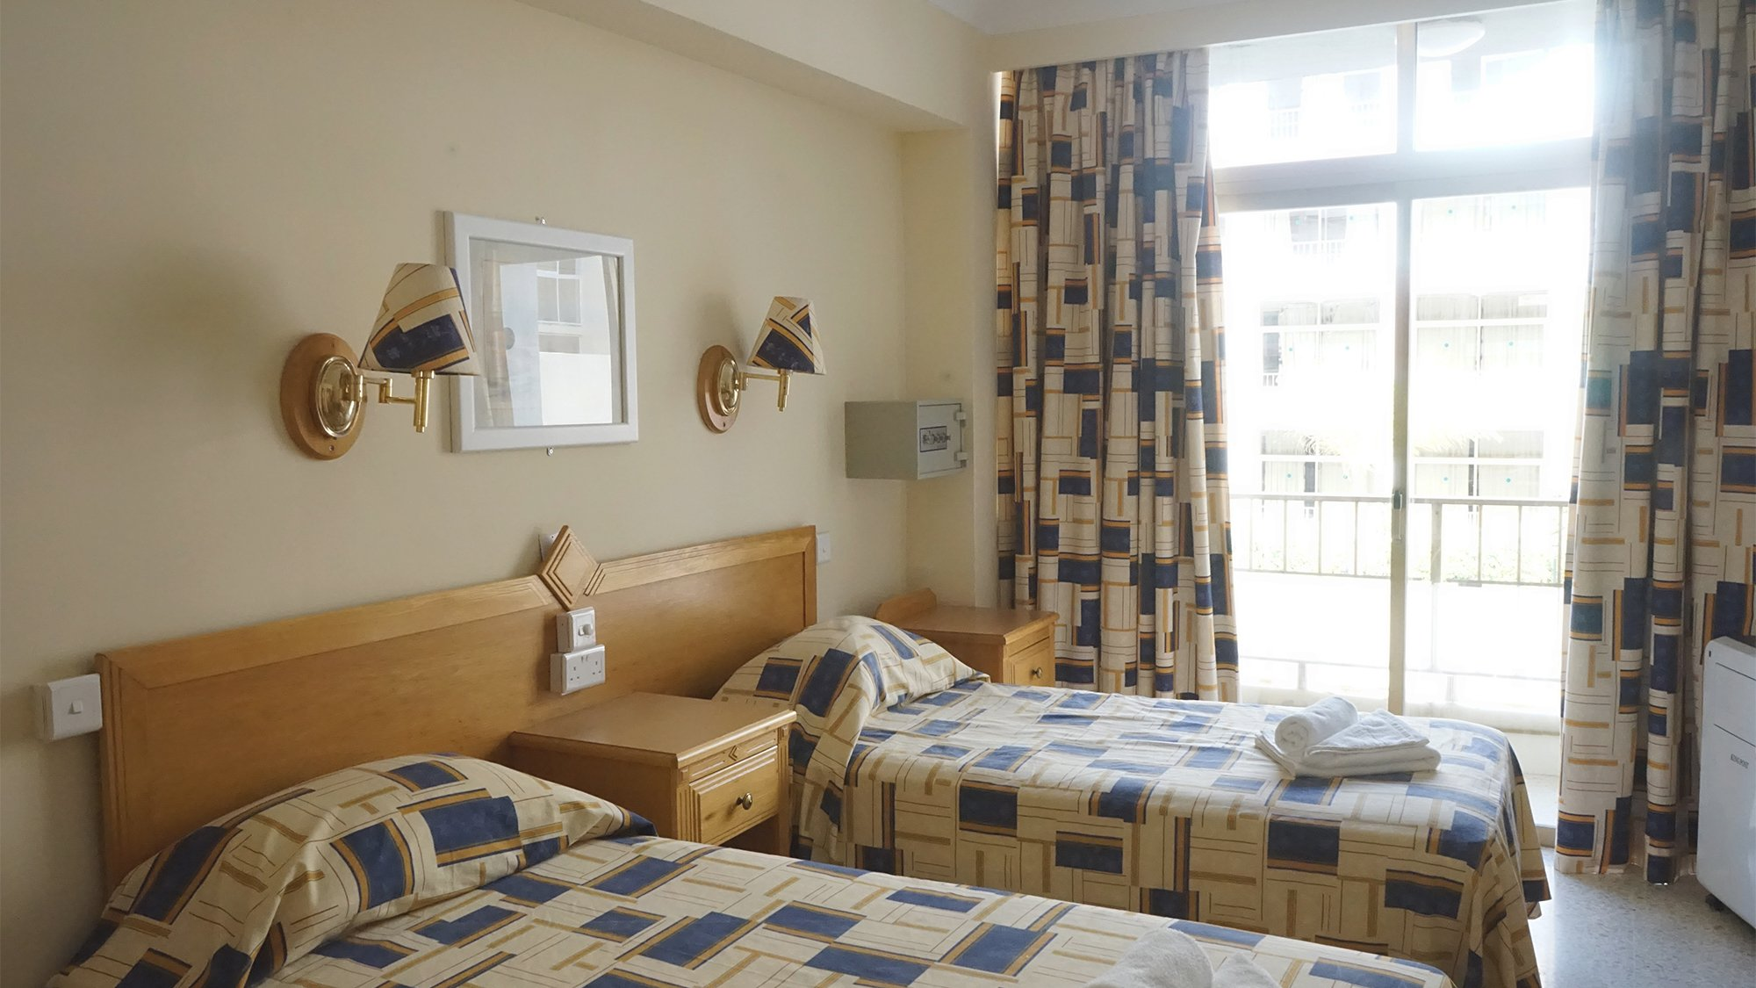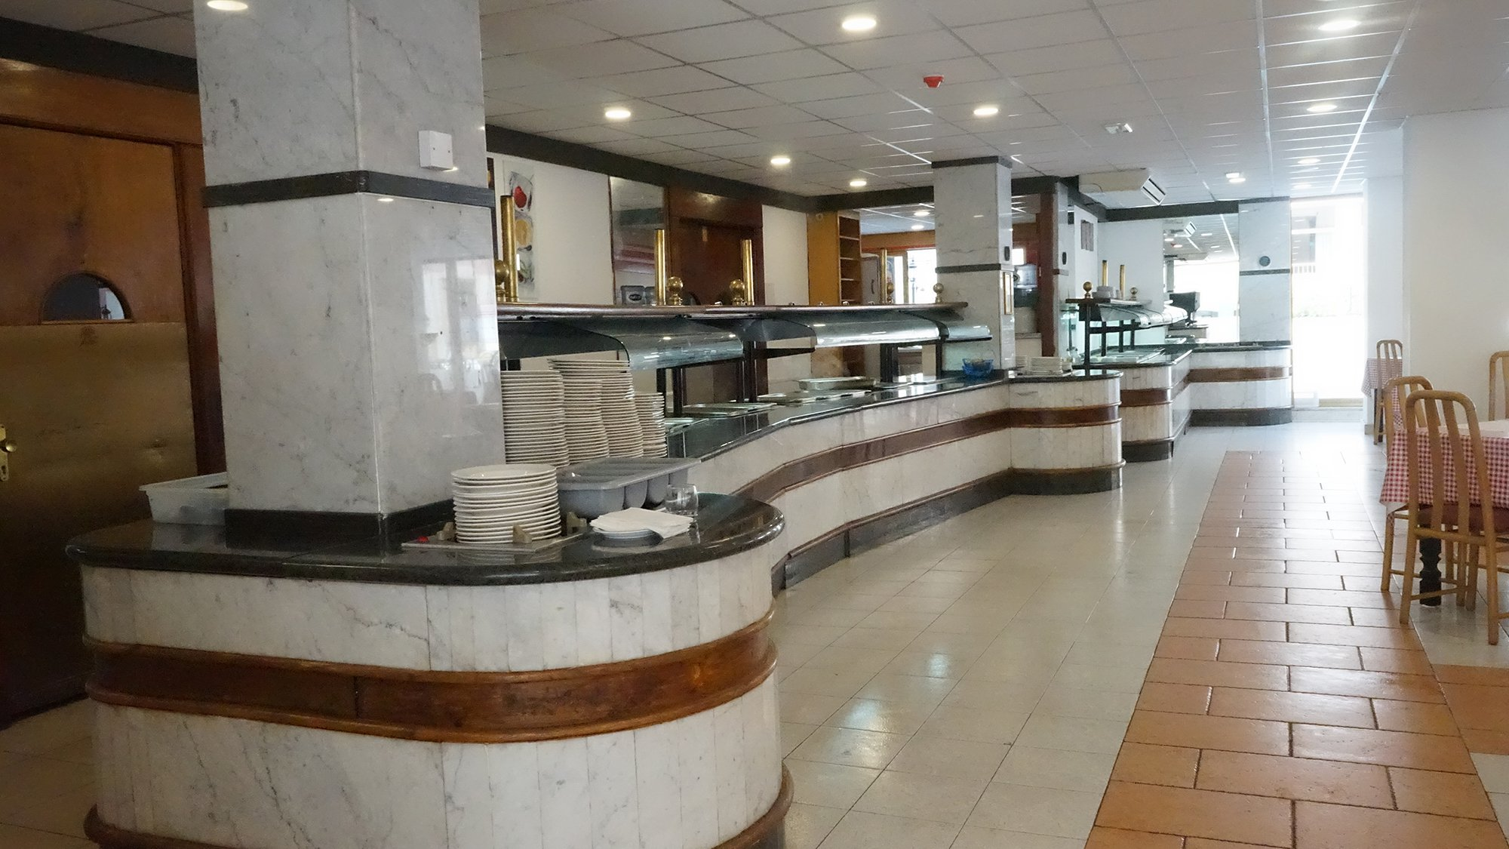

St. Paul's Street, St Paul's Bay, Malta, from 10 to 16 age

Course intensity | 15
Accommodation | Résidence
Room type | Triple
Bathroom facilities | Shared
Meals | Breakfast, Lunch and Dinner
Excursions per week | 4
Weekday excursions | 4
Full day excursions

Description

Why choose this program

Infrastructure

Sport infrastructure

Hobbies and clubs

What else included in the program price

Recommended arrival city

Валлетта

Sample timetable
 | Morning | Afternoon | Evening
Day 1 | Valletta tour & Malta 5D Show | Afternoon Rocky Beach Experience | Welcome Talk & Orientation Walk
Day 2 | Splash & Fun Waterpark | Lesson | BBQ dinner by the sea & Night Swim
Day 3 | St. Julian’s tour, Shopping & Swim | Lesson | Free Evening
Day 4 | Sandy Beach & Volleyball Games | Lesson | International Student Party
Day 5 | Free Morning | Lesson | Beach by Night
Day 6 | Comino Island & Caves visit by Power boat | Lesson | Sports Evening & Farewell Night
Day 7 | Free Morning | Chill out by the pool | Buġibba Photo Hunt

For booking please go to www.travelclass.org

