Australian International College of Language — language school in Australia

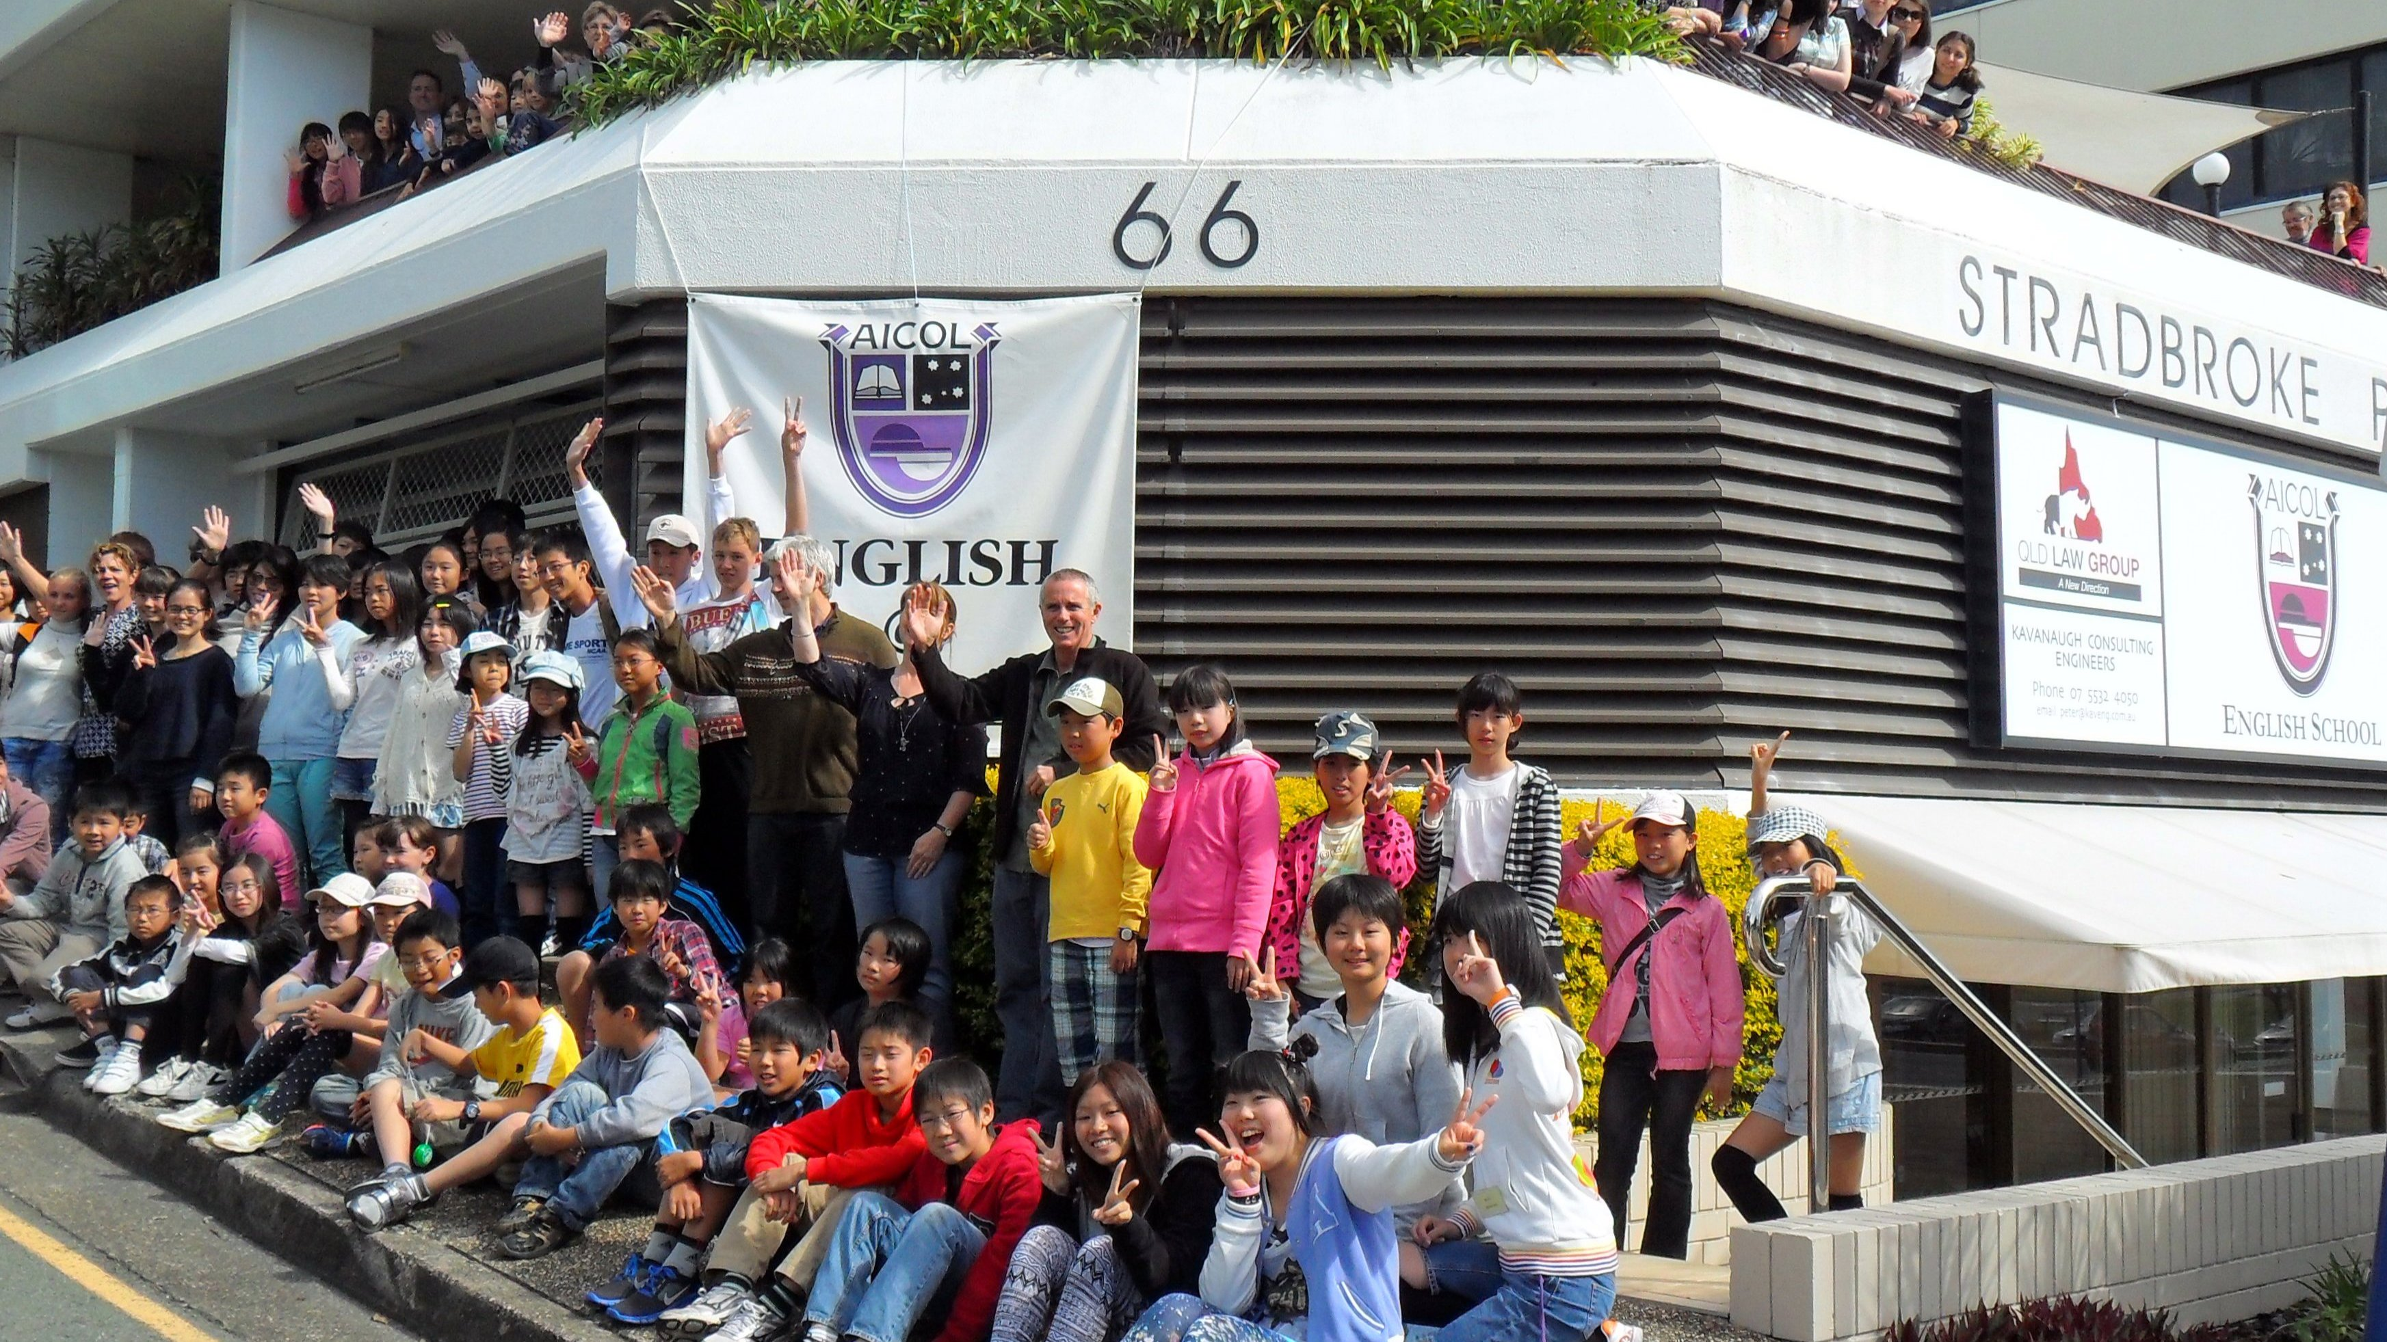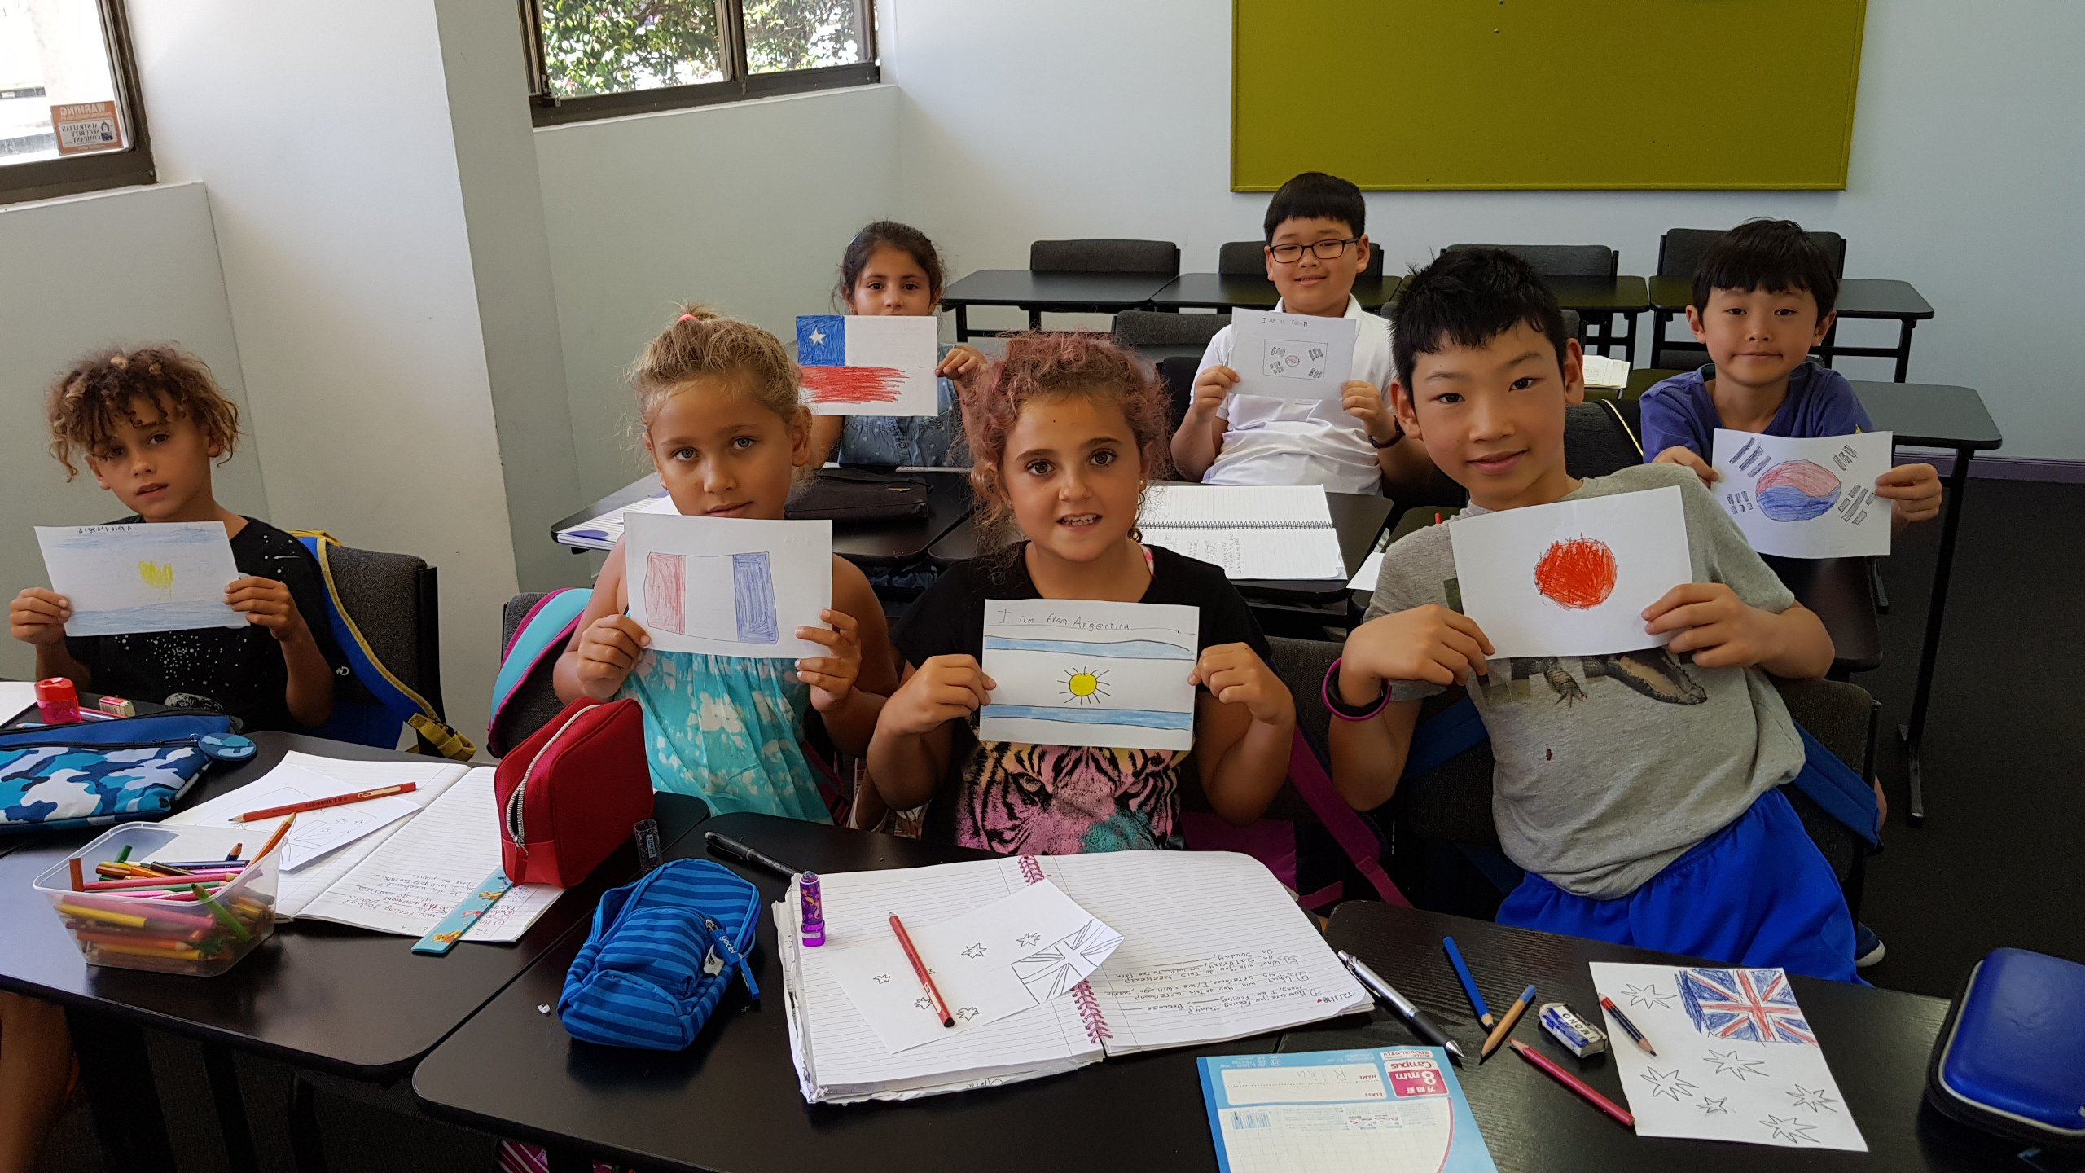

3/66 Marine Parade, Southport QLD, Australia, from 6 to 18 age

Course intensity | 20
Accommodation | Host family
Room type | Twin
Bathroom facilities | En-suite
Meals
Excursions per week | 3
Weekday excursions | 2
Full day excursions | 1

Description

Why choose this program

Infrastructure

Sport infrastructure

Hobbies and clubs

What else included in the program price

Recommended arrival city

Голд-Кост

Sample timetable
 | Morning | Afternoon | Evening
Day 1 | Arrival | Arrival | Meet your Homestay family
Day 2 | Lessons | Gold Coast and Botanic Garden | Homestay pick-up
Day 3 | Lessons | Time Zone | Homestay pick-up
Day 4 | Lessons | Volleyball | Homestay pick-up
Day 5 | Lessons | Shopping | Homestay pick-up
Day 6 | Lessons | Kayaking Lesson | Homestay pick-up
Day 7 | Lessons | Mt. Tamborine & Glow Worm | Homestay pick-up

For booking please go to www.travelclass.org

