Stafford House School of English Brighton — language school in the UK

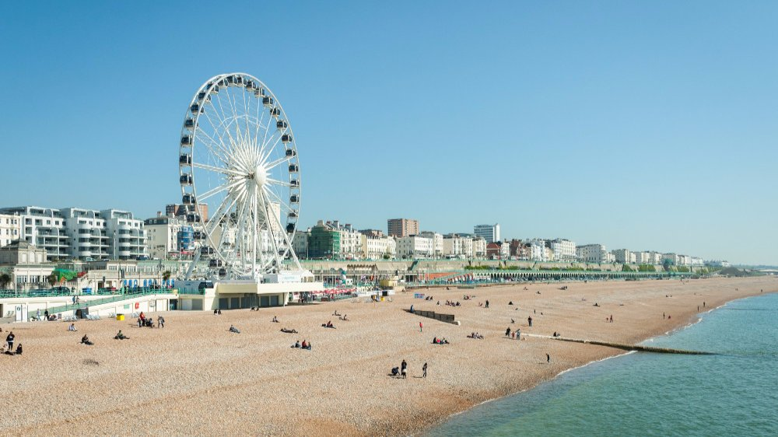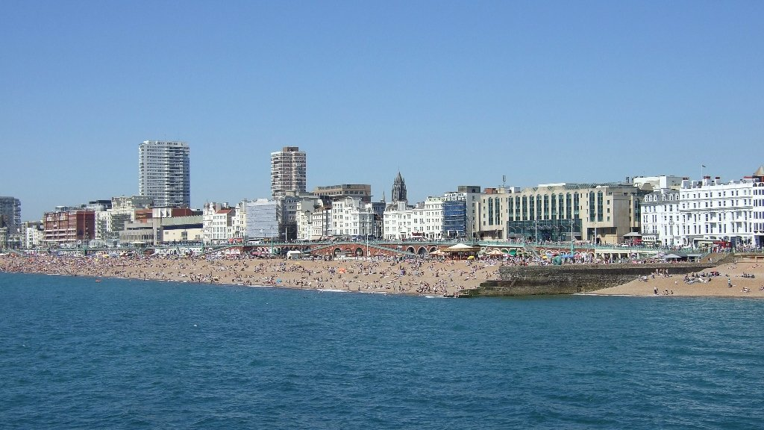

61 Western Road, Hove BN3 1JD, UK, from 12 to 100 age

Course intensity | 15
Accommodation | Host family
Room type | Twin
Bathroom facilities | Shared
Meals | Breakfast, Lunch and Dinner
Excursions per week | 4
Weekday excursions | 3
Full day excursions | 1

Description

Why choose this program

Infrastructure

Sport infrastructure

Hobbies and clubs

What else included in the program price

Recommended arrival city

Лондон

Sample timetable
 | Morning | Afternoon | Evening
Day 1 | Arrival | Arrival | Evening with host family
Day 2 | Walking tour of Brighton | Placement Test and Lesson 1 | Evening with homestay hosts
Day 3 | Sports or Arts & Crafts e.g Graffiti Design | Lessons | Welcome party
Day 4 | Included Half Day Excursion: Lewes & Lewes Castle | Lessons | Evening with host family
Day 5 | Local Visit: Brighton Royal Pavilion | Lessons | Movie & Pizza Night
Day 6 | Sports or Swimming at Brighton Outdoor Lido | Lessons | Evening with host family
Day 7 | Included Full Day Excursion: London Walking Tour | Included Full Day Excursion: London Walking Tour | Evening with host family

For booking please go to www.travelclass.org

